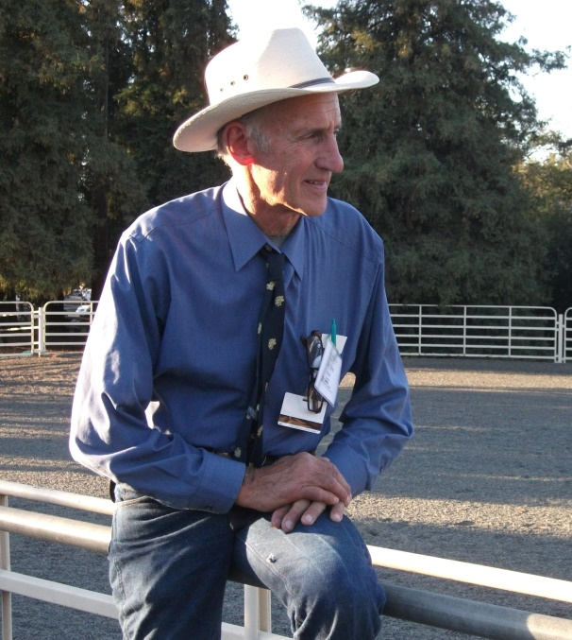
The First DONKEY WELFARE SYMPOSIUM
By Marlene Quiring
Several years ago, my husband Roy and I attended the world’s first ‘’Donkey Wellness Symposium’’ at the University of California, Davis, CA.[ near Sacramento.] This was a greatly anticipated gathering of veterinarians, rescue organizations, breeders, trainers and just everyday folk that have a common concern for the welfare of donkeys and mules worldwide. Several hundred people attended including representatives from across the United States and four other countries; Canada, England, Mexico and Portugal.
There was an impressive lineup of presenters at the symposium. Dr. Eric Davis, of the University of California, Davis University is a world leader in the crusade for Donkey Wellness. Dr. Stephen Blakeway and David Cook from the Donkey Sanctuary of England gave excellent presentations on the work that is going on in their locations around the world. The Donkey Sanctuary of England works with and has connections in many countries and currently cares for about 6,000 donkeys and mules. They have 8 farms in the United Kingdom and 3 in Ireland. Their website is full of everything you ever wanted to know about donkeys and their staff and veterinarians are available for advice and help 24/7 year round. They can be contacted at www.thedonkeysanctuary.org.uk
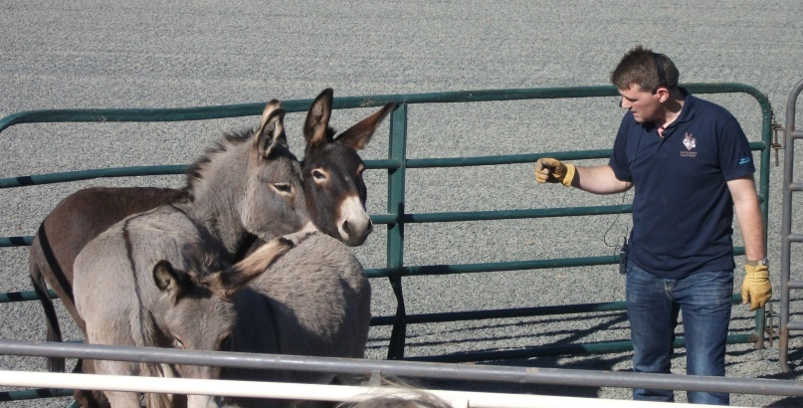
Benjamin Hart, an expert animal behaviorist and part of the training team at the Sanctuary gave daily live demonstrations with a group of donkeys provided by a local rescue. Other presenters were: Drs. Amy McLean and Cami Heleski on the behavior of donkeys as compared to horses.
Dr. Brandao Rodrigues give a presentation and live demonstrations on donkey dentistry. Mary Sanichas also provided live demonstrations on working with donkeys naturally.
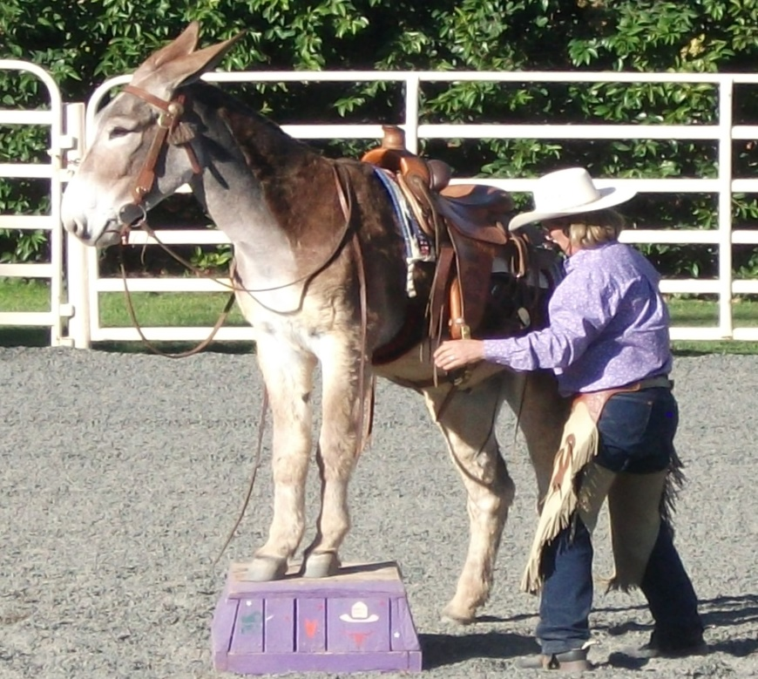 Crystal Ward, long time breeder, trainer and judge, explained her passion and her personal program for training donkeys and gave us an impressive riding and obstacles demonstration with her handsome mammoth donkey. Dr. Nora Matthews gave a very informative presentation on donkey reactions to drugs and Dr. Rosina Krecek spoke on controlling parasites in donkeys. Linda Cowles addressed hoof care and Mark Myers of Peaceful Valley Donkey Rescue explained how their rescue organization works and the great need that there is for donkey protection and rehoming in North America. Kim Hayes, from Guelph Ontario, represented the Donkey Sanctuary of Canada and spoke on how our Canadian Sanctuary works which was very enlightening for me and I was able to converse with Kim on common concerns that we face in the western provinces regarding donkey welfare.
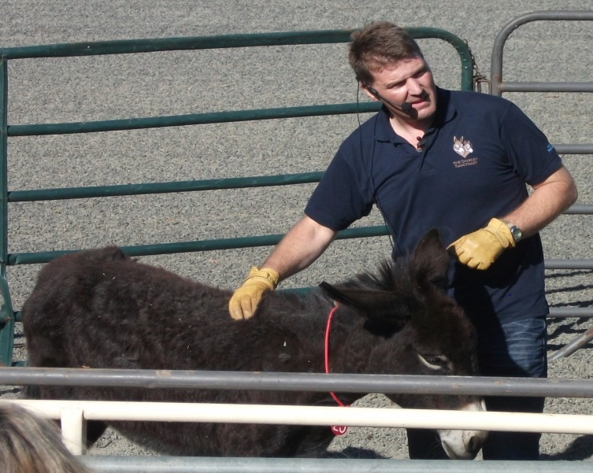
Animal behaviorist and trainer, Benjamin Hart, said in order to learn,’’ we needed to empty our cup first, so that we had room to fill it.’’ He stated that ’’ we are all trainers every day, all day.’’ He reminded us that each donkey or animal is an individual and that each will require an individual training style. Ben uses positive reinforcement to train; patience, kindness and encouragement which includes scratching instead of patting which is not really suitable. Much better to find an itchy spot and relieve it for them! Food rewards [not bribes] can be used, but being that most of us do not have good timing, is not always recommended. Watching Ben work with and progress with a group of timid rescue donkeys was very rewarding. As he worked, he also explained what he saw in the donkeys and how he thought each donkey needed to be treated, and what approach would work best with each animal. Ben stated that a horse’s motto when fearful is ‘’ It’s better to be safe than sorry’’ so the horse will resort to flight. A donkey is more territorial and might more readily resort to fight instead of flight. Ben believes that it is a fundamental error when we do not truly take in the true nature of the donkey. Timing was everything in Ben’s communication with them.
There are over 50 million donkeys and mules worldwide. They are the ‘’invisible equine’’ – still used in many developing countries and often providing the means to make a living for many of the world’s poorest people. David Cook stated that ‘’Poor people have donkeys, even poorer people don’t!’’ Another Ethiopian saying often used by the Donkey Sanctuary is: ‘’A man without a donkey is a donkey!’’
Unfortunately, ignorance in these countries often cuts short the lives of these working donkeys. An example is the following story shared by the Donkey Sanctuary of England.
The expanding suburbs of the city of Cairo, Egypt have literally been built from bricks hauled on carts pulled by donkeys. These donkeys are still used to transport ‘wet bricks’ within the kilns where the bricks are made. Workers from the Donkey Sanctuary of England and from the Society for the Protection and care of Donkeys and Mules in Egypt had tried to help the donkeys by providing free veterinary care, but improvements were not satisfactory. Donkeys that weighed no more than 400 lbs. were used to pull loads of bricks up to 4, 400 lbs! Open, weeping sores on their backs, necks, heads and shoulders from poorly fitting, poorly maintained harness, were horribly common, yet the donkeys still had to work. The Sanctuary workers realized that a different approach was necessary.
First they had to get to know all the groups of people working in the kilns and involve them in looking at the welfare of the donkeys. Among the problems was badly designed harness. In a country where change is not well received and harness makers have been following the same pattern for many years, it was difficult to convince a harness maker to try a new improved design. So they did a simple trial - the same donkey pulled the same cart with the old then the new harness. The owner of the trial kiln immediately threw his old harness away and ordered new. Not only did the sores heal up; he found the donkeys work better and made more money. Once the other kiln owners realized that they could make more money they too changed to the new improved harness - and told relatives who owned kilns hundreds of miles away. So even though the donkeys still had to work hard, they were now working efficiently and without pain and the owners also learned how to better care for and feed them. More loads of bricks hauled, meant more money for the owners, so that is a ‘’language’’ they understood! And thus the donkeys also benefitted from the change. They also started to see the donkeys differently, respecting them more.
Another simple improvement was to modify the stables. Previously donkeys when not working stayed crowded in dank closed crowded brick stables. Owners were persuaded to add on outside rest areas - brick kilns are not short of space or bricks so this was a small investment. No longer standing continuously on urine soaked floors, feet hardened up and lameness dropped significantly; no longer crowded miserably together, and able to get out into sunlight and fresh air, the donkeys stopped fighting and biting wounds reduced significantly. And finally by treating the child laborers with some dignity and respect, and by giving them some simple training in donkey behavior and how to communicate with the donkeys, beating wounds dropped by 80%! Understandably SPWDME and The Donkey Sanctuary are now firm advocates of this ‘whole community’ approach.
Before attending the symposium, we gathered together a list of questions that fellow Donkey and Mule lovers wanted us to present to the ‘’experts’’ for some advice. The following content includes these answers plus extra information on similar subjects regarding donkeys and mules that were discussed over the weekend.
QUESTION: Is it possible to have geldings and jennets living together in a pasture? [The owners tried but the geldings harassed and kept trying to breed the jennets in season.]
Crystal Ward, donkey trainer: Putting Jennets and geldings together in a pasture is usually common. Yes, the geldings will mount the jennets. And yes, the jennets will also mount the other jennets. And quite often the geldings will also mount the geldings. This happens so often in the donkey’s world, and less often in the horse world. It’s usually quite harmless, but something I can’t stop. In general, the geldings are so much more playful and the jennets just are not. The Jennets don’t get as much exercise as the boys do. I am usually more concerned with dietary differences in the pasture donkeys than anything else. If the ‘’chunky’’ donkeys need less feed than the more slender ones, that is the bases of my separating them. I’ve also noted that the younger a donkey, the more active. The young geldings are so much like young puppies. They want to play all the time and giving them dog toys helps to entertain them. It’s only on a rare occasion that I see the jennets play. If it takes a gelding to keep the girls active, I’m all for it.
Ben Hart, trainer and animal behaviorist: This is a common problem and it is a normal trait of castrated male donkeys to function perfectly normally and serve mares when the chance arises. This is obviously different from horse geldings who very rarely show this behavior. The persistence of such harassment depends on factors such as the time of year, age of the donkeys involved, the age before castration, whether the jack was used for breeding before castration, numbers of males in the paddock, mares coming in to season and the individual nature of the animal. It can be worse if the donkeys don’t know each other and are introduced without gradual introduction process.
It really is only a problem if it becomes excessive or if size differences in the animals are likely to result in injury; if this is the case separation is required.
Make sure there is plenty of space for the donkeys to move around. Keep a diary of their behavior to see if it is worse as the mares come into season and then you can predict when to separate them for a few days and the most sensitive times. Mares, if they are big and strong enough will defend themselves when not willing to cooperate and although it can take a few days to calm down it will settle naturally.
Ensure lots of mental stimulation for the donkeys, non-poisonous bark covered logs to chew, toys to pull and carry, such as rubber buckets, old rubber boots or large safe dog toy. Hide some high fiber low cal treats such as small pieces of carrot and apple around the environment or scatter some high fiber nuts in the yard or field to make them search for their treats. Try to increase the exercise the donkeys take and a track grazing system works well at making them walk further during their day. To a degree if it is not excessive or dangerous it is natural behavior and could be considered to be part of the welfare and enrichment of the donkeys lives within domestication.
Try the other methods first but If the problem continues or is excessive you could speak to a herbalist, nutritionist, vet or research a product call Agnus Castus, or Chase Berry, same product, it is a herb which has shown benefits in regulating natural hormone levels in humans and mares. It might be possible to consider a course of this herb especially in spring and early summer when the behavior is worse.
QUESTION: Is it true that donkeys would be better off with no grass? If on grass, how long should they be grazing per day? How many fresh cobs of corn can they safely eat in one day as a supplement to their diet? How many cornstalks? If they’re being fed grass/alfalfa cubes as their total diet, how much should they be fed?
Dr. Eric Davis DVM MS DACVS DACVIM: Donkeys can be grazed on grass. The amount of time depends on their level of exercise or work and the quality of the grass. Generally 45 minutes might be enough. Donkeys should NOT be fed alfalfa or corn. Neither should they be fed cubes with alfalfa. This is just because these feeds have too much digestible energy for the relatively light work that most donkeys experience in the USA, Canada, or the UK. They just don’t burn enough calories, and as a result can become obese on high quality roughage.
The Donkey Sanctuary of England: A healthy adult donkey’s basic diet is of 74% straw – barley straw preferably, 25% meadow hay in winter or grass, in the summer. Grass intake can be controlled using paddock rotation or electric fences. Donkeys should always have access to straw so that their browsing/snack feeding behavior is encouraged to maintain gut activity. Access to browsing is also encouraged in the form of logs or branches – this is important as donkeys are browsers as well as grazers Total daily maintenance for a healthy fit donkey on good quality fiber such as barley straw and meadow hay will eat between 1.3 and 1.8% of their body weight.
QUESTION: How do you feed a very aged donkey that has a swayed back, a pot belly and looks unhealthy?
Dr. Eric Davis: At an advanced age, a donkey that looks poorly could be showing some signs of Cushing’s disease. Having a pot belly is not unusual because donkeys store food longer in their system than horses and become more prone to a pot belly. There is nothing you can do about a swayed back. Donkeys do also need their teeth checked, especially if they have never been checked before!
QUESTION: Why do donkeys often get horizontal, not vertical, hoof cracks? How can they be prevented? What causes bulges in the top half of the hoof? Is it white line disease erupting?
Chris Gerber, Farrier for the Donkey Sanctuary of Canada: Donkeys with good body scores rarely have horizontal hoof cracks’ [so a proper diet as stated earlier might be the key.] Regarding the bulges, many things could cause that and I would have to see the animal or a picture in order to answer this further.
Dr. Eric Davis: Many donkeys have low grade laminitis that doesn’t get noticed. Donkeys can founder not just in their front feet, but also in their back. [Donkeys are not designed for a high protein diet combined with low activity.]
QUESTION: How long should a donkey be worked in a round pen? Do many donkeys learn to neck rein?
Crystal Ward, Donkey Trainer: 15 minutes is probably a good time and more is not always better. It is very challenging to train a donkey to neck rein and very few can actually get there.
QUESTION: What potential problems are there for 9 or 10 year old jennets that have never been bred before?
Dr. Eric Davis: On the subject of breeding the middle aged jennets: assuming these are in otherwise good health, especially that they are NOT obese, breeding them should not be a problem.
Crystal Ward: I don’t see any potential problems with breeding a jennet who is 8 or 9 yrs. old. Sometimes a maiden jennet [one who has never been bred before [who is 12 yrs. or older is difficult to get pregnant. It used to be 15 yrs. and older, but now they consider 12 years the cut-off. So, yes, an older maiden jennet will still come into heat, but getting her to conceive is more difficult.
QUESTION: Do donkeys show age on their teeth the same rate as horses?
Eric Davis: Yes, except for a longer wait for the eruption of certain teeth.
Dr. Brandao Rodrigues, Equine Dentist: Dr. Rodrigues says that the first 5 years in a donkey’s life is the most crucial for dental intervention. Almost 60% of colic cases are caused by food that has not been chewed properly because of dental problems. He encouraged us to do a head exam by checking for the shape and symmetry of the donkeys head – the muscles and the bones. We can also check for dental problems by pressing along the cheek on the side of the jaw where the teeth are; also check the tongue and check the nostril for any nasal discharge. He advised that floating the teeth of a donkey should occur without a gag. The donkey’s internal throat structure differs from a horse and they may stop breathing. For the same reason, you should never spray or syringe a large amount of water into a donkey’s mouth.
Donkeys have a lower protein requirement than a horse and it is not uncommon for them to consume plants high in tannins. They have a unique ability to recycle high levels of urea. The temperature, pulse and respiration in a donkey is different than a horse. Their breathing is more similar to a cow, with short, shallow breaths. Their respiration rate is higher, at 20 – 30 breaths per minute.
QUESTION: How is the drug combination for castration different between horses and donkeys?
Dr. Nora Matthews, Anesthesiologist: A donkey has thicker skin than a horse and thus it is harder to find their veins to needle. Creams appear useful in ‘’needle shy’’ donkeys. She recommends using Lidocaine cream or an oral horse-size dose of Dormosedan gel and then wait 40 minutes before administering the needle. She says it works really well on mules too. She stated that horse doses usually work well on donkeys but not mules.
Dr. Matthews stated that mini donkeys are hard to keep sedated for castration with anesthesia alone. Ketamine is commonly used in castration – one dose for a horse would be 20 mm, or 10 mm for a donkey and maybe 5 mm for a mule. It metabolizes more quickly in donkeys so requires re dosing at shorter intervals. Donkeys are more sensitive to effects such as stopping breathing. For anesthesia inhalants, Dr. Matthews says there is no difference between donkeys and horses. In administering Xylazine, mules need 50% more than horses or donkeys. For Analgesics such as Bute, the life is shorter in donkeys so they require more frequent doses. However with Carprofen, the opposite happens and it lasts longer in donkeys. Firocoxib is an oral paste which is rapidly absorbed.
Dr. Eric Davis: We do a lot of donkey castrations in the field and basically there isn't much difference in the combination that we use for horses. We "premed" or sedate them with xylazine and butorphenol at a similar dose to those used in horses. One difference is that we then follow the sedation immediately with diazepam (valium), which gives a rapid and smooth relaxation prior to anesthesia. After about 2-5 minutes the donkey is given ketamine for the actual anesthesia. Sometimes a slightly higher dose of ketamine is used, depending on the donkey's personality. In our experience one of the main issues is recognizing stress and excitement in donkeys. This will affect the dosages used and donkeys do not show excitement the same way that horses do. If the veterinarian does not recognize this they tend to under-sedate the patient, which results in anesthetic difficulties that have given donkeys a reputation for problems with field anesthesia which they don't deserve.
Crystal Ward: My vet uses xylazine first, and a few minutes later he uses ketamine for castrations. Check out the book ‘’Donkeys, Miniature, Standard, Mammoth’’ by Stephen Purdy DVM. Dr. Purdy describes in great detail about castrations. As to the differences between horses and donkeys, I believe that the veterinarian should [MUST] ligate. I’ve had 3 post-castration bleeders in the past 17 years and all ended up being rushed in for expensive surgery. Horses don’t generally bleed after castration, although I understand some miniature horses have. I recommend ligating all donkeys and mules.
The whole weekend was a must for any longear enthusiast! Many veterinarians were in attendance, but the discussions and presentations were very much geared so that we every day donkey and mule owners could fully understood the knowledge presented. And last, but not least, the lunches and supper provided were excellent!
Because of the great success of this first every Donkey Wellness Symposium, the Donkey Welfare Symposium in collaboration with Peaceful Valley Donkey Rescue continues as an annual event. To find out more information visit: www.ce.vetmed.ucdavis.edu.

