PART THREE of Appropriate Tack and Fit for Mules, Horses & Donkeys
By Marlene Quiring
SIGNS OF POOR SADDLE FIT:
• White spots, dry spots, swelling, back or loin soreness. Check after the ride, an hour or two later and the next day!
• Steps away from the saddle, pins ears, try's to bite, or is cold-backed
• Becomes short- strided
• Excessively tail switching
• Stumbling when ridden [can also be from poor trimming or shoeing, exhaustion or too much forward weight]
• Acts grouchy under saddle
• Saddle rocks even when cinched tight
• Saddle rides too far ahead or too far back
• Gullet touches the withers Saddle won’t stay centered
• Saddle pops up in the back or tips down in the front
• Rumpled hairs under the saddle
• Movement causing loss of hair over the loins or any other area
Several of these problems can be occurring at the same time and may require several different adjustments. Always check the tree to make sure that it is not causing problems because of inferior workmanship. Nails, screws or staples may also be visable or working their way out which will cause real grief. Many factory made saddles are not necessarily symmetrical or can become warped and twisted and this can cause saddle-fitting problems.
White hairs happen when the blood supply to a localized area is diminished. There is a breakdown of connective tissue between the skin caused by too much weight or pressure. White hairs are not always the sign of poor saddle fit. They can also occur by having too much saddle movement, front and back or too heavy a load. Pulling your out of condition animal from the pasture and using them hard can also cause white hairs or you can scald your animal’s back by using a pad that does not wick away moisture.
If you already have white hairs where your saddle sits, one of the above scenarios may have happened or your saddle may not fit properly or have a combination of the above. If the white spots are on his shoulders, you are likely riding with your saddle too far forward and the tree is creating too much pressure on a small area. If the white hairs are further along the back, you have had pressure spots from the tree or experienced other problems.
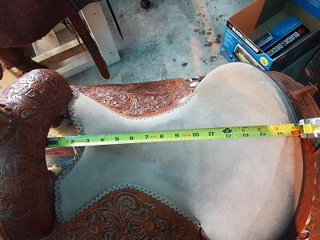
It is of great importance to find a saddle that fits your animal well, but after that you must also make sure that the saddle fits you! Chose a seat design that is comfortable for you; us women and some men need a seat that is not too wide or round and has room for our thighs. You must choose a saddle that has the proper seat length for your body, too long and you sit too far back behind the stirrups. Saddles are often built with the lowest part of the seat near the rear and if your butt settles there, most of your weight is there also and your legs will be thrown ahead as sitting in an easy chair. A balanced rider should sit in the center of the saddle, over the stirrups, and not against the cantle. Riding with proper equitation is essential and works along with a good fitting saddle. The saddle in the photo has quite a level seat, enabling the rider to sit in the middle. Typically seat size is measured from the front of the pommel to the back of the seat. This seat size is about a 16 inch.
SADDLE TREE FIT
Specialty saddles, barrel racing, cutting, reining, roping, etc. are designed to accommodate the movement required for a particular discipline of riding. They may exert more pressure in certain areas, which is tolerable to the animal for short periods of time. For example a reining saddle is designed to really flare in the front of the tree and flatten out at the back to allow for more freedom of movement of the spinal column. However taking a reining saddle and expecting it to work well for trail riding is much like us wearing running shoes to go mountain climbing or wearing high heels to run in. You must pick the right equipment for the right job.
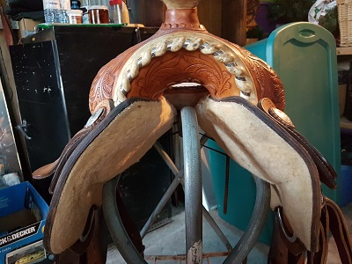
Fitting saddles to mules or donkeys who have different muscling and back structures is harder than fitting saddles to horses and takes more attention and effort in finding the best fit possible. Finding a saddle that has a tree that has bars that mirror the mule or donkeys back as close as possible takes some work. Some will ignore the fit and add cruppers, breast collars and britchens to try and keep the saddle in place. Now don’t get me wrong, all these pieces of equipment have their place but not to make an ill-fitting saddle stick to that which it wasn’t designed to fit. A tree that is not fitting will dig in some areas and not even touch in others.
The ‘’twist’’ is the shape of the tree that accommodates the change in angle from the wither to the loin. The ‘’belly’’ of the tree describes how much rock is in the middle. The width of the tree is how far apart the bars are set. The length of the bars must also be considered for each animal, as having the bars too long will interfere with hip movement. Watch so that the front and back edges of the bars have enough flare so as not to create any digging in. The saddle in the photo ‘’appears’’ to have fairly flat bars with little or no belly in the tree and did fit some mules very well. There is very little flare in the front of the saddle so it was important that the saddle be set behind the scapula for the best result.
Unfortunately, all trees are not created symmetrical [even from side to side] and there are saddles around whose trees may be twisted, warped or broken. When working with a bare tree, make sure you thoroughly check it out for uniformity from side to side, balance, and check to make sure the horn is centered. If your tree is defective, it needs to be fixed if possible or replaced.
A saddle tree that is designed for a horse often does not fit many mules and will be even less likely to fit a donkey. The bars need to be designed to evenly distribute the weight of the rider. Mules and donkeys generally have much flatter backs than a horse so most horse trees will have too much ‘’belly’’ in the center of the tree. When you have too much belly only the center of the tree sits on the mule’s back. This creates a rocking effect in the saddle and localized pressure at this point, even when cinched up tight.
Ideally the tree must mirror the animal’s back. Bridging occurs when the front of the saddle and the back of the saddle are connecting with the animal’s back but the middle of the tree is not. This can sometimes be hard to see on a finished saddle but is very obvious with a bare tree. This happens a lot when people ride with their saddles up on the withers, creating a large pocket between the front and back of the tree, resulting in a very small weight distribution area and great pain and discomfort to your critter. Fitting a saddle tree to your mule’s back without a pad is the best way to check for fit. It is extremely hard to do if you try to access the fit with a pad already in place. You must also be sure that you fit the tree so that it is not sitting on the shoulder blade and leaves adequate room for full shoulder movement.
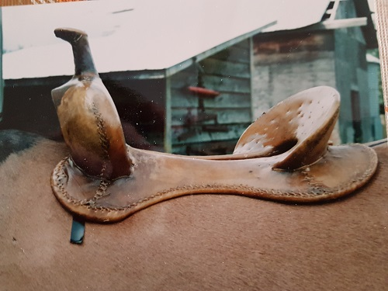
In the photo, the black tape under the front of the tree marks the end of the mule’s shoulder blade while standing still. This is typically where many want to set their saddles. You can see that the front of the tree is right on top of the shoulder blade and will not go over great with most mules.
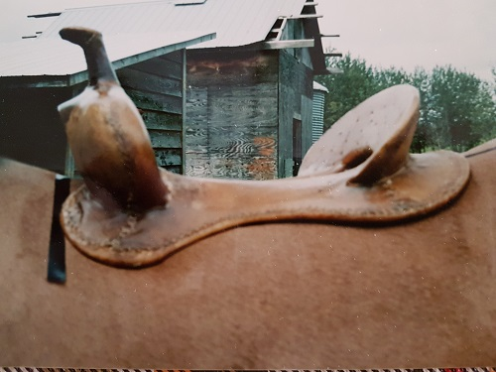
In this photo the front of the bare tree has been moved to just behind the shoulder blade. A bit further back would be ideal so as to allow the mule to stride out when moving.
Often, the saddle sizes available in retail tack shops are very limited and the actual sizes of the trees are rarely marked or can vary. Tree manufacturers often size their trees differently so a ‘’semi-quarter horse tree’’ or ‘’a mule tree’’ can sometimes vary in dimensions from one company to another. This needs to be taken into consideration when trying to fit a bare tree or a saddle to your equine of choice.
When fitting a saddle, check that the gullet, the open area under the front of the saddletree, sits well above your animal’s backbone when your weight is in the saddle. You should be able to easily insert several fingers in the space. At no time should any part of your saddle ever exert any pressure on your animal’s spine. Some saddle trees have the bars attached too close to each other and do not leave enough width to avoid pressure on the spine. In trail riding or performance riding the back of the saddle will move some, even with a tight back cinch, so it’s important that there be adequate width to limit any pressure on the spine during movement.
Something to remember when saddling is to always ‘’ pocket the gullet.’’ That means that when you place your saddle on your animal, before cinching up, insert your left hand under the saddle pad over the withers and lift it up so that it does not touch the withers at all. Besides preventing irritation and rubbing at the withers this pocket allows air to get into your animals back.
If you find a saddle that seems to sit securely on your animal’s back and looks to be a good fit you can check it out further by saddling up without the saddle pad and put a rider’s weight in the saddle. By running the flat of your hand under the saddle and feeling for the fit, you will get a fair idea of how it is fitting your animal.
If the saddle appears to fit, use a thin pad and try it out on a ride that is long enough that your animal should have worked up a light sweat. Riding on a hot day for a shorter time can achieve the same results.
When you remove your saddle, look at your animal’s back and the underside of the pad. If there is an even sweat pattern that mimics the size and shape of the tree on both sides of his back with no dry spots you likely have a good fit. If you find small dry spots the size of a quarter, unlike what you might think, you might have a problem. The smaller the dry spots the worse the pressure points. Larger ones are better. A small dry spot means the pressure is concentrated in a small area. In other words the bars of the saddletree are not distributing your weight evenly throughout your animals back, but causing pressure points instead. This is not a good scenario and needs to be corrected to avoid unnecessary pain and damage. If you are a heavyweight rider you are further exaggerating the problem.
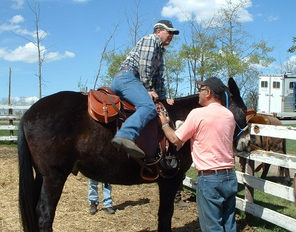
A few other ‘’tricks’’ worth trying for saddle fit are putting the saddle on the back with no pad and do not cinch up. Keeping safety in mind, have an experienced rider try getting on from the ground that way. This may seem rather extreme, but if that saddle stays there with little difficulty it’s one more way to help in determining fit. Another tip is to try the ‘’pillow case’’ test. Take a pillow case or other thin material and place on the mules back. Saddle up without a pad and again do not cinch up. Gently pull on the fabric and if it doesn’t want to move you might have a snug fit. Repeat this along the length of the bars of the saddle. Try it on both sides. It will give you a good idea of where the bars are fitting OR not.
NEXT UP - Part 4: Modifying and Levelling Saddle Fit

