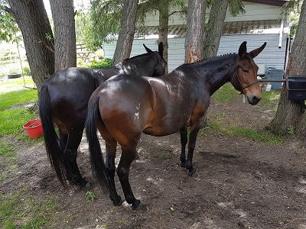
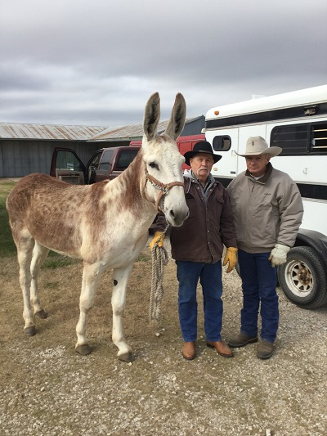
BASIC CARE OF A LONGEARS
by Marlene Quiring
Are you thinking you might like to buy or raise a mule? If you have decided that a mule or a donkey might be the animal for you, the following will give you some helpful information.
Mules are not very demanding, however those of us who were raised with equines or have had them for years forget what new ownership of an equine, especially a mule, might mean to a person who has had no past experience or knowledge to fall back on. In reality, sometimes that can be an advantage, as new owners are often more open to suggestions and better training methods. So, whether you are new to the ownership of a mule, donkey or a horse, or have been around them all your life, you may pick up something useful in this article.
Although I specifically want to address the care required for a mule, I couldn’t do that without often referring to and including the mule’s father, the donkey, who is the originator of the mule’s uniqueness. The mule’s dam, the horse passes on her size and beauty but also a flight instinct that can sometimes get the mule into trouble. Horses in general resort to flight to flee from danger as compared to the donkey’s instinct, which is to stand and fight. The mule often inherits a combination of these instincts, which can make life interesting! Mules who flee from danger, generally do not go far before they stop and look back to study the situation. However, mule, donkey or horse, their basic needs vary little from one to the other.
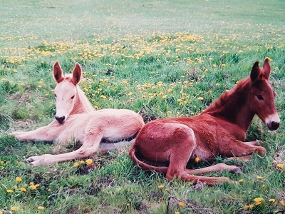
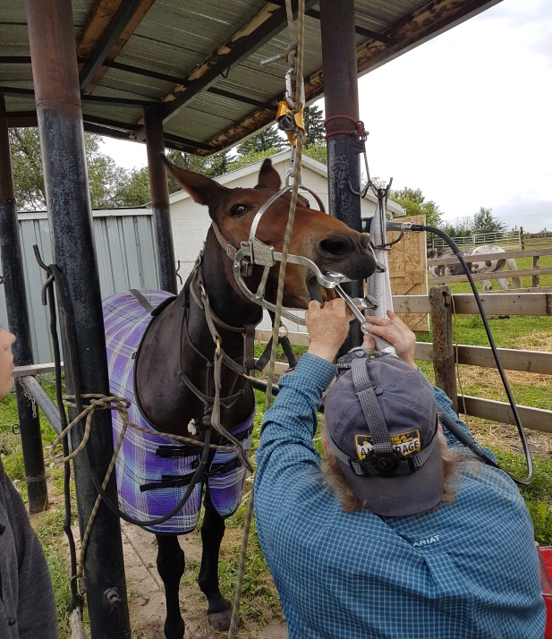
MULE PSYCHOLOGY AND HANDLING
Mules benefit from human contact from the moment of birth. In my experience this is even more important than with a horse foal because a mule left unhandled until weaning can be a big handful and few people have the ability to deal with such a mule successfully. They must be taught to respect their human handlers so that as they grow and mature they always recognize humans as their ‘’herd bosses’’.
However, a warning to those who think that in order to teach respect to a mule you have to rule over them with an iron rod. That won’t work with a horse and even less with a mule or donkey. No animal can learn when he is hurting whether physically or mentally. Make sure when you handle or train your mule that you do not take out your frustration or anger on them. If you do cause them any unnecessary pain they will remember it and will not forgive you as easily as a horse will and you will have taken 3 steps back in your training program.
Handling a foal does not mean that they should be spoilt, as raising your voice is often sufficient discipline in correcting any offending behavior. Young mules need a lot of consistent, gentle training and should never receive harsh treatment.
Mules are generally quite jealous creatures and really hate to be ignored when others are getting attention. Withholding your affections is often very sufficient punishment for a mule, especially one that adores being the center of attention. Some mules will sulk and pout when they think they have been treated wrongly, often it’s best to let them ‘’stew’’ on their own and give them time to ‘’get over it.’’ And as long as you have not physically hurt them, they will ‘’think’’ about it and usually learn quickly not to repeat any offending behavior. This method combined with a sharp word such as NO, works very well with young mules that get over rambunctious and think they can play with you by nipping or kicking at you.
I find that young mules that are born less trusting or for whatever reason have received a scare, respond very well to a ‘’soft’’ voice and touch and soon are back on track. We use to try and push ourselves on these foals and demand that they fall in line, but the results were less than satisfactory. My theory is that you cannot fight with a mule and win. I find that if I have a problem with one, such as teaching them to lead, or picking up their feet, instead of trying to ‘’bully’’ them into accepting my demands, I have had very good success with a non-aggressive approach. It may sound simplistic, but in essence I just make sure that I never give them anything to push or pull against. It’s very important to work on your timing, so that you immediately release any physical or mental pressure [that’s how they learn] when asking them to work with you. For example, when teaching them to lead, a pull on the lead rope and they take or even rock forward, needs an immediate release of the lead line pressure. You can ask again, release again and keep it up until they understand that giving to pressure is the right and easiest answer. It won’t be long and they will willingly follow the lead rope. This pressure and release method will work with many things their whole life.
You must always check your frame of mind before working with a mule that has shown difficulty in any handling problems. I know that I can never physically out muscle a mule so I never have any intention of trying. With the attitude that we will get done what we get done, it really doesn’t matter if it takes one hour, one day or all week. When my mental vibrations and body language can be read by the mule as being non-threatening, soft, slow and quiet, I have the best results. I talk a lot to my mules and in a gentle soothing voice. In tough situations, a soothing voice can help a lot. A loud voice is used only for reprimanding or later for commands.
Trust is a very important key in getting your mule to work for you and it just doesn’t happen overnight. If you take the time and the patience to get to know your mule and stay away from abusing or harming him both mentally and physically, he will develop a trust and a bond with you that is akin to a loyal dog and his master. You will have a lifelong partner. Don’t miss out on this very important link in your relationship with your mule.
When you acquire an older mule with serious problems, you will have to find ways to out think them so that when they get themselves into a pickle, you can rescue them and they in no way relate that you caused their distress. It will take a very long time to build up trust with a mule that has been hurt or mistreated in some way by man. For some of us, we do not have the patience or knowledge to bring such a mule back to usefulness. They do have good memories and this can work against them when trying to retrain such a mule. A spoilt or abused horse will be easier to retrain than a mule in the same situation.
Another notable trait of mules, is their ability to pick whom they like and whom they do not like. I think most mules know when someone likes them or not and often behave accordingly. Mules are very sensitive and will learn to trust and be comfortable with one handler but can get scared and anxious when their handler changes. Mules do bond with certain people and do tend to make strange with people they don’t know. With time and patience they will accept you if your behavior with them is kind and consistent. Be aware of this trait when you go looking for a mule and don’t necessarily judge a prospective mule by his first reaction to you.
John [male] mules must be castrated or they can be much more dangerous than a rank horse stallion. Castration is advised between 6 to 9 months of age. Castration at a younger age increases the risk of excessive bleeding with possible tragic results. Mule colts left past yearlings, because of their strength and size can be more difficult to handle. Thus, waiting until 6 months of age but before they are yearlings, is the best time to call your veterinarian for the job. By this time the youngster’s stomach wall has strengthened and the danger of a tragic outcome is greatly decreased. I also prefer that the veterinarian suture the stomach wall as this would have prevented the death of several mule and donkey colts that I know of that eviscerated after surgery.
Dr. Suzy Burnham of Texas advocates ‘’ Anesthesia with amnesia’’ I strongly agree with her advice. Mules remember pain for a very long time and will relate it to a person or persons who inflicted it whether intentionally or not. Some mules will blame their present pain on the person who they remembered handled them last. Some ‘’forgive’’ quickly but others carry a grudge for a long time and may become very defensive of their back end.
Have a veterinarian who has taken the time to learn about the differences in sedatives for mules or donkeys and is willing to learn about them, work on your animal. If they say they are no different than horses to castrate, look for another vet. Mules will generally require more sedative than a horse but not always. This fact can make them challenging patients to sedate safely and effectively.
WATER, FEED AND TEETH
While mules generally show more personality characteristics than a horse and do require you to be on your toes to out think them when you are handling them, they in no way require any less basic health care than a horse. Mules are tough, but that doesn’t give anyone the license to purposefully neglect their basic needs.
Donkeys, and to a lesser degree mules, require less feed than a horse and actually cannot tolerate feed that is too rich. It can be fatal to them if they are forced to exist on a high protein, high sugar diet. However that knowledge has been taken to extreme in some cases and people have been known to severely malnourish donkeys because they thought they didn’t need to eat anything but a few wisps of straw. You can feed donkeys and mules less than horses and they do well on a lesser quality feed, but they do need to eat and they do need some protein,
Most mules will not gorge themselves if too much food is presented to them. They tend to only eat for their needs and leave the rest. However there are some who will overeat and these are the ones who can founder, just like a horse. We had an older mule that would founder if she got too much fresh grass in the spring, so we had to keep her corralled during this time. Unfortunately, over the years, we did not always catch her in time and this happened more than I’d like to admit. Last time I thought her coffin bone must be rotated, but x-rays showed very little rotation. Each time we were able to bring her back to usefulness, but I often thought if she had been a horse and foundered this many times, she would have been a lost cause long ago. She’s tough, and I have reason to believe its cause she’s a mule!
An added warning to all equine owners; do not ever be tempted to feed fresh grass clippings from your lawn to your animals. The clippings can produce toxins that are deadly.
Fresh, clean water must be made available at all times to horses, mule or donkeys. Ice cold water deters them from drinking as much as they should so make sure their water supply is kept at a reasonable temperature. Equines can survive on snow if necessary but that is only when there is lots of clean fresh snow available and they have grass under the snow to paw for. If left to eat snow for lack of water they will require more feed as it takes them much more energy to convert that snow into water for their daily need which is 10 to 15 gallons per animal. Also, forcing them to eat snow when only hay or other dry feed is available is a recipe for colic.
Free choice salt and minerals should be available but not mixed together as if left the salt will harm the minerals. Loose salt enables them to get their required needs more easily but is not always practical, in which case a salt block will do. According to Dr. Lori K. Warren, Provincial Horse Specialist, Alberta Agriculture, blue salt or red salt is suitable for equines. In general white salt is plain sodium chloride, red salt is sodium chloride with added iodine and blue salt contains sodium chloride, iodine and cobalt. The only nutritional difference between red salt and blue salt is the added cobalt in the blue salt, which is not harmful to equines. White salt lacks iodine, which is usually lacking in feeds so is not recommended. Brown salt usually contains trace minerals and may or may not contain sodium chloride.
Because donkeys originate from the desert, both donkeys and mules are more susceptible to problems caused by heavy rain or cold and need proper shelter from rain and cold northern winters. Donkeys are especially deceiving with their fluffy coats, but they do not carry the same insulation value as a horse’s coat. They especially cannot tolerate being wet and cold at the same time, so in cold climates, they must be able to keep dry when the thermometer drops. However, mules and donkeys do tolerate heat very well and will be fresh long after your average horse has succumbed to heat exhaustion. It is very hard to get up a sweat on my saddle mule as compared to when I rode horses. You can ride a horse ‘’into the ground’’ but a mule may quit you when he’s had enough and a donkey definitely will.
Mules do need to have their teeth checked and dental care provided if necessary. Tim Barton, College instructor in equine anatomy and outfitter for over 50 years says ‘’ Horses [or mules] don’t die of old age, they die of bad teeth.’’ Mules and donkeys can have all the same dental problems that a horse can have, such as caps that won’t fall out on their own, abscessed teeth, over bite or under bite, sharp hooks, uneven chewing surfaces; overgrown incisors or they may lose a tooth from being kicked. Since equine teeth keep growing, if not attended to, the tooth opposite the missing partner has nothing to grind against and will grow into the jaw and face of the poor animal. One of our Jacks had a missing front tooth and so we had to get the corresponding tooth cut down when it became too long. Also unless they graze 365 days of the year, most will not wear their incisors down enough and will need them cut back so that they can effectively still grind their food with their molars without packing their mouth full first. Periodic dental checks by a qualified Equine Dentist are a must for all equines.
All of our mules have had wolf teeth that needed removing. These small, usually shallow rooted teeth just in front of the upper molars [and sometimes bottoms] if not removed can cause pain when your mule carries a bit. You can check for these un-necessary teeth yourself by running your thumb in the interdental space [where the bit would be carried] and feel for a small, hard, and quite often sharp bump. This is a wolf tooth and needs to be removed before you ask your mule to comfortably carry a bit.

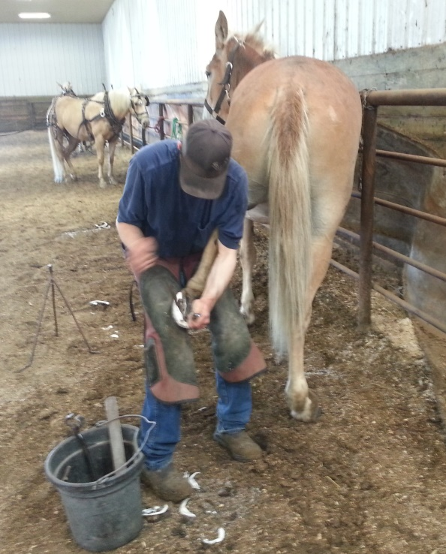
HOOF CARE
A disturbing myth that is still being circulated is that mules or donkeys do not need their feet trimmed. If donkeys were in their natural native habitat, the desert, this would be so, but it is certainly not true for today’s domesticated donkey or mule. They need their feet trimmed just as often as a horse, which is roughly every 8 weeks. It’s not terribly uncommon to see neglected donkeys or mules, with severely overgrown feet, in roadside pastures or abandoned in auction market pens waiting for their fate. It would seem that their owners thought they would require no care, including foot care.
Most people are aware that mules do have tougher feet than horses. Just pick one up and look at the thick hoof wall and the nice cupped foot as compared to a horse’s foot. Because of this, mules do not need shoeing for everyday riding. However, they do need to be shod if they are being ridden or driven on pavement or used in the mountains for any length of time. When spring comes to Alberta and I want to get my saddle mule in shape, I have to put the miles on by riding gravel roads, so unless I shoe him, I will excessively wear down his hoof wall. Our mule teams are always shod up with borium spot welded on their shoes for traction before they go out to spend the summer in the mountains where they are used for hauling freight and passengers over rocky roads. If their feet were not shod, they would wear down to nothing on the sharp shale.
Mules are extremely sure-footed in rough terrain. It will only take one trip to convince you of this if you are riding a mule on some seep trails behind a horse that is scratching and scrambling to get his footing. Your mule is climbing effortlessly and silently on the same terrain. A mule’s eyes are set further on the side of his head, thus enabling him to see where his back feet are going. This combined with his survival instinct and greater agility and strength make him a better mount for treacherous terrain. This is why it’s mules that have been used to carry folks into the Grand Canyon for well over 100 years without incident.
It is imperative that a mule preferably while young, become trusting of their legs and feet being handled. If not it will be up to you to accomplish that before expecting a farrier to trim or shoe his feet! The mule does have a more upright hoof and must not be trimmed to look like a horse’s foot that has a lower angle. The rule is the same for all equines: follow the angle of their pastern. I have seen several mules where the owner has trimmed their feet to be too low in the heel and the angle of the foot becomes broken. This is very hard on their tendons and can result in soundness problems. If you do not have the knowledge yourself to trim your mules feet, call a qualified farrier who knows the differences in a donkey’s foot versus a horse’s foot.
Mules have a reputation for sometimes being hard to trim or shoe. There is some truth to this. This goes back to their very protective nature; if they for whatever reason have never fully trusted man with all of their body parts, especially their feet and legs, they can be a real problem. Although a mule has never kicked me, I have been in situations where they have sent me a message by the use of their feet. By this I mean, I have had mules warn me about something going on that they don’t like by lifting and subtly threatening me with a foot. While I always let them know, this kind of communication will not be tolerated, I think they communicate with their body more so than most horses. After I reprimand them, [usually my stern voice is all that’s necessary], I always make sure I try and figure out their discomfort and make the necessary adjustments where I can. Sometimes it has been tack that has been ill fitting or rubbing them the wrong way. Sometimes they are just mentally distressed about their situation, but one thing I have learned is they always have a reason for their actions and it’s up to me to find out what they’re trying to tell me and fix it if I can.
Because of the mule's cupped foot, when shod they do pick up rocks easier than a horse with its flatter foot. Sometimes the rocks can become so wedged in that they are very hard to get out. Make sure you check your mule's feet often if they are worked on rocky terrain.
It is also important that they enjoy handling of their head and beautiful long ears! There's nothing a mule or donkey enjoys more than a good ear scratching, deep into the inside of their ear. Good and enjoyable ear handling also makes them a breeze to halter and bridle later on and prevents ear-shyness which unfortunately is often caused by rough handling of their ears by unknowledgeable or ignorant owners.
HEALTH AND SAFETY
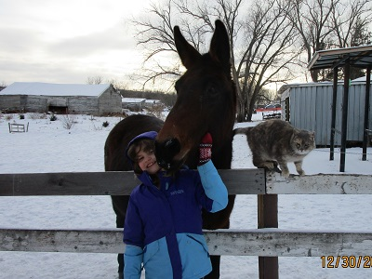
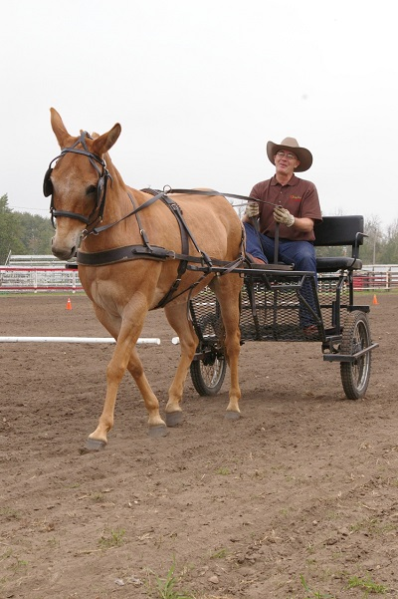
Vaccinations should be discussed between yourself and your veterinarian. Authors, Dr. Tex Taylor, Dr. Nora Matthews, and Dr. Terry Blanchard from Texas A&M, state in an article published in the New England Journal of Large Animal Health [volume 1, number 1, pages 21 – 28] ‘’ Few if any currently available vaccines are specifically approved for donkeys and mules. We vaccinate them the same as horses under similar circumstances.’’ As to anesthetics they say: ‘’Donkeys and mules don’t seem to respond as well to most of our short-term anesthetics as do horses. It is common to not get good relaxation or to have a shortened period of down time.’’ Under drug metabolism they say: ‘’Research into the metabolism of the common medications used to treat horses continues to confirm that this process is not identical in horses, donkeys and mules. It also suggests that there are differences between the different size donkeys…regrettably we cannot make specific recommendations for dosage changes nor treatment intervals at this point in time.’’
While there is still much to learn about the differences between donkeys, mules and horses, it is generally accepted that they should receive the same vaccinations as a horse. Tetanus, East and West Sleeping Sickness, Influenza, Rhinopneumonitis, and West Nile are the main vaccinations you might want to consider. Strangles, Potomac Horse Fever and Rabies are other vaccinations that may be recommended by your personal veterinarian. A holistic approach to health care is becoming popular and can give owners an option to some of the above vaccines.
Many new mule owners do not realize the importance of worming. Please do not try and save any money here. Mules are tougher than horses and less prone to diseases but I do not believe that an overload of worms can do them anything but harm. We use an ivermectin-based product to deworm our mares a month before they foal. The foals themselves are wormed between 1 and 2 months of age. A good program for us here in our cold winter climate is to worm our young stock every 2 or 3 months throughout the warm weather followed by a late fall [after several ‘’killing’’ frosts] and then an early spring worming. It is important that the fall worming is a brand that will also take care of ‘’bots.’’
Mature animals running on ample clean pasture may only require worming in the fall and then again in the spring. However this is the absolute minimum treatment that you should consider. Animals kept more confined will require treatment more often as they will contaminate themselves easier by close quarters with other animal’s feces.
Please don’t turn any equine out with barbed wire lying around, old farm machinery and parts scattered everywhere or any other junk littering their pastures. Eventually someone will get hurt. Why take these unnecessary risks? Your animals should not be credited with the ability to figure out for themselves that they are to avoid these traps. They’re smart, and they can reason to a degree, but they cannot be expected to know that if they rub against, or worse get a foot hung up in that piece of machinery with all the sharp corners and edges, that they can be cut to shreds. I have heard of several animals hurt and killed by people leaving junk lying in their pastures that I would wonder why some common sense didn’t prevail in the first place. These are injuries and fatalities that we can prevent.
While a mule is less likely to harm itself in junky pastures or inadequate and poorly constructed fencing than a horse, you still need to make sure your fencing is safe, secure, visible and free of broken planks, stray wire, protruding nails and anything else that could possibly cause injury to your mule. Barbed wire is not a great choice for any equine; however mules and donkeys do fare better in it than do horses. Smooth wire can still cut but the results are usually less disastrous. Electric fence is good, but you must make sure that you give your mule or donkey a chance to be ‘’educated’’ by it first with you nearby. We almost lost a young just weaned molly that got her head stuck between a ‘’safe’’ pipe fence that had an electric wire running next to it for good measure. With her head trapped, she was getting a continuous shock. Thank goodness, we were right there when it happened and were able to rescue her before she was seriously hurt.
Any fence can be dangerous. Pipe fences are visible, solid and will last forever, however if a mule gets run into one, there is no give. On the other hand a wooden fence has some give, but it can splinter and cause damage. Also wooden fences seem to make tasty snacks for some equines and require much upkeep. There are some new fencing products on the market that appear to be quite safe with low maintenance.
If you have animals in pastures next to each other, make sure you do not have a wire running close to the ground. Horses or mules who sometimes paw at fences or antagonize their neighbor over the fence can easily get a foot caught on this low wire. I had a mare that cut off part of her foot in this way. After much doctoring and a wait of 5 years, the mare became sound enough to ride again, but I consider myself lucky in my outcome. That last, low strung barbed or smooth wire between pastures is a disaster waiting to happen. We have removed the bottom wires from our fences and have had no more of these types of injuries.
The same folks who have junky pastures and unsafe fences also often insist on leaving their halters on their animals. Halters left on can become lethal weapons. Animals can get a hind foot hung up in their halter when they go to scratch an itch on their face. Those of us who own mules know how often they love to reach up with a hind foot and get just that right spot under their chin or above their eye for that perfect scratch. They are experts at marksmanship; however they do not know that they risk snaring their foot in their halter every time they do this. Halters, even if fitted properly, can get snagged on trees, limbs, posts or any object in their pasture. Animals can be choked to death this way. When you turn your mule out, take his halter with you. It’s best to come back to a live animal even if he’s hard to catch then a dead one. You can prevent this accident from ever happening.
A few years ago a neighbor of our, unbeknownst to us, thought he would ‘’teach’’ his mule baby to be halter broke. So he haltered the foal and left a rope trailing from the halter. Then, he left the foal in his machinery-cluttered pasture and went away on holidays. Needless to say, when he came back, he found a really ‘’dead’’ halter broker mule. What a needless tragedy! No animal should ever be left unsupervised with a halter and a lead rope.
If you can’t catch you mule, you can work on that. May I suggest you beg, borrow or buy a videotape by Brad Cameron titled ‘’ Catching the hard to Catch Mule.’’ In this very well produced tape, Brad shows you how you have to work on the mind of the mule before you can get the body to follow. Indeed, capturing the mind of a mule in any circumstance is the key to successful mule handling.
While taking care of all these requirements for your mules, don’t forget that they also need special consideration in the fit of any tack you will want to put on them. Pack or riding saddles must be modified so that the actual bars of the bare tree will mirror your individual animals back. This is essential so that weight is distributed evenly and pressure points are eliminated. No animal can work with ill-fitting gear. Many are forced to but problems can result from sore, grouchy animals to runaways and buck offs. Whether horses, donkeys or mules, many behavioral or training problems are actually due to tack that is not fitted properly for that animal and is causing them pain. The only way they can let us know is by their reaction, and we, with our superior intelligence, often miss the real reason for their bad behavior.
The position of your saddle is also an area that needs to be addressed for mule riders. I see many equestrians who ride with their saddles much too far ahead, seriously impeding their animal’s ability to perform. This, combined with an ill-fitting tree can cause a myriad of problems, not the least of which is a very unhappy and hard to handle mule.
The front of the tree in your saddle must sit at least two inches behind the end of your mule’s shoulder blade. If you are not sure of where his shoulder ends, follow with your hand from the front of his shoulder upwards and towards his back until the firmness of his shoulder blade drops off and you feel a slight dip and softer tissue. This should be the end of his shoulder and the front of your tree should not sit on or in front of this area, but behind it. Most of us have been ‘’educated’’ into thinking that we have to have that saddle pushed right up on the withers to secure it. Wrong! Get that saddle moved back and make sure your saddle rigging will keep the cinch at least 4 inches away from your mule’s elbow. You will be amazed at the improvement in your mule’s disposition and by the way he moves out with his new freed-up stride. The same positioning of your saddle applies to a donkey or a horse.
Bridles must be made to fit the generally larger brows and jowls of the mule. Bits must fit the animal’s mouth and must not be severe. Don’t start a mule in a bit with a shank on it and expect to end up with a soft-mouthed mule. Although mules do have stronger necks than horses do, they can be taught to be just as flexible and giving to the bit. This can only be taught by the use of a bit that allows for lateral or side-to-side pull. A shanked bit only teaches them to brace against the pressure if they have not been first started properly in a snaffle bit. Proper use of a snaffle bit, which is a bit with NO SHANKS WHATSOEVER, is one rein at a time is pulled, not both.
If you want to drive your mule, the same good fit of tack is necessary. The collar must fit your individual mule’s neck and shoulder. Too often we see mules driven with collars that are too large and flopping. This is not acceptable and will make your mule, horse or donkey shoulder sore and unable to painlessly pull any weight. One size does not fit all. Collars need to fit the shoulders and neck of each animal. It’s no different than individually fitting a pack or riding saddle. If you use britchen it must be adjusted so that it is neither too tight nor too loose, it must not be too high or too low. All the straps and buckles must be adjusted to the size of the individual mule. Make sure that your mule is comfortable in his ‘’ working clothes.’’ It will make a big difference to his attitude.
I hope that I have touched on some of the basic requirements that need to be addressed if you plan to, or already share your life with an enchanting creature with long beautiful ears [or the short – eared variety if that is your choice]. If you are not prepared to supply them with these basic needs, please don’t buy one. If the one you already have is not getting the care he needs, please rectify his situation or find him a different home, one that has the time and knowledge to provide him with a good and useful life. Their care rests in your hands.
Marlene is a long time ‘’mule fancier’’ and has raised mules for many years. Now retired from that hobby, she has more time to enjoy the mules she has and help others by making as much information available as possible with articles she has written on her experiences over the years. She heartily endorses the training techniques of Tindell’s Horse and Mule School for all equines!

