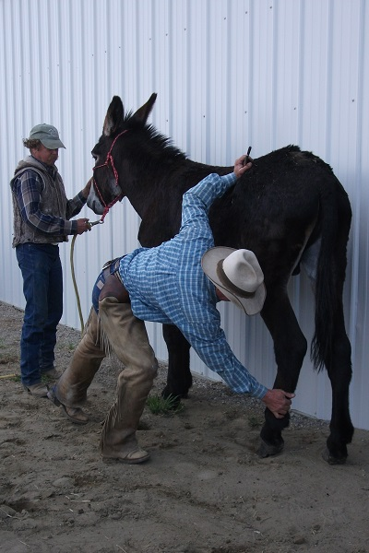
TRIMMING & SHOEING MULES & DONKEYS
Courtesy the Brayer:
www.lovelongears.com
WHAT IS THE CORRECT ANGLE TO TRIM FOR IN MULES AND DONKEYS? Let’s make this clear: There is not a set angle to trim for in donkeys, mules or even horses. The farriers all say that angles such as 53 degrees were given in the past, but modern farrier science has said that this is something that should be dropped. The only correct angle is one that best lines up the hoof and pastern of the particular animal you are working on. Amateurs and poor farriers may make mistakes – even bad ones. This takes a lot of experience and education. If you wish to do your own trimming and are not sure, get a lesson from a good, experienced farrier. The basic difference between our animals and horses is that the heels are left longer on our animals, but that is because our animals often but not always have more upright bone and fetlock structure. The following paragraphs are taken from the book ‘’THE PRINCIPLES OF HORSESHOEING II by Doug Butler.
HOOF DIFFERENCE: Conformation of the ear and head is considered more important that the feet by most mule enthusiasts. Mules usually have sound feet and legs. The mule’s foot is smaller than that of a horse of equal body weight. A heavy draft mule may have a hoof that would be a size 1 or 2 compared to a size 6 or 8 on a similar sized draft horse. The foot has a peculiar long narrow shape. The frog fills the entire heel area and is proportionately large in relation to the rest of the hoof than that of a horse. Weight is borne directly by the frog. The sole of the hoof is very concave. The hoof wall is rounded and thick in the toe, pinched in and thinner at the quarter and flared out and thick at the heel. The bars are usually thick and prominent. The length of the hoof wall is relatively long and upright when compared to a horse’s hoof. Mule hooves are usually denser than horse’s hoofs and less subject to quarter cracks. The wall may have an almost vertical slope in the area where the toe nails are placed in a shoe. The angle of the wall may be more than 90 degrees in the area where the heel nails are placed.
SHOEING DIFFERENCES: Mules usually have a higher pastern angle than horses. Excessive trimming of the frog and bars should be avoided. The heels often grow faster than the toe and must be trimmed accordingly. The frog protrudes below the heels since the buttresses do not project as far back as they do on a horse. Shoes are fit to the outline of the hoof wall around to the quarter. The heels of the shoe are turned out, tailored or ‘’muled’’ at the heels to follow the outward curvature of the hoof at the buttress and clear the frog. The shoe heels should extend beyond the buttresses ¼ inch or more depending on the foot’s conformation and shape at the heel. Mule shoes should be lighter weight and not as thick as a horseshoe. Calks are popular. Low toe and heel calks are preferred. Borium is usually not needed, since mules are naturally very surefooted. Six nails per shoe are usually enough even for a large mule. Small mules or jacks need only four nails per shoe. Nail holes should be punched perpendicular to the shoe or as the wall slope indicates. Solid pieces of tire tread cut to expose the frog may be nailed to the foot in place of shoes for traction in rough country or on roads. Small washers may be slipped over the nails to prevent them being pulled through the rubber.

