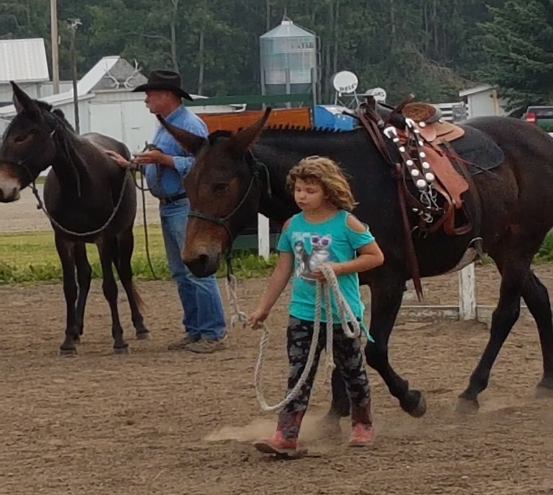
Never Forget the Importance of Good Ground Manners
By Jerry Tindell
It is important for the human to take responsibility for their horse, donkey or mule’s manners and we owe it to them so they can get along in our world. Every horse, donkey or mule in our care should receive a basic education, built upon what they learned from their mothers and the herd. We need to take care of, protect and continue their ground manners.
Through observation and awareness we know that herd animals have a pecking order which they follow pretty closely. They will test that chain of command from time to time but after any change that may occur, the new lead animal will be giving direction that at one time he wanted to avoid. That’s when I refer to the animals as having purpose – leadership has meaning.
The human must continue that lifestyle by encouraging, motivating and disciplining for correct, soft behaviors. That brings us to our groundwork and its importance. Groundwork, to me, duplicates what equines learn in the herd. I honestly believe that we, the human, can gain the same status as that lead animal and accomplish these things with a much softer approach.
As we teach the back-up, shoulder control, forward flexed circle, hindquarter control, stop and stand (my 6 steps to safety), we can now offer our stock the control and confidence they require from both the herd and the human. Whether a pet or a performance animal, I prefer my stock to be soft, supple and safe.
Whether it be to catch and groom them, pet them, trailer load them, evacuate in emergencies, take them to the vet, saddle them, ride on a trail, chase a cow or ride over the mountain, they need to be well mannered. It looks bad for our stock and us as handlers when they are out of control when you call someone out to trim their feet, do vet work, do a saddle fit, or whatever it might be. They need to be well mannered and represent everything softly.
Horses live in an orderly world….the herd leaders won’t let them be wrong – they get disciplined. The human, through our lack of awareness, allows them to be wrong which doesn’t work in their natural world and only confuses them. We have to get to a point in our understanding of the stock that we can no longer let them fail. Be true to them, like the herd, never hurt them, don’t allow them to be afraid, always release the behavior you want, and they will do what we ask.
I really appreciate everyone developing an interest in getting right with our stock as I continue to do daily. Whether it’s horsemanship, mulemanship or donkeymanship, it all boils down to the human getting right and being fair.
www.jerrytindell.com

