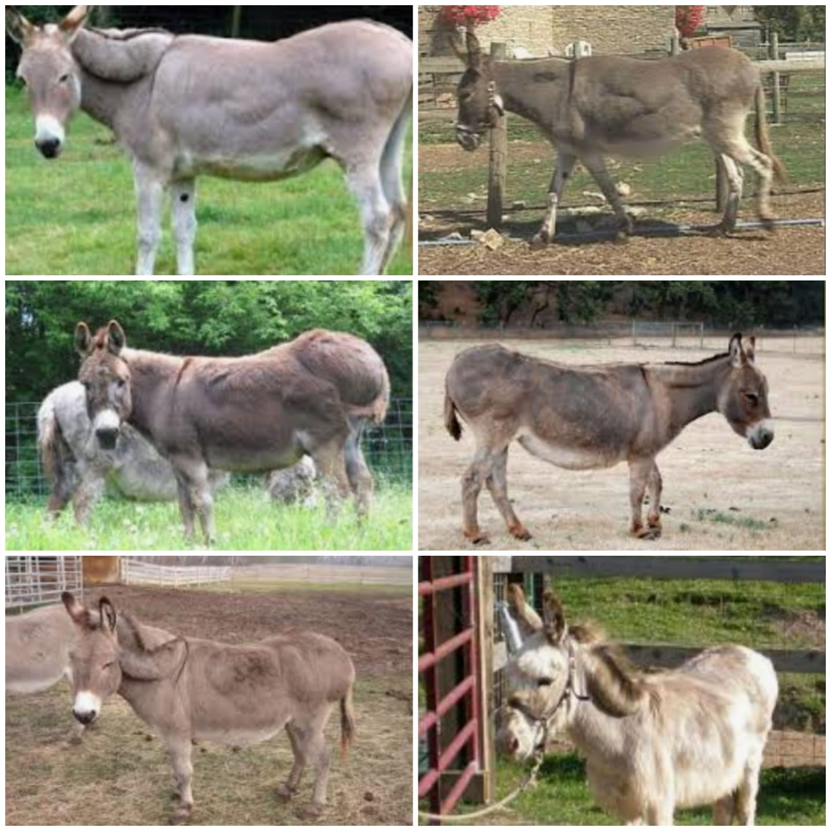
DEALING WITH THE OVERWEIGHT DONKEY
By Paulette Jacklin
Dieting overweight donkeys can be frustrating and take a lot longer than you might expect.
First and foremost, before starting any donkey on a weight management program, you must rule out any underlying medical condition first. Have your vet come out and do some blood work, and give the donkey a complete health check. If no underlying conditions were found, you should tackle the problem "head-on" ASAP to correct it.
If you have recently acquired a donkey, you won't want to start them off on a diet right away. Start off by feeding them as they have been accustomed to at their previous home. Give them time to get settled in first; then, when they're adapted to their new environment, start them on their diet.
If this is a donkey you've had for a while now, then portion control is an important place to start. Do not attempt to reduce their portions too drastically as this could sabotage their health by causing unnecessary stress, lead to the development of hyperlipidemia and could even be fatal.
Start with whatever amount the donkey has been accustomed to eating and reduce that amount by 20%. If at all possible. Rather than one or two large meals a day, you should try to imitate the way donkeys feed in the wild breaking their mealtimes down into smaller portions fed frequently throughout the day.
After about a month, re-valuate your donkey’s weight and body condition. If you've not seen any changes, reduce those portions by 10% and re-evaluate again the following month. Continue doing this until you see a reduction in size or weight.
Exercise is also very important. so space the waterers, feeders and shelters far apart from each other to encourage them to move more. Another good idea would be to take their meal ration and scatter clumps in small portions all over their paddock to encourage them to move around more. Provide toys (such as old tires, rubber boots, traffic cones, small rubber feed tubs, etc.).Teach them to drive, ride or pull heavy objects (like tree trunks, carts or old plows). Or take them for walks on a frequent and regular basis.
Keep in mind, donkeys that have been obese for a very long time may never lose the fallen fat pad on the crest of the neck or the fat pads on their trunk.
HERE ARE SOME ADDITIONAL TIPS AND TRICKS TO HELP YOUR DONKEY CONTINUE LOSING WEIGHT AND INCHES OR MAINTAIN A HEALTHY WEIGHT:
* when feeding hay, try serving it in a slow feed hay net or in slow feed hay pillows.
Donkeys will gain weight easily if allowed unrestricted access to pasture grass. You can try using a grazing muzzle or you can try restricting the amount of grass that is available to them by pulling them from the pasture after a specific length of time and placing them in a Dry Lot (with bare ground, sandy ground, bark chips, cement or gravel) for the remainder of the time supplementing any remaining feed needs with hay.
However, some donkeys are very intelligent and, when they figure out you're going to pull them from the pasture after a number of hours of grazing, they will become very adept at gulping down a days’ worth of pasture grass into their limited turn out time. If that happens, you might consider Strip Grazing or creating a Track System as a useful alternative. Even though you're still restricting their grazing time, the fact that they can see the pasture and that they are still in it or around it, gives them the illusion that they have plenty to eat and they won't try to gorge themselves all at once.
* Avoid feeding cereal/grain-based feeds and sugary treats. These are too high in starch and sugar and will encourage weight gain and contribute to the onset of gastric ulcers and laminitis.
* Substitute COCONUT MEAT (and the brown fibers from inside the husk), PUMPKIN SEEDS, UNSALTED PEANUTS (in the shell or just the shell itself), MESQUITE BEANS or SUNFLOWER SEEDS (important to note that the striped sunflower seeds that humans consume should not be fed to donkeys) for training incentives.
*Check your hay for any retained grain.
*Although the Donkey Sanctuary of the UK highly recommends free feed Barley Straw as a good quality, clean feeding straw to make up the majority of the donkeys diet, it is very difficult (if not impossible) to find here in the U.S. Timothy (in limited/smaller quantities), Wheat Straw (if the donkey has good teeth) or Oat Straw (in limited/smaller quantities) are acceptable alternatives.
* Monitor their body condition and take heart/girth measurements (i.e. over the lowest part of the withers and around the girth by the elbow-see artist sketch in photo) monthly (to monitor their weight gain or reduction) then adjust their feeding regimen accordingly.
NOTE: It is always a good idea to discuss your dieting plans with your veterinarian. especially if you're dealing with senior donkeys.

