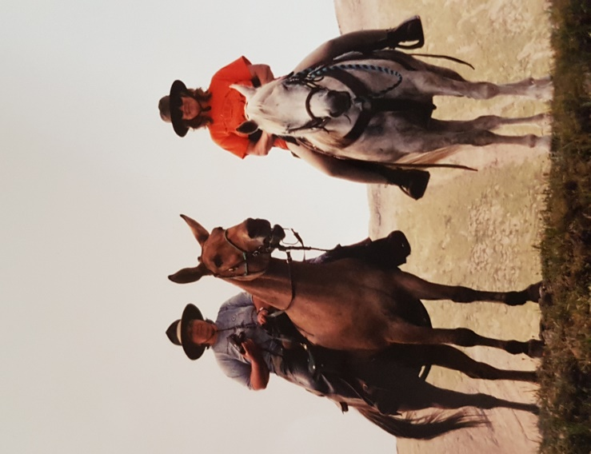
Differences between Horses and Mules
The mule compared to the horse:
• Higher mean value for corpuscular volume
• Lower white blood cell count
• Lower monocyte
• Red blood cell tend to be lower
• Mean platelet volume tends to be lower
• Normal temperature is similar (normal temperature for a resting horse is 37.5 to 38 degrees C)
• Mules metabolize most drugs similar to horses but still the sedation may wear off sooner
• Mules tend to show signs of acute pain and generally it’s easier for an owner to detect an issue
• When restraining avoid ear twitching and consider a humane twitch or pharmaceutical restraint
• Mules are very social animals
• Mules can survive on coarser pastures
• Hooves are tougher and more elastic, they are narrow in shape. Weight is placed directly on the frog portion of the foot. The hoof wall is rounded and thick in the toe area, more pinched in and thinner at the quarter and flared out and thick at the heel. The bars are thick and prominent, length of the hoof wall itself is relatively long and upright
• Mule offspring have 63 chromosomes (donkey 62 – horse 64)
• Internal parasites are typical for other equine species therefore the recommendations for control and treatment are those that are used for horses
• Protocols for a vaccination program are usually adapted from those recommended for horses
• Mules are able to cow kick
When talking about the differences you have to include the donkey – because the mule is a hybrid differences also vary from animal to animal.
• The angle of the larynx at the back of the throat (top of the trachea) of the donkey is different than in horses, and donkeys have a pharyngeal diverticulum (pocket) in their throat, excess tissue in their pharynx, and elongated laryngeal saccules (part of the airway that aids in vocalization).
• Nasal intubation also is more challenging because donkeys have narrower nasal passages than horses
• Donkeys tend to grow longer, coarser coats that lack the protective undercoat that horses have in the winter. The coat does not provide the protection needed during periods of weather extremes (colder and wet weather).
• An obscured jugular furrow (the place where blood samples are taken or tranquilizers are given). The cutaneous coli muscle is much thicker than in the horse and hides the middle third of the jugular vein. It is easier to find the upper third of the jugular.
• The nasolacrimal duct of the donkey is located on the flare of the nostril rather than the floor of the nostril as it is in the horse.
• Some medication can produce complications such as breathing in donkeys
• Higher doses (typically 1.5 times the horse dose) of a number of drugs are needed in donkeys. An exception is guaifenesin (a centrally acting muscle relaxant). Horse doses of this drug in donkeys can cause respiratory arrest.
• Lungworms are reported to be more common in donkeys than horses

