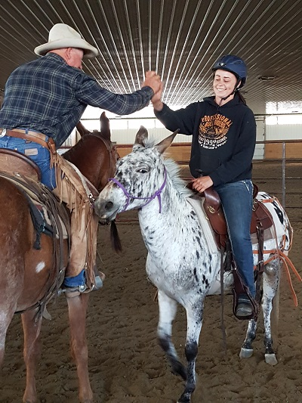
Choosing the Best Clinic for You
By Marlene Quiring
The biggest mistake you can make when registering for a clinic is to overestimate the level or ability of your equine, or your own present ability to handle them. You may have a very well trained animal, but if you are relatively new at working with the equine species, OR if you are fairly experienced, but have an animal that does not have a lot of training or experience, you will not get the best ‘’bang for your buck’’ by registering for a clinic that is beyond you or your stock’s present level. Doing so also forces the clinician to go back to the basics with you, possibly holding up the rest of the group from progressing forward. For simplicity I am going to refer to the ‘’mule’’ when referring to your equine of choice.
When considering taking a clinic from someone you have not worked with before, it is prudent to start at the beginning level of their program so you do not miss any of the basic and important steps. Following the training in a progressive sequence will help prevent holes that may show up later with unpleasant consequences. If you are unsure of what clinic you should be in, consult with the clinic host or contact the clinician for their assessment. They should be happy to help you! Find out as much as you can about the clinician; audit a clinic of theirs first to get a good idea of their program.
The other extreme can be registering for the same clinic year after year, never allowing you or your mule to progress to the next level of training. Look for a good balance in your training program which includes stepping up to the next level once you feel comfortable and confident with where you are at.
And here’s just some personal advice from a mule lover. If you have a sensitive ego, you might not want to choose a mule to work with. They can soon make you aware that there is more to learn than what you assume you already know! Their world has to make sense and that means you might need a reality check of your own abilities and where you stand in your progression with them. Taking a clinic that is above you or your mule’s present level can lead to frustration for you and also for your mule! Conquer the basics first for both of you and then sign up for an advanced clinic.

To Sum it all up? Please register for a beginner or Intermediate type of Clinic unless you and your mule really are good at walking, trotting and loping safely and with good control in a group and arena setting. This means your mule should be fairly good at guiding well, be attentive to your aids [seat ,legs, and hands] and be comfortable riding in a group. Don’t underestimate the importance of all the essential ground work that every mule needs to accomplish in order to transfer into a safe pack animal, saddle mule or harness mule or all of the above. Please start at the ‘’beginning’’ in order to have a happy ‘’ending!’’
