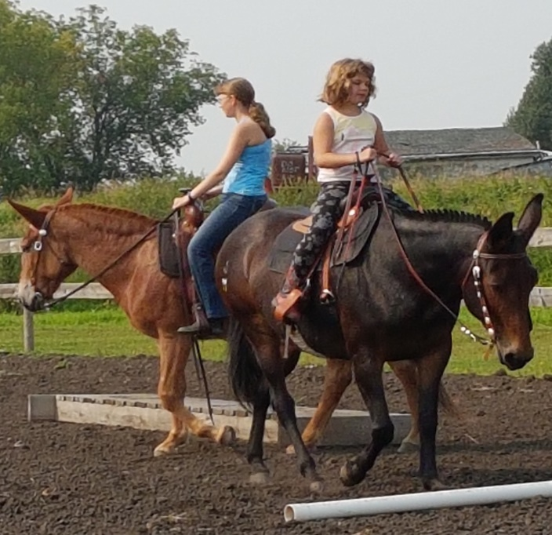
When Things Aren’t Right
By Terry Wagner
Reprinted from Western Mule Magazine August 2020
This article is going to be right to the point. Not a week goes by that we don’t get a call or calls from someone having issues with their mule or mules. It happened again this morning just as I was starting on my first cup of coffee. Some of these folks are completely exasperated, frustrated, or ready to sell their mule and buy a goat broke to pull a cart. My effort at helping these folks is to direct them to experts who can provide guidance in solving their problem. Keep in mind, when a problem arrives, the pages of Western Mule Magazine contain information from some of the best mule trainers in America. All of these folks are there to help you and answer your questions.

Many of the calls I get have to do with saddle fit. Many times people complain that their mules charge downhill or won’t climb a steep hill. Or, the mule fights the bit, won’t stand to be tacked up, rides with its head up in the air, or won’t give to the bit.

Many people act surprised when I ask them the last time they had their mule’s teeth checked by a vet or an equine dentist. Hand in hand with this is when was the last time they had their mule checked by an equine chiropractor. A mule whose teeth hurt will give the owner all kinds of
problems with the bit. Some of these issues can by pretty original when a mule sets his or her mind to it. This can lead to problems as simple as not wanting to walk a straight line on the trail to dangerous rearing problems. The mule’s entire way of traveling can also be affected including
not wanting to take the proper lead, shortening the stride, and, in the worst case, dumping the rider.

A mule, whose spine, neck, or hips are out, can have the same issues, only they are usually multiplied when the teeth are an issue. A mule with spine issues can have even worse traveling issues and always reserves the right, in their mind, to buck off what hurts. Complicating this is
the fact that lots of mules are big sissies. They have a tendency to react to every little ouch that comes along, real or imagined.

Sometimes we can’t easily tell what the problem is. In that case, have someone ride with you and observe the mule. If the mule is riding with its head up and its back is dropped, suspect a chiropractic problem, which may be complicated by a saddle that doesn’t fit. If a saddle has too
much rock in the center of the bars, the mule will drop the center of their spine to avoid the pressure. However, they can’t drop their spine without raising their head. This may be accompanied by a lot
of swishing of the tail as the mule moves. The saddle causing the head to raise and back to drop can result in a chiropractic problem as a result of the way the mule is forced to travel. If the chiropractor finds a problem and makes an adjustment, and the mule still rides with the same issues, then suspect a saddle fit problem.

Refusing to stand for saddling can be, again, a combination of a saddle fit and chiropractic problem. Closely related to this is a bit that doesn’t fit right or even a brow band on the headstall that is too
tight around the base of the mule’s ears. If the mule has a tooth problem bothering him, he may not want to be tacked up just as a poor fitting saddle can cause the same issue. Just imagine your trying to drive through the heavy freeway traffic with a toothache. Not a good deal.

There are a lot of people who spend a fortune on different bits and training trying to get a mule to keep its head down when the problem is a tooth issue. I have talked to people who have ridden the
same mule for years going down the road with no real control simply because the mule was trying to tell them their teeth or back hurt.

Couple a back issue with a dental problem in your mule and you have the makings of some really unpleasant riding. A mule with the wrong mindset can combine these as a real excuse to give you
some really memorable trail time. We have preached for years now the four parts of saddle fit as originally enumerated by a Colorado saddle maker. One is the mule, next the pad, the saddle, and finally the rider. Couple this with a vet check of the teeth and you are on your way to solving the problems you may be having.

You can do all the training you want to get the mules head down, but if you are fighting a dental problem, all the training hours are a wasted effort. If the saddle is hurting the mule, all the training to get their head down is likewise throwing effort after foolishness.

In your effort to evaluate the problem you may be having, fit and adjustment of all your tack is of utmost importance. I have seen people going down the trail with their bridle not properly adjusted and complaining all the time that they can’t keep their mule from throwing its head. I have seen people with a death hold on the reins making the same complaint. I have also observed riders with a bit that looked more like a bear trap complaining about a lack of control of their mule. At the same time, I have seen mules that were simply not broke and no amount of tack can overcome that problem. In this light, several years ago, a lady in Oregon asked me to evaluate her horse for a new saddle. She said she was having all kinds of problems with the big gelding. After working with the horse, it was obvious he was simply not broke. They devoted a year to his schooling, and he now carries one of our saddles.

Years ago, I bought a rescue mule. When I first went to see him, the seller was riding him with a big heavy bit with almost no tongue relief. The mule was throwing his head, refusing to stop, and
generally not being very manageable. I told the man I had seen enough and asked him to unsaddle him. While he was putting his tack away, I opened the mule’s mouth, and at some time in his life, his
tongue had almost been cut off by some rough handling. The tongue had healed with only one half of the tongue attached at the location of the cut. I told the seller I would be back the next day to ride the mule with my tack. The next day, I tacked the mule with a mechanical hackamore. He dropped his head and walked off like a real gentleman. Later, I found he would work just fine in a bit with a massive amount of tongue relief and properly adjusted in his mouth. When things aren’t going well with a mule, and things just aren’t right, the mule’s reaction is trying to tell you he hurts. Don’t continue on in the face of this. Our challenge is to slow down, evaluate the reactive behavior and how it can relate to tack, teeth, skeletal issues, or a combination of all of these.

Tu Amigo, Terry
To contact Terry Wagner for
information on this article
or prior articles, email:tbmsaddles@gmail.com

