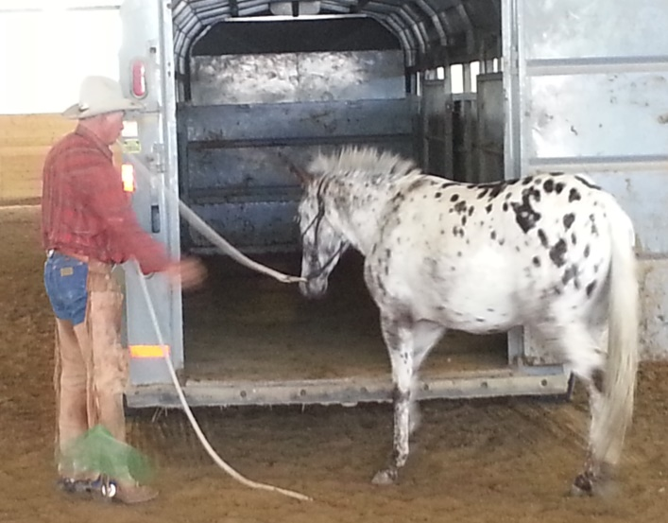
Trailer Loading
Why Are We Not Better Prepared?
By Jerry Tindell
Over the past few years we have watched the fires burn throughout California and other parts of North America and floods that devastate all those in their paths. Homes burnt to the ground or swept away, families displaced for days, weeks, even months, rolling blackouts on the power grid, and countless numbers of animals evacuated and sometimes just left to fend for themselves.
Not only is it difficult to see all the destruction left behind, but to see news story after news story of the hundreds of equine and livestock running for their lives amongst the smoke and flames or drowning is heartbreaking. The confusion and chaos for the animals, the owners, and handlers is sad to see.
Each year it seems we see more and more news stories and videos of the mass number of livestock (mostly equine) being turned loose because the fires or floods are approaching too fast or people ignored evacuation orders. Unfortunately, more times than not, there was simply no plan. I cannot help but ask, “Why are we not better prepared for these emergency situations?”
Think about it - we prepare ourselves and our families in daily life for things that are important to us, like insurance for our cars, home, medical, and even pets. We walk through preventive and emergency planning with our kids in school and elders in homes. We make sure we pay our bills so we can have water, food, electricity and heat. We plan for our children’s future by helping them to take the steps necessary to go to college or get a job and be able to care for themselves on their own. We even prepare our equine to have the best life possible by providing top notch food, supplements, water, shelter, veterinary care, and a set hoof care plan. So, “Why don’t we take the time to prepare our equine in any way we can for emergency situations?”
As a professional equine trainer for the past 30 years, I am very aware of my role and responsibilities to maintain the highest level of care for my stock. I also believe that all equine owners think the same way. I work with people from all over the country teaching horsemanship with control and safety. One of the most important things that we can train our stock to do is to be able to load in a trailer safely, quickly and under all conditions. This MUST be a top priority for all equine owners! It is our responsibility to keep our animals safe!
Every time I get a call or hear about an emergency or evacuation where equine had to be turned loose to survive on their own because they could not be loaded in a trailer, I ask myself “Why are we not better prepared?”
We can make the excuses “it was a strange person loading and handling the animals, it was a different trailer, it was the stress and the fear of the fire, the smoke and the chaos”, but the reality is – they simply don’t load. Now I don’t want you to misunderstand me…with all these things taken into consideration, I am here to say and encourage everyone to take extra consideration and practice loading under all conditions. Trailer loading is one of the most beneficial things we can teach our stock. I practice it every chance I get!
The best part about practicing trailer loading is you do not always have to have a trailer. The key principle about trailer loading is forward movement. If you have forward movement, you can take your equine anywhere. We practice driving our stock through gates, over logs and on platforms/bridges.
You can also practice getting your equine to step up on a log or platform simulating stepping up into the trailer. Same goes for backing out of a trailer. Practice your backup on the ground. Back them through gates, over logs and off platforms. Back them any chance you can. Practice, practice, practice!! It is best to be prepared for the worst and not use it, then to not be prepared and need it.
Regardless where you live or what challenges you may face, trailer loading is one of the most important skills that we need to have in our daily mule/horsemanship. I can’t stress enough how important it is to be prepared for any situation, especially when it is an emergency. We love and care for our animals too much not to take this seriously and make a change today! Remember Trailer loading, you can’t leave home without it!
If you need any assistance or have any question please don’t hesitate to contact me @ (760) 403-3922 or info@jerrytindell.com. I can help set up a plan and a program that fit your needs.

