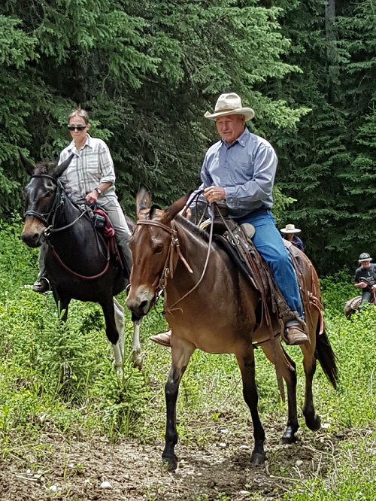
HORSE/MULE SENSE FOR THE HUMAN
By Jerry Tindell
Horses and Mules Live by a Code
We know there is a pecking order, a discipline process, motivators and purpose and these are the guidelines by which they function. It is all set into play by the lead animals.
As they go through the ranks and rise to that position they start to dictate all the rules. That’s what builds the pecking order, discipline, motivators and purpose and unifies the herd. What’s so special about this process is that it is not negotiable.
As the strength of the lead animal deteriorates or he otherwise becomes unable to perform, that position is filled by a brand new start, but the process never changes – there are no new rules. That’s what makes it such an honest system.
Now let’s talk about the fear and flight within the animal. Animals become so aware, which is why they have the flight instinct – they leave things they don’t want to confront, things they are concerned about.
This does not pertain to horse-to-horse relationships – the former herd rules still apply there. Fear and flight come into play when dealing with a stimulus outside their ‘family’ or herd. The flight process, which is so special to these animals, allows safety and removes their fear, because they can get away from the fearful thing. It is important to understand that this process does not build fright in the animal.
The Human in the Equation; Humans must learn how to read the horse and mule. We must possess the qualities to be a leader and we most definitely need to have some form of direction. That direction must have purpose and it must remain the same all the time. Likewise we must find motivators. Motivators for the horse and mule are very simple. The beauty about what the human can offer, if he follows the guidelines of the animal’s world, is to protect the code of the pecking order, the discipline process and build motivators.
That means we must be fair but firm with the direction and purpose; when we release (reward) an expected result, it becomes the motivation for the animal to repeat the lesson. Lessons must make sense to the horse or mule! When a horse moves another horse around using discipline and motivators, he releases the pressure and stops as soon as the other horse yields.
On the other hand, when we humans give direction, are we clear about what we want? Have we given it enough thought to communicate it to the horse? Think about what you want to do and then simply ask them to do it. Remember you are dealing with an animal that lives, breathes and makes decisions.
Every time we establish a connection with our stock (even as subtle as eye contact or body language) we are giving them direction, whether good, bad or indifferent. If we give direction at all, we don’t always release it on time, if ever, therefore there is no motivation on the animal’s part to get better, in fact it builds negative motivation because it doesn’t make any sense to him!
I believe that the human has a big job and responsibility to not change the rules, but rather follow what has been built for us by our animals. A few things the human needs to master:
1) How to read and understand the horse or mule so we can produce direction
2) Correct ways to give direction
3) How to motivate and give purpose
4) Learn timing and proper release (reward)
5) Know what correct behavior is so it all makes sense when we do release them
I am so fortunate to have the opportunity to handle animals at clinics and for training. Unfortunately I see so many horses and mules that are simply fed up with the human (if the shoe fits, wear it).
They exhibit behavior that tells me they are tired of being jerked on, pulled on and kicked with no purpose or release. They are resentful and mistrusting. We pick them to death--the human is greedy, not satisfied and upset because they’re not getting the result they expect when they often don’t even know what they want from the animal in the first place.
Don’t put a human spin on things and then get mad because it’s not working. The horse or mule only gets mad when we ask him to do something, then don’t recognize when they’ve done it, and we ask them to do it again and again with no release or reward for the try…only picking and nagging.
We must get out of ourselves and get into our horse. I am not suggesting that the human become complacent or passive and allow the stock to do the wrong thing, but that we use the blueprint the horse or mule came with and be responsible for protecting it.
I really believe that we must teach them to be well mannered, keep them right, and that will make them happy. Let’s follow the rules that work within the herd – not mix it up and produce only frustration for horse and human. Teach them to be soft, supple and safe. Allow them to be what they are and work within parameters they can understand. Remember: “You’ll never have a thoroughbred if you keep treating him like a nag”!
Jerry Tindell
www.jerrytindell.com

