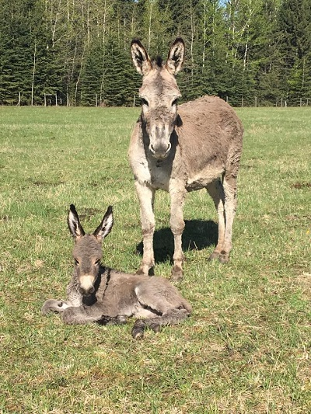
Methods of Breeding Donkeys
By Sybil E. Sewell
Breeding donkeys may seem as simple as the equation of one jennet plus one jack will produce a fuzzy, longeared foal next year. However, donkeys are part of the equine family and as such the breeder has a choice of three basic breeding methods.
1. Pasture breeding occurs when the jack is turned out with a group of jennets. The advantage is a natural breeding situation.
The disadvantages:
- If the jack is not excellent condition he may not be able to successfully breed all the jennets.
- Risk of injury to the jack by aggressive jennets, or vice versa.
- Risk of injury to foals in the herd. The jack may try to kill any jack foal born.
- Risk of infection being spread in an uncontrolled situation.
- Unless closely observed, it is difficult to determine dates of breeding, and hence foaling dates the following year.
2. In Hand breeding occurs when the jennet is placed in a breeding chute or stall and the jack is controlled by his handler. Disadvantages to this method are the requirement of extra care, handling, and facilities during regular teasing and breeding of the jennets. Some jacks are very slow breeders.
Advantages are:
- Controlled situation for breeding with minimal risk of injury to either jack or jennet. The foal can be placed close by so the jennet is not worried about her offspring.
- The jack's energy can be conserved and is not wasted chasing jennets.
- Risk of infection is minimized in that both jack and jennet can be disinfected before and after breeding.
- Exact dates for breeding can be recorded and more accurate dates for foaling can be predicted.
3. Equine Artificial Insemination occurs when semen is collected from the jack and used to inseminate one or more jennets ready for breeding. The disadvantages to many small breeders would be the costs involved for a trained technician, or the courses and purchase of equipment to establish them in Equine A.I. The advantages are the lowered risk of infection, and the breeding of a larger quantity of jennets at the same time than could be possible by in hand breeding.
Jacks can be very precocious at an early age, and young jennets often show their first heat cycles early in the yearling year. Since the donkey is a very slow maturing animal it is unwise to allow breeding prior to the age of three years old. Pregnancy in the immature jennet can produce congenital malformations in the foal. The lengthy gestation period, which can very from 11 to 14 months, can produce permanent damage to skeletal and muscular systems of the immature dam. Physically immature jennets may lack the mental maturity to be good mothers.
Careful choice of both jack and jennet, as well as the method of breeding, can indeed yield a fuzzy, longeared foal next year, which will make the long wait worth it!
Sybil has been a long time breeder of Mammoth Donkeys in Canada and a major contributor to this endangered Breed.

