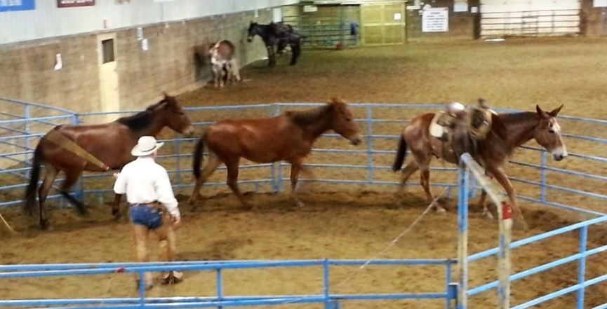
ALWAYS MUCH TO LEARN
By Marlene Quiring
No matter how much you learn, there’s always more to take in if we are open to adding to our tool box.
Most of us recognize that mules and donkeys don’t always react quite like horses. Each equine is an individual and we have to be able to adjust ourselves and the methods we practice to allow for some differences in each mule, donkey or horse that we encounter. Being able to read an animal by watching their body language is something all of us need to take a better look at. After that assessment of the individual, basic ground work is something that should never be by-passed or cut short.
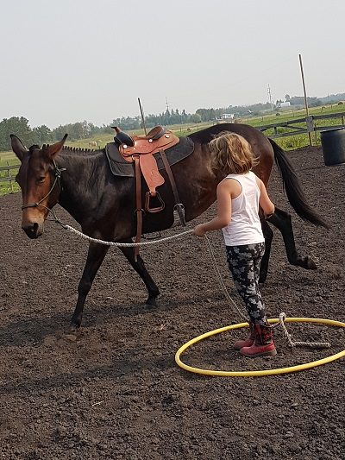
When things aren’t going just like we want them with our mule, we do need to back ourselves up and go back to some basic ground work. If we are not well schooled in it ourselves, it’s time to take a deeper look at it and begin to understand just how important it is not just for us, but our equines. How many people do we hear of each year that go out, catch their horse or mule and just jump on without first checking where they are mentally and physically with some all-important ground exercises? Some go directly from catch and saddle, ignoring the equine’s body language which is the window to their mind, and then hit the trails and end up with a bad ride or worse, end up getting hurt? Unfortunately it happens too often and the animal is blamed for bad behavior, when in fact it is the fault of the human for not taking the time to do some basic ground checks to make sure the mount is sound in mind, body and soul and is paying attention to you and not all the distractions around. SAFETY FIRST….accidents aren’t accidental…they can be prevented.
A few weeks ago I was lucky enough to join in a Zoom discussion and lesson with Jerry Tindell of Tindell’s Horse and Mule School of California. I have nothing but admiration for this man and the wisdom that he tactfully and clearly shares with others. Jerry took the time to explain his answers and illustrations in detail so that anyone really wanting to grasp the subject had a good chance of understanding the process. This session was aimed at ‘’Finding the Balance Point.’ ’Jerry referred to the ‘’imaginary line’’ behind the shoulder of your equine from which we either drive them ahead or push them back depending on our body position. Realizing of how we use our body to move them is very important. [The photo here was hard to resist…teach them young.]

This reminded me of sessions previously with Jerry regarding us working on the ground with our equines. In relation to round pen work, if we move in front of their shoulder, they read that as a sign to stop, if we step toward their hip, their reaction is to move ahead. Good movement is so important and learning how to ‘’talk’’ to them with our body in an effective, consistent way is the key to build an understanding and a connection. Jerry states that ‘’the way to get to their mind, is to move their feet. Think about training through movement, not restraint.’’
One of the questions brought up on the Zoom call was from a concerned owner with an equine that they described as ‘’loads beautifully’’ but then pawed, was nervous, wouldn’t back out and so on. Jerry explained that to say the equine ‘’loaded beautifully’’ was incorrect and it was not good for the owner to believe this and also not good for the equine. Jerry tried to make the owner understand that they needed to take the time to really work on groundwork basics. Ground work consists of exercises you can do so that you have your equine leading well on the halter, backing well on the halter, flexing well on the halter, moving the shoulders over on the halter, disengaging the hindquarters on the halter, stopping well on the halter and standing well on the halter. Taking the time to go back to those basics is the KEY to fixing problems of any kind. The holes will soon show themselves if you by pass these basic mind and body controls that are the key to a safe ride later. Everything learned and done well on the halter will then transfer to riding, driving, loading in the trailer and so on. Jerry says ‘’ The best way to fix problems or bad habits is by building new habits. Build on the positive, don’t dwell on the negative.’’
Jerry explained how this had to be first successful when everything was calm. Then it had to become successful when there were a few distractions and so on and yet the horse, donkey or mule still followed the directions of the handler even in challenging situations. In other words those ‘’basic’’ maneuvers had to be solid from the ground in order to predict how well things would hold up under stress or once in the saddle or harness. This basic ground work and handling is something most of us want to rush past and then wonder what went wrong when things fall apart.
It came to mind that our human nature tends to only listen to the answers with half an ear, as the other part of us is already thinking of a response in defense of our actions. I am also guilty of this when I get in the way of myself! Often our reply after someone we look up to gives us advice about a situation with our mule with something like this. ‘’My mule is really good, but….and Jerry would counter that with ‘’ Your mule is not good if you have to add a BUT.’’ We tend to get defensive instead of listening and learning the lesson set before us. Sometimes we just are not ready to accept the reality that we have skipped basic lessons and it’s really not our mule’s fault, but our own and we are the ones that have to fix it or better yet, fix ourselves.
Most of us have made those statements like. ‘’ My horse, mule or donkey is really good to ride, drive or lead, BUT, he is scared of, bolts, bucks, has no stop, or whatever - you can fill in the blank! We state or ‘’believe’’ that he is good at something, but if that statement is followed by a BUT?... Well hopefully you get the picture! We are failing ourselves AND our equine. It DOESN’T have to be that way if we pay attention to listening to and working on the ANSWER. It was MY reminder lesson for the day and I hope it helps someone else also! Work and ride safe! Nothing beats it.

