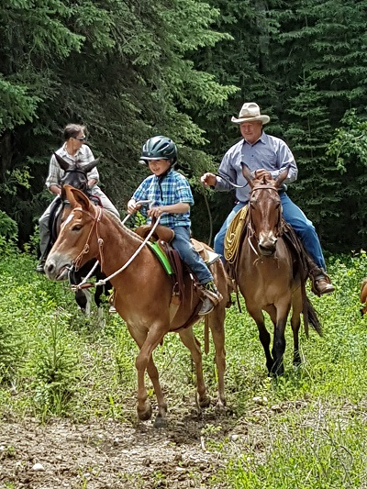
ARE MULES FOR YOU?
By Jane Lambert
Are you considering becoming a mule owner? Perhaps you should ask yourself the following questions.
How experienced with horses are you?
If you have not ridden or owned horses, you may not have enough background to deal with mules. They are smart, and if you make mistakes with them, they will take advantage of you. You must understand equine psychology and be able to read horse or mule body language – something that takes time and experience. If you allow your mule to outsmart you, he will.
How patient are you?
It takes patience to own mules. You have to be able to outthink them, not overpower them. If you start trying to force a mule to do something, instead of convincing them that he wants to do it your way, you will have problems. Working with mules involves a lot of head games.
So….do you enjoy head games?
If you like to match wits, you will enjoy mules. They are highly intelligent animals who are always thinking. Mules don’t program like a horse, so in your training you need to mentally challenge your mule, keep him interested, quit before you bore him, and give him praise when he responds well. If your mule gets mad, or is in a bad mood, you might as well forget the day’s training session.
Realize, when you have a well – trained mule, that he is humoring you by responding correctly to your cues. Make him mad and watch him ignore you.
What kind of facilities do you have?
I’ve decided mules need electric fence. If you have barbed wire, they eventually cut themselves. If you use smooth wire, they lean on it and stretch it out. If it’s wooden, they eat it. For their own protection and for the good of your fences, consider a hot wire.
Do you have a decent rolling area- a good “dust bowl?”
If not, your mules will make one, even in your irrigated pasture. Simply expect it.
Do you have other animals?
Mules are very social and do not like to be by themselves. In fact, some people feel you can make a mule bond to you by making yourself the only animal your mule sees.
You should know that if you have horses, especially mares, your mule will become herd-bound. This is good if you are in the mountains, as you can just turn your mule loose, and he won’t leave his horse friends. This is bad when you need to take your mule out by himself. It bothers him a lot to be tied alone, ridden alone, and hauled alone, and takes time for him to know that he will get to come home and be with his buddies again.
Also, mules trample small animals. Do not put mules in with sheep, goats, hogs, colts or calves. Watch out for our dogs and cats, and I would not advise letting small children be unattended near strange mules.
What type of riding do you do?
Select a mule to meet your needs. Because mules can come from any breed of mare and from different sizes and types of jacks, try to select you mule with the mental and physical aptitudes you need.
Keep in mind that the jack will contribute to size, disposition, and soundness, but the majority of the mental attitudes and athletic ability will come from the mother. Know what you expect from you mule before you buy him, and select him to meet your expectations.
Do you “have mare, need jack?”
If you have a mare with the attributes you want in your mule, then find her a mate. My main advice in selecting a jack is to look at this offspring from similar mares. Jack beauty lies in the quality of his get. If you can’t see his get, get another jack.
Mules can be your dream come true or your worst nightmare. I love mine and thoroughly enjoy their unique personalities, surefootedness, and the mental challenge they present. But in deciding if mules are for you, realize that a mule is not “like a horse.” He is much more than a horse and is not for everyone.

