PART ONE of Appropriate Tack and Fit for Mules, Horses & Donkeys
By Marlene Quiring,
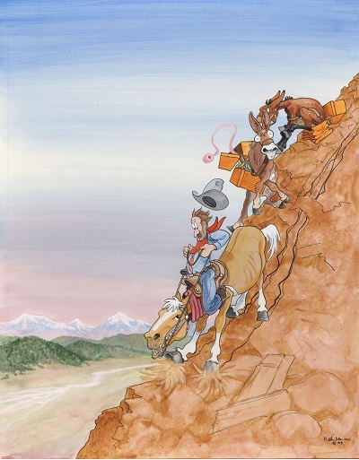
WHY THE CONCERN ABOUT TACK FIT
Fitting the right equipment to the right animal is important for several reasons.
# 1, ECONOMICS - Simply put, using correctly fitted and positioned tack directly affects our pocketbooks. If you have enough knowledge to put the right kind of equipment on the right animal for the right use, you will save yourself hundreds of dollars in tack and useless gimmicks that end up hanging on your tack room walls or collecting dust in the corner. And you will select and fit the right animal to the right job. Putting animals to work in circumstances and conditions that they are not suited for and expecting them to work in tack that doesn’t fit will shorten their usefulness to you and can become a financial burden.
# 2, PERFORMANCE - You will get better performance out of your animal if you have taken the time to fit the tack to that animal. There is no doubt that the horse, mule or donkey that is not limited by ill-fitting tack, will outperform one that is limited and/or hurting from tack that is not fitted or positioned correctly for their conformation.
# 3, SAFETY - Your animal’s well-being and comfort will directly affect your personal comfort and also your degree of safety in working that animal. If your mount is not comfortable with the working gear that he if forced to accept, he will not be an attentive, thinking animal that will respond as well to your cues or be as aware of any outside dangers that might threaten his or your safety. Ultimately, an animal that is in distress from ill-fitting tack may decide to buck, bolt or exhibit other undesirable behaviors.
GROWTH & MATURITY
It’s important to understand that the saddle you fit to your equine’s back today may not fit so well when changes happen to that animal such as maturity or conditioning which can vary from one season to the next. You will be wise to constantly monitor your animal’s back to check for signs that your tack may need adjusting.
Starting horses at 2 or younger requires thoughtful consideration into making sure that at that young age, they absolutely should not be asked to stand up to any strenuous riding if to any riding at all. Mules, because of their even slower maturity should be started later and donkeys not till around 4 years of age. All equines at these tender ages are still growing; cartilage is changing into bone and muscles are strengthening. Permanent damage can result to the animal’s frame that can limit the usefulness of that animal and shorten his working life if one forgets that they are young. Many mules don’t fully mature until 6 or later, so don’t punish their bodies by riding them hard at a young age. It would be more reasonable to ride horses lightly as 3 year olds and mules and donkeys at 4 and 5. It will pay off in the end by having a critter that will last for you. Because of the changes that will occur during these ages, expect that fitting a saddle to a young animal will take many adjustments as they mature.
CONFORMATION RELATIVE TO SADDLE FIT
Years ago, when only riding horses, long mountain trips often left my horses with cinch sores and/or hot swollen spots on their shoulders, which sometimes left white hairs. Arena riding and pleasure riding didn’t usually give me any clues that my saddle fit or saddling position was causing my horse grief; but riding in the mountains told another story. When I started riding mules, saddle fitting became even more of a problem and forced me to search for answers. Some things I figured out the hard way, but mostly I’ve been able to learn from others, especially from Tim Barton, who is a retired College teacher in Equine Anatomy and longtime horse and mule man. Tim also operates an exclusive mountain retreat www.outpostatwardenrock.com that is only accessible by team and wagon or saddle animal. For most of his life he has worked with mules and horses and had to keep them happy and sound in order to pack, drive and ride in rough conditions.
In order to understand how to fit tack you need to first become a student of conformation, particularly the differences in backs from one equine to another. Prepare to ‘’see’’ the obvious, perhaps for the very first time. Most of us understand that a mule’s back is generally different than a horse’s back, but what you will find is that there is no ‘’standard’’ back for mule, donkey or horse – each is an individual with individual needs in tack fit. Some horses have wide flat backs that are more commonly seen on mules and some mules have backs with high withers and quite a bit of belly [a definite concave curve or dip in the middle of the back]. Therefore it is incorrect to assume that any one saddle will fit any equine. It’s simply impossible.
When you begin to really look at backs you will be able to discern the differences. Backs can be long, short, wide, narrow, flat or with lots of belly. It’s not uncommon to see a back that has some deviation [curves left or right] of the spine. Some animals may have one leg shorter than the other which can affect overall balance and require compensation when fitting tack. A shoulder can be uneven, whether born that way, from injury or an unbalanced rider. The best way to see this is to get a bird’s eye view of your equines back from behind and at an elevated position. The animal is unsaddled and standing straight on even ground. It is not unusual to see that one shoulder is more muscular than the other, which will make saddle fitting more challenging as an extra shim on the less developed shoulder will be needed to compensate. Ultimately the situation could be corrected by a chiropractic adjustment or by developing that shoulder but in the meantime, make those changes to keep your saddle balanced and animal more comfortable.
Corrections might be needed in riding and help needed to level the saddle or the pad with extra shimming to help the shoulder that is low. If we ride lopsided whether due to an injury or sloppiness; we will affect the balance and eventually the conformation of our animal. The first step towards understanding good tack fit is to take the time to really study equine conformation and develop your eye to see the difference. You will begin to realize that you cannot assume that any one saddle can possibly fit all the different back structures.
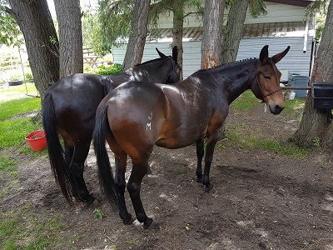
In the case of mules, saddle fitting can be even harder because of the influence of the donkey’s structure. Mules can have narrower shoulders, wider barrels and low withers. It is misleading to rely on a saddle advertised as having ‘’mule bars’’ as being the answer for your mule. We know that not all mules have the same conformation so it is not fair to think that a ‘’mule’’ saddle will fit most any mule any more than it is to assume that one saddle will fit any horse. For example, a 14 hh saddle mule and 16 hh draft mule will likely have different backs, so that needs consideration. Expecting them to perform well with bad fitting tack is a grave mistake and it’s our responsibility to strive for the best fit.
Once you have a better eye to see how the conformation differs in individual backs, find a saddle maker or shop that will let you look at their bare trees to further develop your eye. Aim at learning to see which trees might best fit which backs. A good fit will make contact throughout the length and width of the bar; as compared to only spots of the bar making contact with the animal’s back which will cause localized pressure spots. Also watch that the bare tree does not ever sit on the mule’s spine.
A mule tree does not automatically fit a mule back. Some mules need horse trees and vice versa. A very flat backed horse may need what many call a mule tree. So don’t get mislead into thinking that a certain tree will fit a certain animal. This is where you have to see for yourself which tree will fit the best. After that, you or your saddle maker may need to start modifying a tree that has the closest bare fit. Modifying a bare tree is much easier but you can also modify the tree in a saddle. It is more work, but well worth the effort.
NEXT – Click on Part TWO: The Importance of Saddle Position

