NO FOOT NO MULE

By Marlene Quiring [ please view photos and explanations at the end]

Out of the many mules I have raised over the years I have held onto a few of them for personal pleasure. One is Daisy, now an older, sweet natured molly that allowed me to train her to ride and drive with a little help from friends. However, her ‘’working career’’ has been rather challenged. She got very ill when she was young and our vet was never able to determine what was wrong with her but she did recover. Then, a few years later I had to take her for surgery as she had become a ‘’roarer’’ which meant she was easily winded if asked to do too much of anything. That surgery was almost a disaster, but with about 75% recovery from that she was useful again.

After that Daisy spent most of her adult life being off and on lame. Her soundness seemed to come and go. I’d spent my share of money on x-rays, examinations, massage therapists, chiropractors etc. trying to find out the problem and treat symptoms. Nothing ever really showed up except stiff and sore shoulders and with what I know now, that only makes sense.

Several years ago while Jerry Tindell, horse and mule trainer, from Oak Hills California was in Alberta teaching clinics, I had him take a look at my 28 year old saddle mule Smokin’ Joe. Jerry has also been a horse and mule shoer most of his life so I figured he might know why Joe was not moving like he used to. Smokin’ Joe had been totally sound until the previous year when he became ouchy on his left front. Other friends, experts and farriers had checked him out with only limited success as to why he favored that foot.

Jerry checked his feet and showed me that Joe’s heels were under slung and were contracting, especially on his left front. He had too much toe and his heels were unbalanced and had been allowed to get lower and lower. Without the aid of proper farrier tools, Jerry and my husband Roy [a welder] managed to modify a pair of shoes that would help Joe. Jerry trimmed Joe’s toes shorter, made sure he was balanced side to side and put shoes on him that gave him more heel support and would allow for his foot to spread out and stop the contraction of his heels. He also put pads on his feet for added protection. Joe was sound immediately and stayed that way.

Unfortunately not all farriers understand how to properly trim or shoe a foot, especially a mule or a donkey. What a lesson for me this has been! Jerry stated that it’s up to us as owners to ask questions, give our input and work together with our farrier and vet. If neither is open to our input, it might be time to find another.

After seeing the help that Smokin’ Joe received from Jerry’s trimming and shoeing, I had him also take a look at Daisy. Guess what? Daisy had much of the same thing going on, also the left front being the worst. So build more shoes and more proper trimming. Daisy had been lame that season for most of the year. It was painful to watch her move some days and when she got up from a rest, she moved like she was riddled with arthritis. Jerry said this may not be the complete fix to her problem, but it should help and only time would tell. She too had under slung heels and unbalanced feet. The next day, Daisy was moving easier and by the time she was due to be reset, she was moving 80 % better.

Having my current farrier follow Jerry’s work on her feet, she was reset to the same degree and in another few weeks, I couldn’t see that she was unsound at all. Roy got out his saddle and we went for a ride and Daisy moved out 100%. What a change from a mule that suffered daily just to get around to one that floated over the ground. You can’t imagine how awful I felt that Daisy had suffered all these years because no one recognized what was going on with her feet.

Daisy was given a new lease on life. Never would I have thought that it was actually such a simple basic thing as improper and out of balance trimming! I always felt that Daisy’s feet especially did not look ‘’right’’ after a trim job…I should have listened to that instinct years ago! My mules and I owe Jerry Tindell a great deal of gratitude for the work he did on them and his willingness to help when no one else had been able to help.

Jerry says that it’s safe to say that in most cases, mules and donkeys may require a steeper hoof angle than a horse. If proper angle and toe length according to the angle of shoulder is not correct, the animal will develop movement problems and could contribute to lameness. Improper trimming over time can cause a scenario similar to my problems above with my mules.

Jerry suggests that owners communicate and get more involved with the work their farriers do on their animals. It may also be necessary to consult with your vet and make sure that both professionals are ‘’on the same page.’’ A good farrier will take into consideration your concerns, and should be open to working on something that doesn’t seem quite right to you. Your vet may also need to be consulted to make sure that there is not some other reason for the lameness.

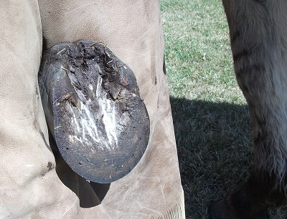
The following is a series of photos with explanations to try and give you an idea of what Joe and Daisy’s feet looked like to start with, what the problems were, and how Jerry worked on fixing them.

1.This photo shows Smokin’ Joe’s left front foot before Jerry started to trim it. The heels are under slung and contracted. This is caused by pinching and too much pressure, either by improper trimming or a too small or too tight of a shoe. Joe’s frog is not functioning properly because of the condition of his foot and so it is recessed. His toes are too long and his foot is too narrow. It also shows the unbalanced heels and how they have been forced to move ahead, one heel is more under slung than the other. His heels need to be back under him to give him the support he needs.

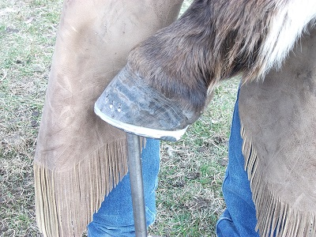
Photos 2 and 3 show Joe’s foot now properly trimmed, balanced and shod with shoes that will help to support his feet. Notice the shoe has a bit of a trailer to give support in the heel area. It is desirable that the shoe is slightly wider than the foot as shown in the photos so that the foot can expand. Also the surface crack you can see in his quarter area will now get relief from pressure and a chance to also expand. The pads will give him further protection, as his feet get healthier.

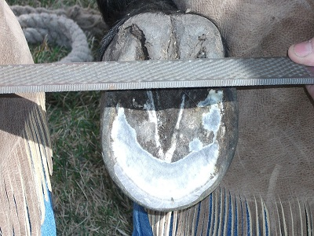
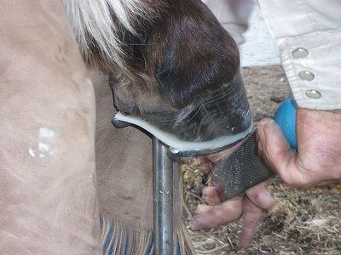
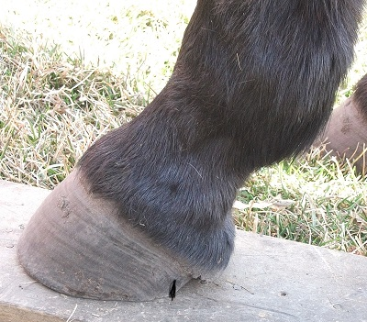
These 2 photos are of Daisy’s left front foot before trimming. At a quick glance, the bottom or her foot looks not bad but long in the toe. In the next photo the side view, shows that her heels are so far ahead that they are not supporting her like they need to. [Her heel actually ends at the black mark where it touches the wood and then there is air – no support] If you were to run a ruler from the back of her heel to straight up her leg you could see that she was constantly putting a strain on the tendons, muscles and ligaments in her legs as her heels were not supporting her. A symptom of that was her sore shoulder problem. Massage and chiropractic treatments gave her some relief, but in retrospect, only treated the symptoms and not the cause, which were her under slung and contracted heels!

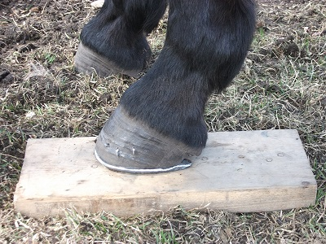
Jerry’s solution was to shorten up Daisy’s toes giving her a steeper angle, which she needed to give her an easier ‘’break-over’’ point. She also got shoes with trailers, also wide enough to leave room for expansion all around. Notice the big gap at the back of her heel, now given support with the longer shoe. Many farriers are leery to do this as they feel it is too easy to then pull a shoe, but in these cases, the support must be there and we had good luck with keeping the shoes on until the next reset. She didn’t require pads, as we would not use her until she was sound which happened quite quickly after this intervention.
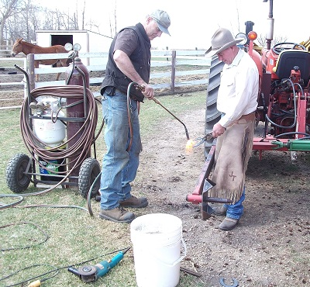

Making do with what you have! Roy Quiring and Jerry Tindell shaping shoes for Joe and Daisy with no anvil, so the tractor bale pick up was used and 2 innovative minds.

If you have questions or concerns about your own stock and their soundness you are welcome to contact Jerry by phone at 760 403-3922 or contact him through his website at www.jerrytindell.com. Jerry would be glad to answer any questions anyone has regarding their stock.

Marlene is a long time mule fancier and resides with her husband Roy and 5 mules at their home in Ponoka, AB. She raised mules for many years and never tires at sharing information about them.

