CHOOSING THE RIGHT DONKEY and MORE TRAINING AND RIDING HINTS
by Donna Quick
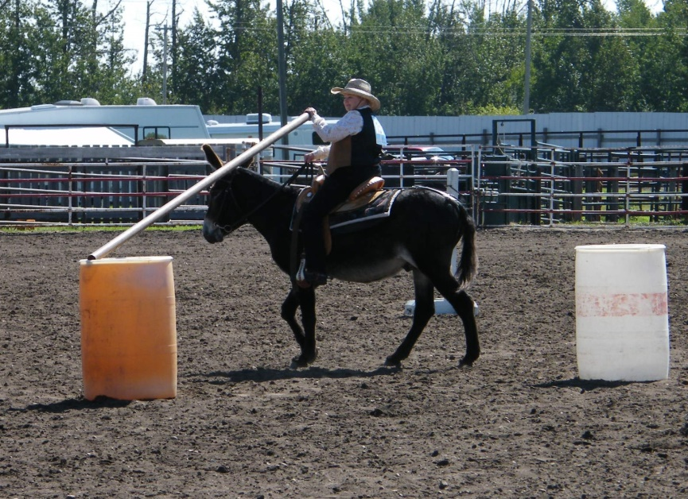
Most people are surprised to learn that donkeys are now being bred in the 14 to 15 hh range, with some animals reaching 16 hh. This means that donkeys can definitely be a practical alternative to a horse or mule as a saddle animal.
Donkeys are much less likely than a horse or mule to buck, rear, shy or bolt, which makes them a good choice for beginning, senior, or disabled riders. And they’re ideal for people who have limited time to ride. Donkeys won’t become hard to handle if they’re ridden infrequently. There’s no need to dread that first ride in the spring – your donkey will act as if you climbed off just yesterday.
Mammoth donkeys are sometimes more sluggish and less co-operative than Large Standards. If you’re just interested in trail riding, this may not be a problem. If you’d like to try showing, including gymkhana and fun classes, a Large Standard might be a better choice. They’re usually more willing to hold a lope for longer periods and move a little faster when required. However, some smaller donkeys have a definite “pony personality” and like to see how much they can get away with.
Even though donkeys have the reputation for being very sure-footed, some riders report stumbling, even to the knees, while loping. This usually happens to donkeys with large, heavy heads and smaller hooves, especially if they haven’t been ridden too often. They can sometimes carry too much weight on the forehand. Building up strength in the hindquarters through stops and starts and hill climbing can help, as well as making sure you’re not leaning forward while travelling at speed. To be on the safe side, lope only on smooth surfaces.
Carl and Sybil Sewell have raised top-quality large donkeys for almost 40 years at Windy Ridge Farm near Leslieville, AB. According to Sybil, “A donkey doesn’t have to be 16 hh to be a viable alternative to the horse. We have, out of research and experience, avoided extremes of height and have found that the most athletic animals have fallen into the 14 or 15 hh range.” Even a 13 hh donkey with good conformation can be a suitable mount for a small adult, but Sybil warns that donkeys need sufficient bone and substance or they will beak down sooner or later. “I don’t think there’s anything worse than a 14 hh plus donkey with a Mammoth-sized head and body fitted onto spindly, fine-boned legs, unless it is to see same under saddle ridden by an overweight rider.”
Saddle-broke donkeys are fairly difficult to find, but anyone with basic riding skills should be able to start their own animal. Training a donkey can be more challenging than training a horse in some respects. In other ways, donkey training is easier and less stressful. Many people report just saddling up and climbing on for the first time with no problems. But it’s still advisable to go through the steps outlined in Meredith Hodges’ training articles. Donkeys are slower to mature than horses and are not ready for riding until age 4.
Avoid accepting a free donkey or rescuing one from an auction unless you have a good deal of equine experience. Free donkeys often come with this kind of information: “Nobody’s ever done very much with her, and she hasn’t had her hooves trimmed for a while.” Translation: She’s isn’t even halter broke, and we can’t find a farrier who will come back a second time.”
Mature donkeys with little or no handling can be just as wild as the BLM burros rounded up in the U.S. It can take a lot more than offering treats to catch a neglected donkey. Picking up feet can be a long and hazardous process. It may be necessary to use a glove stuffed with padding mounted on a broomstick to start touching the legs. Chances are your free or rescued donkey will have badly overgrown hooves. Even after these have been trimmed into shape, tendons and ligaments may have become stretched out of shape and the donkey will never be sound for weight-bearing work. And you may find it impossible to locate a farrier once you admit that your donkey isn’t good with her feet.
It’s money well spent to buy a well-socialized donkey from a breeder or owner who can demonstrate that his donkey can be caught, will lead, will pick up its feet without a fight, and doesn’t shy away from being touched.
Once you begin riding, if your donkey outright refuses to do something, sharper spurs are never the answer. It’s up to the rider to somehow trick the donkey into thinking the required movement is in his own best interest. Donkeys have a low tolerance for repetitious ring work, and these sessions should be limited to half an hour or less.
Donkeys really can’t see any reason to go into a lope unless they’re playing tag with their pasture buddies or racing to the feeder. However, loping can usually be initiated by following behind another cantering equine, and eventually your donkey will be willing to lope on his own. They sometimes like to lope with their head down and kick out with their back legs, making you think they’re going to start bucking. Donkeys often run this way when out in pasture, but if you gently pull his head up each time, he’ll eventually stop doing this.
It’s harder to fine-tune a donkey than a horse or mule. Rollbacks, sidepassing, backing and similar movements aren’t on a donkey’s want-to-do list, although all animals should at least be schooled to back and move their hindquarters over. (Refer to Meredith Hodges’ articles.) They usually respond well to voice and leg aids. (Apply leg pressure slightly behind the cinch on the side opposite the direction you want to turn.)
Neck-reining can be a struggle unless the donkey had planned to turn in that direction anyway. These long-eared equines are particularly hesitant to cross water or struggle through a bog. They may require a tow job for the first few crossings, but eventually they overcome their fear, especially if they’re part of a group.
Donkeys have been described as “the pet you can ride.” On the other hand, they’re often less willing than horses to unquestionably follow their rider’s orders. They usually put their own comfort and safety first. Although many people insist that donkeys aren’t stubborn, just careful, don’t be surprised to encounter some behaviour that will make you question this statement. Here are two personal examples.
One evening when he was home alone, my husband Ken had completed 20 minutes or so in the riding ring and was heading for the hitching post where we unsaddle. Halfway across the ring, his Mammoth jennet stopped and wouldn’t go any farther, despite Ken’s spurs and crop. He wasn’t able to pull her off balance enough with the reins to get her feet moving, thanks to donkeys’ strong, limber necks. Ken decided to wait it out and see how long she would stand there. It was over 2 hours before she finally started moving forward again!
Right from the start, my Large Standard gelding would try to head for the hitching post whenever he was circling our ring. There was no way I could straighten him out in the direction we were going. However, if I just reversed, he would change direction with the lightest pull on the reins and continue circling. He continued to do this for the first four or five years I rode him, even though he was NEVER allowed to actually get to the hitching post. Finally one year he just suddenly stopped trying and never did it again. About the same time, he gave up trying to turn around and go home when I was out riding by myself.
Unfortunately, finding a saddle or even a bridle to fit your donkey can be a long process of trial and error. Because of their lack of withers, a crupper or breeching is necessary. It’s also a good idea to use a thin Tacky Too pad under your main saddle pad. These are made in a waffle pattern from a soft, rubbery material and really help a saddle stay in place. You can even make your own by sewing anti-slip carpet underpad to a felt pad.
It’s worthwhile to take extra time and care while saddling and mounting. Make sure your saddle is in exactly the right spot, and have a helper hold the saddle in position while you’re tightening the cinch so it isn’t pulled toward you. Even if your donkey is short, you should use a mounting block because it’s so easy for the saddle to slip on a round donkey back. A tool box with a handle from a hardware store is excellent for this and can also hold your brushes, hoof picks, etc. If possible, have someone apply weight to the stirrup on the off-side as you mount. By following these steps, in 15 years of donkey riding we’ve never had a saddle slip.
Generally speaking, if you want absolute obedience, the ability to excel in gymkhana events or to lope a pattern, donkeys may not be for you. On the other hand, if you just want to compete against other donkeys, take on the challenge of working with a completely different equine species, or simply enjoy a stress-free trail ride, a saddle donkey may be just what you’re looking for.

MORE TRAINING AND RIDING TIPS FOR SADDLE DONKEYS from Donna Quick
It’s always best to follow the advice of professionals like Meredith Hodges when starting a donkey under saddle. However, the following tips may prove helpful after you’re already riding your donkey. They’re based on my experience after being involved in saddle breaking one Large Standard and two Mammoth donkeys and participating in a wide variety of shows, demonstrations, and trail rides. Although more experienced trainers may have other methods, these are a few solutions and observations that worked for me.
Once you begin riding, if your donkey outright refuses to do something, sharper spurs are never the answer. It’s up to the rider to somehow trick the donkey into thinking the required movement is in his own best interest. Donkeys have a low tolerance for repetitious ring work, and these sessions should be limited to 20 minutes or so. If you’re trying a certain movement – e.g., a small circle to the right – and your donkey rebels after a circle or two, insisting on one good circle before you quit may not be possible, unlike working a horse. You may have to give up on the circle and do a completely different movement just to show that you’re still in charge. You might have to avoid the problem movement for days, weeks, or even months, but eventually your donkey will forget about resisting and you’ll be able to go back to it.
For the first four or five years that I rode my Large Standard gelding, Spider, in our riding ring, he would try to veer off almost every time I circled past the hitching post where he was unsaddled, even though he was NEVER allowed to return to the post. There was no way I could straighten him out and continue in the direction I had been going, thanks to a donkey’s limber neck. However, if I just reversed, he would change direction with the lightest pull on the reins and continue circling the other way. As long as I kept him moving, I was still the boss. When he finally gave up on this misbehaviour, he gave up completely and never regressed. At about the same time, he stopped trying to turn around and go home when I was out riding by myself.
Loping can sometimes be a problem. The best way to get your donkey used to loping is to follow behind another cantering equine. I found that trying to lope up a slight rise often worked better, probably because my seat felt more secure and I would use my aids more forcefully. Although this is something to avoid with horses, loping toward your home barn or corral is often an easier way to get a lope started. Donkeys sometimes like to run with their head down and to kick out with their back legs, making you think they’re going to start bucking, although this is rarely the case. Donkeys often run this way when out in pasture, but if you gently pull his head up each time, he’ll eventually stop doing this.
It’s harder to fine-tune a donkey than a horse or mule. Rollbacks, sidepassing, backing and similar movements aren’t on a donkey’s want-to-do list, although all animals should at least be schooled to back and move their hindquarters over (a turn on the forehand). Even the experts agree that not many donkeys are willing to neck rein, but they usually respond very well to voice and leg aids. Moving the hindquarters over is easy to teach, starting on the ground. If you pull your animal’s head toward you while applying pressure to the side where your heel will press when mounted, he’ll have no choice except to move if he wants to keep his balance. You may have to use an assistant to help you start backing and sidepassing, someone strong enough to actually push your donkey if he won’t respond to the tap of a whip. Use different voice commands for each movement. Sidepassing over to a mailbox, a common trail course obstacle, or over a log will give your donkey some reason to want to move sideways, but be prepared for a wait of years before you accomplish a few sidepass steps. If you’ve ever tried giving a needle, you’ll realize that a donkey’s skin is thicker than a horse’s, so don’t feel guilty if you have to use spurs for all these exercises.
Donkeys are very quick to pick up on patterns. If you want to be able to lope several large circles for a donkey pleasure class or a games class, don’t start letting your longears stop after six or eight good lope strides or else that may become all he’s willing to do. If you want to be able to back through an “L” in a trail class, don’t let your donkey always stop after four or five backing steps.
You may want to do some sharp turns (“sharpish” turns, in donkey terminology) if you’re going to enter gymkhana or games classes. Most donkeys will definitely require spurs for this movement, and a voice command, such as a loud “Whissht,” noise at the start of a turn, can be a big help.
SAFETY CONCERNS
Even though donkeys have the reputation for being very sure-footed, some riders report stumbling, even to the knees, while loping. This usually happens to donkeys with large, heavy heads and smaller hooves, especially if they haven’t been ridden too much. Building up strength in the hindquarters through stops and starts and hill climbing can help, as well as making sure you’re not leaning forward while travelling at speed. To be on the safe side, lope only on level ground.
Unfortunately, finding a saddle or even a bridle to fit a larger donkey can be a long process of trial and error. Because of their lack of withers, a crupper or breeching is necessary. It’s also a good idea to use a thin Tacky Too pad under your main saddle pad. These are made in a waffle pattern from a soft, rubbery material and really help a saddle stay in place. You can even make your own by sewing anti-slip carpet underlay to a thin felt pad.
I’ve had good luck using a snaffle bit with a fairly thin mouthpiece and very short shanks which swivel and also provide a mild gag action. Although it’s often said that donkeys will freeze rather than run when spooked, the larger donkeys know they can go fast enough to try running away from danger. I’ve had a number of bolting sessions, so I like a bit that gives me some control, which my current bit provides.
It’s worthwhile to take extra time and care while saddling and mounting. Make sure your saddle is in exactly the right spot, and if possible have a helper hold the saddle in position while you’re tightening the cinch so it isn’t pulled toward you. Even if your donkey is short, you should use a mounting block because it’s very easy for the saddle to slip on a round donkey back. A tool box with a handle from a hardware store is excellent for this and can also hold your brushes, hoof picks, etc. If you have a helper, have her apply weight to the stirrup on the off-side as you mount. By following these steps, in over 15 years of donkey riding, I’ve never had a saddle slip.
Training a donkey will take much longer than training a horse because of the fact that you can only do ring work for 20 minutes or so at a time, unless you want to have a sullen, unco-operative donkey. You may hit roadblocks now and then, but don’t give up. Your donkey may surprise you and suddenly start doing what you want all on his own, if not this year then maybe next year. If you remember that donkey time is different than human time, you’ll both be much happier.
Donna Quick
Spruce Grove, AB

