PART SEVEN of Appropriate Tack and Fit for Mules, Horses & Donkeys
By Marlene Quiring
BITS AND BRIDLES
The most basic bit to start your animal in is a snaffle bit. Please walk away from anyone who advocates that it is fine to start a mule or donkey in a shanked bit! This should not happen with any equine.
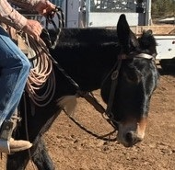
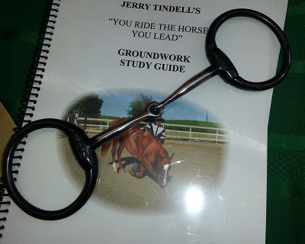
Halters and bosals are often used at the beginning, but at some point you will want to advance your animal into a bit. If your mule or donkey has never had their teeth checked by a qualified equine dentist you should first consider doing this so that wolf teeth are extracted, retained caps and sharp points on the molars are removed and any other problems attended to. Please refer to our section on Equine Dentistry in ‘’ Care for all Longears.’’A painful mouth can cause serious training problems so it is necessary to rule out dental problems in all equines before asking them to carry a bit.
Snaffle bits come in all sizes and widths and it’s important to have a good look at you animal’s mouth as they may have a high or low palate or a fat tongue or lips; all of which will affect how comfortable they are with different bits. You need to be aware that a snaffle bit is one that has no leverage whatsoever. A snaffle bit has NO shanks period. It works on the lips, corners of the mouth, bars and tongue. A ‘’Tom Thumb’’ bit is NOT a snaffle but a curb bit.
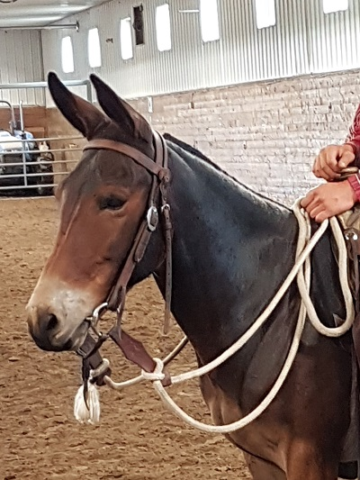
In a snaffle bit a direct pull on the rein results in a direct pressure on the side of the mouth. This is the easiest communication for the animal to understand and all the basics of good reining skills will start here. A snaffle bit may be an O ring, a D ring, an egg- butt or a full cheek snaffle. It may be broken in the middle, or three pieces, or a solid piece. The narrower the bit the more severe it is. Always keep in mind that the bit is only as severe as the hands that are on the other end! The bit should hang in the mouth at the correct height. The bit does not need to apply pressure at the corners of the mouth; this should happen only when rein pressure is applied. The width of the bit must also be considered. If the bit is too narrow it will pinch the corners of the mouth, if too wide, the side to side movement can cause sores.
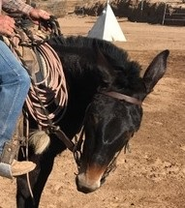
The use of the snaffle bit is not always well understood. It is NOT a bit designed for pulling on both sides at once. It is designed to be pulled one rein at a time! It is the only bit designed to teach flexion from side to side as it gives a clear line of communication from one rein to the same side of the bit, asking the equine to give to that pressure. With time, once the direct communication is better understood by both parties, both reins can be used in aiding collection, backing up, stopping and so on. Educated and light hands make for a light, responsive, happy equine.
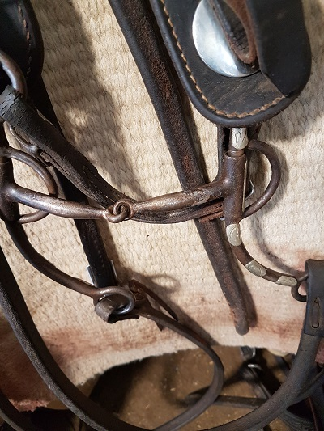
According to most Breed Show rules, a curb bit is technically defined as any bit that has shanks, no matter how short or long the shanks are. So even if the mouthpiece is broken, straight or has a port, if there is any sort of leverage attainable with the bit, it is classified as a curb bit for show ring purposes and should be ridden with one hand as compared to the two hands allowed with a snaffle bit. If you plan to do any showing with your animal, make sure you check out the rules and regulations applicable to that show or organization. The bit in this photo has shanks thus it is a curb bit even though it has a broken mouthpiece. It is a good bit to transition to from a snaffle as it still allows for some lateral flexion.
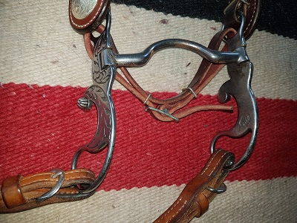
Unlike the snaffle bit that works on direct pressure, a curb or shanked bit works on leverage. The bit in the photo here to the right is also a curb bit with shanks, but it does not allow for lateral flexion so would be a transition up from the bit above with the broken mouthpiece. This more advanced bit has little movement in the shanks and a solid mouthpiece with tongue relief. The bit should just touch the corners of the mouth or have a slight wrinkle but nothing severe. Both of these bits put pressure on the bars, tongue, poll and in the chin groove by the action of the curb or chin strap. This must be adjusted properly in order for this bit to act properly.
If the chin strap is adjusted too tight, pressure will be there all the time and the animal will become numb to it, too loose and it will never be activated. The rule of thumb is that you should be able to insert 2 fingers vertically between the strap and your animals chin. Most curb straps are made of leather; chain chin straps are best avoided.
A chin strap is always used with a snaffle bit however its only use is to prevent the rings of the bit from sliding or being pulled into the animal’s mouth. Thus it is adjusted rather loose and definitely not snug.
A curb bit is only for those animals that are already doing everything correctly with a snaffle bit, as once you move to the curb bit; you lose your ability for good lateral flexion.
This side to side control attained with a snaffle bit is essential in horses and even more so in donkeys and mules who have stronger and often shorter necks and have more of a tendency to first ‘’brace’’ against pressure. It is always good to go back to a snaffle bit when teaching something new to your animals so that you are not giving them mixed signals with a shanked bit. Animals that need retraining should also be put back in a snaffle. It is only through the give and take direct action that is activated with a snaffle bit or halter that you can really teach your animal to be supple and soft in the head, poll and neck and giving to the bit. The constant pressures exerted by a curb bit in untrained hands will result in what’s referred to as a ‘’hard-mouthed animal.’’ The animal has become desensitized to the constant pressure and abuse and becomes non-responsive to further pressures. He has learned to ignore the pain and discomfort. It’s called survival and mules and donkeys are especially good at it! The answer to a donkey or mule being hard to turn or stop is NOT getting a bigger or harsher, or so called ‘’Mule Bit.’’ The answer lies in going back to your ground work and back into a snaffle bit and start from the beginning.
The bit is often over relied upon to solve all problems when in fact it is only one aid that needs to be combined with educated hands. Weight, seat, voice and leg aids are sometimes neglected in communicating with your longears and many of us need to use these aids more and our hands less!
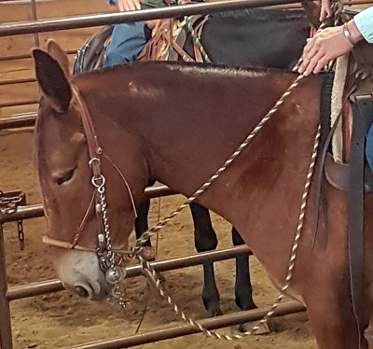
Advancing a horse, mule or a donkey into a curbed or finishing type of bit can take months and years with consistent and patient training. It is not a quick process if your goal is to ride a ‘’Cadillac.’’ The mule in this photo is in training to transition up to a very fine tuned bit that requires soft educated hands and is not for green stock or riders.
In fitting a bridle to your mule or donkey keep in mind that they generally have a larger head and thicker jowl than a horse and usually require a longer brow band and a longer throatlatch to fit them comfortably. You may need to order those pieces separately. Be careful if you intend to use a ‘’one eared bridle’’ as here too you must be very careful that the ear opening is large enough to comfortably accommodate your friend’s large ear. Brow band bridles are usually easier to put on and fit. Bridles built for warmbloods or draft horse may sometimes fit mules. Just make sure that you choose wisely and do not settle for tight brow bands or throatlatches as both can cause distress for your mule or donkey.
Reins can be of your choice, just make sure they really are long enough and of good strength. I prefer reins with some weight to them as they aid in developing a good feel for your animal’s mouth. Your specific riding interests will determine whether you use split reins or one continuous rein. Reins that tie into the bit are much more reliable than ones attached with a screw.
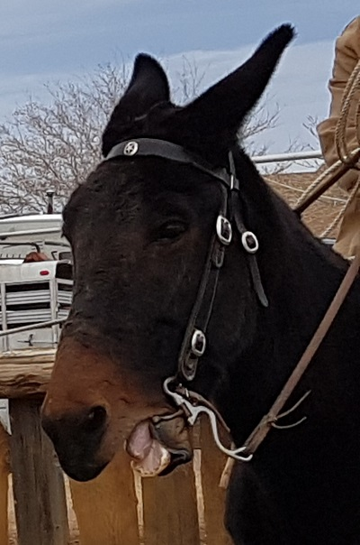
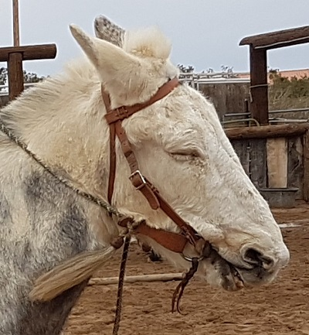
Use common sense when tacking up your animals, If they are distressed, sore, grumpy, unwilling or displaying other unwanted behavior, first have a real good long look at the tack you are using. The only way they can ‘’speak’’ to us is by their actions, so listen to what they are saying by their attitude under saddle, packsaddle or harness. If you take the time to learn how to properly fit tack to your animals, you will be rewarded with safer, happier and more efficient partners that can do their jobs without unnecessary discomfort, interference or pain. You owe them that!

