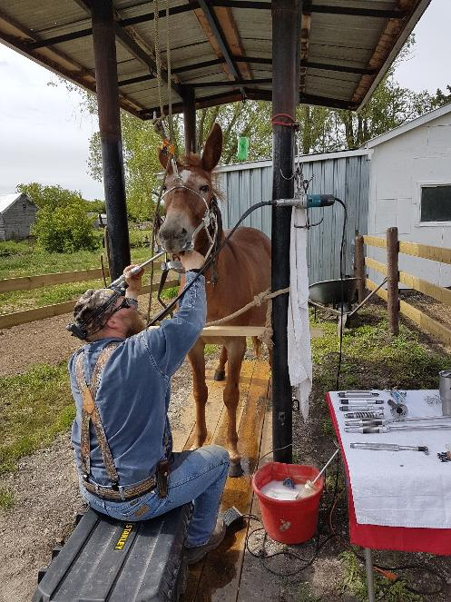
DENTAL CARE FOR DONKEYS, MULES & HORSES
by Marlene Quiring
Much of the information in this article comes as a result of the knowledge I’ve gained over the years by observing Certified Advanced Equine Dentist, Grant Mackinnon. MacKinnon is a certified graduate of the Academy of Equine Dentistry for better than twenty years now and is proud of the intense participative efforts he’s taken to develop the Canadian Association of Equine Dental Practitioners. Grant and his wife travel across Saskatchewan and Alberta providing professional dental services to their client’s (donkeys, mules, horses, ponies, miniatures, drafts, all their crosses and everything in between). You can read more about Grant on his website www.mackinnonequineservices.com.
In my opinion, Grant has done amazing work on our mules and of course all the other horses and donkeys I've watched him balance through the years. I’ve come to learn that equine, more than not, experience great discomfort when their incisors and molars are not balanced. This incisor/molar relationship influences not only comfort but rideability and soundness as well as their overall health. Therefore, even the slightest imbalances can cause a mule, horse or donkey to rebel and eventually exhibit various kinds of negative behaviors from such discomfort.
In my many years of breeding, raising, handling mules and working with horses, donkeys and mules all too often handlers assume that an animal's poor attitude has no cause and resort to disciplining or restraining them with confining gadgets such as tightly fitted nosebands, tie-downs, harsher bits, alongside harsher training methods. MacKinnon strongly believes that if the cause of the behavior was attended to, the behavior influenced by pain and discomfort is often removed. Needless to say animals like us, usually have a good reason for their actions, both good and bad. Donkeys and mules can be very stoic about showing pain, so realizing that they are in distress can be an additional challenge.
Unlike human teeth, equine teeth are constantly erupting and designed to evenly wear when grazing every bite of food they take in. It's when they deviate from grazing for a living when provided hay, oats or pellets, which initiate nipping imbalances. Nipping is therefore not required, while the molars continue to chew food provided them. An equine’s dentition works like this: as grasses grow, silica is brought up into the blades for the plant from the earth. When animals nip, very small particles of tooth are abraded against these minerals and coarse grasses. The tongue then brings the fodder into the chewing teeth, designed to pulverize the material fine enough for the gut to break it down for the body to use. Molars work like a millstone and similarly, grind away very small particles of its surface in the process, giving way for the reserve tooth to move into place.
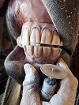
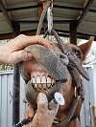
Nature efficiently manages on its own when Equidae (known as the horse family) are given an opportunity to wander through the vast and harshest wilderness. The mere act of domestication imposes dental abnormalities on all stock. Fencing alone is the most damaging influence on the overall health of our equine companions by restricting their travel. Which is why this knowledge is important to pass on to even the most passive animal owner. We should all be interested in understanding WHY it’s important to properly take care for their feet, teeth and complete nutritional requirements.

The incisors are carefully balanced with the use of a dremel. With the incisors balanced first, it is easier to address problems with the rest of the mouth.

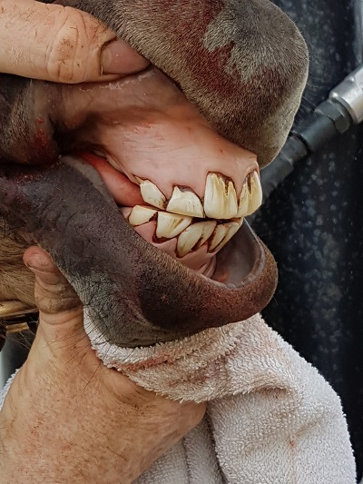
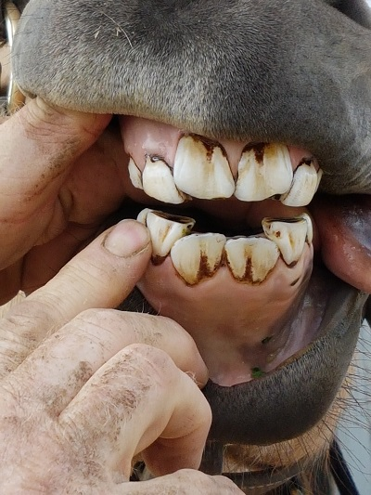
The photo on the left is a mouth of a youngster with adult central incisors trying to fit into a mouth full of baby teeth. McKinnon balanced the front incisors first and then the back molars, also removing several sticky caps. The next photo shows the mouth balanced which will make nipping at grass much easier resulting in needed weight gain of this particular youngster.
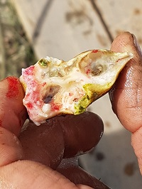

This is a cap removed from the molars of the young equine. It was just one of several that had not fallen out and compromised this young ones chewing.
Horses, mules and donkeys experience a variety of dental challenges throughout their life which is why they should be addressed regularly. Problems can occur at every age so their teeth should be checked at least yearly. Equines under the age of six need to be seen every six months since their teeth are maturing quickly. Teeth are fully grown by approximately 5 yrs. of age, (front teeth are approx. 4" long) (back teeth are approx. 5" long) they erupt or "grow" at 1/8" (3mm) a year (average). MacKinnon always says, “Teeth always seek opposition! Ideally, they find that opposition in the middle. Dentistry labors to facilitate that ideal opposition.” Equines have 24 baby teeth that are replaced with permanent. Equines have 12 permanent teeth not preceded by baby teeth. In young stock, teeth shedding deciduous teeth (caps) can cause problems by not dropping out and remain sitting on top of permanent teeth. This can result in uneven chewing across the entire arcade surface.
Horses, mules and donkeys engaged in an intense training or show schedules should be checked quarterly. Why does intense use cause concern for the dental professional? In order for the horse to masticate its fodder efficiently the jaw needs to be able to move in all six directions or combinations thereof comfortably (forward, backward, side to side, up and down). Since the teeth are dynamic (always in motion), this free movement of the jaw, plays much more of an important role in the body’s ability to freely move. MacKinnon will quickly tell you that teeth are one reason why a horse’s movement becomes restricted, lead change difficulties, breaking patterns, bolting through barriers, unable to get their hip underneath them; to name a few.
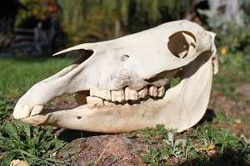
Did you know that the jaw of the horse moves just before the horse does? This is called the biomechanics of the horse's mouth which causes the teeth to come together when it begins to move. When the teeth are at certain and specific angles (properly balanced), the jaw is free to move in every direction. Any distortion in the level or angle impedes movement. To maintain those certain and specific angles allows for functional efficient mastication. Any distortion in the level or angle invokes compensation by the rest of the body. The jaw must move: forward to stop; forward to backup; forward to collect; forward and to the direction of turn, (to turn right or left); and the jaw must move backward to extend. In short, forward for flexion; backward for extension. Riding or (any kind of movement) requires both, a free fluent and fluid jaw. Movement of the jaw is critical for all aspects of riding and masticating. Dentistry is literally a “combination of geometric equation” of angles and levels that must be maintained to continue to function correctly.
The skull shows a clear view of wavy molars. Waves and sharp edges on the outside top molars can cut cheeks and sharp points on the inside of the lower molars will lacerate the tongue.

A qualified Equine Dentist should balance the incisors to the molars as well as attend to other abnormalities so eating can return to normal. When dental assessments are performed, what is generally missed is that which is unknown by many; incisors must be a part of the dental equation. The mouth cannot be properly balanced by ignoring the incisors. When the stock is able to properly process their food, it affects everything from stronger hooves and better resistance to illnesses right to the end of having a longer lifespan.
Variations of each arcade (row of teeth) are continually changing their shape, as the teeth erupt throughout their life. Understandably, they are only fitted at birth with three deciduous molars. The fourth permanent molars meet and grind at 2 years of age, making it the oldest tooth in the mouth. The first molars won’t meet until 3 years of age, the second molars meet at 3½ years, the third molars meet at 4 years, the fifth molars meet at 3 years and the sixth molars meet at 4 years of age. It is therefore easy to understand why waves in the molar arcades are routinely observed when the row of molars include so many teeth of different ages. For that matter this conclusion applies to the incisor arcades as well. (Note: teeth become harder as they age.) The molars uneven wear is largely due to the failing movement of deciduous teeth, growth and wear patterns along with variable density of teeth that meet and grind. Waves, protuberants and sharp edges regularly form that need to be shaped.
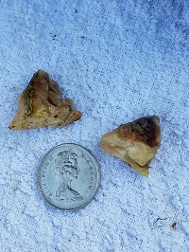
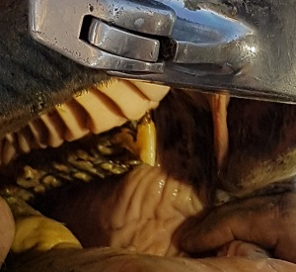
Hooks in the mouth once levelled and the size of them comparted to a quarter.

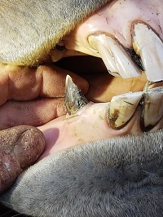
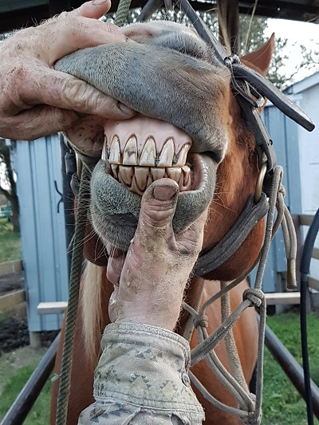
Older equine need extra attention to their teeth, as they are more prone to overgrown or brittle teeth. Over-worn teeth require supplemental feed, minerals and vitamins. Donkeys and mule's teeth do seem to wear better and last longer than horse's teeth, probably one of the reasons they live longer lives. A mentor of mine once said, ‘‘Equines don't die of old age, but of bad teeth.'' The more I learn, I believe that there is a lot of truth to that!
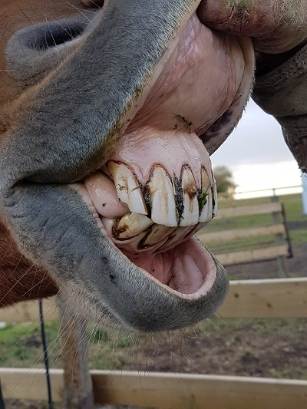
Photos above are of an aged horse with overgrown incisors and sharp bridle teeth, now given a new lease on life with his incisors and molars balanced and sharp bridle teeth ground down.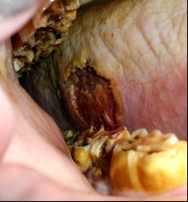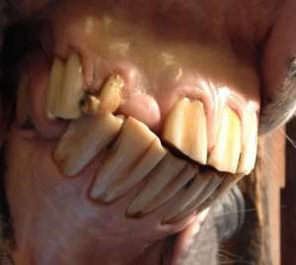
Photos above show how the sharp points on the sides of the molars can easily damage soft cheek tissue. The next photo shows extremely long incisors with an injury which has displaced the upper teeth.
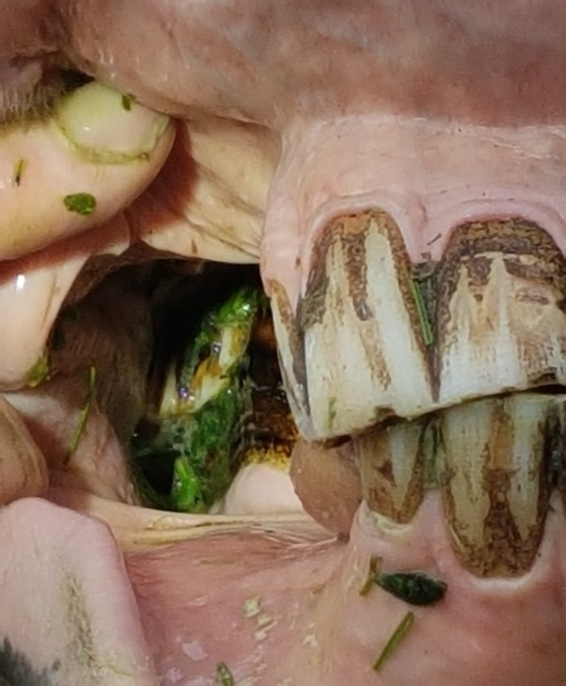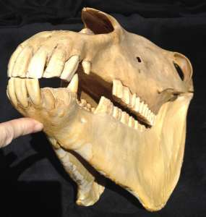
The photo on the left shows an equine with a significant wedge on the incisors and a huge hook on the back teeth. Both will have severe limitations to the free movement of the jaw and therefore the free movement of the feet. Grant was able to bring this mouth into balance. The photo of the equine skull shows how the overgrown incisors hold the back teeth apart and it also shows how the upper molars sit wider than the bottom molars.
To find a certified equine dentist contact the Canadian Association of Equine Dental Practitioners (306-747-2759 or www.caedp.org); International Association of Equine Dentistry (https://iaedonline.com/), or Equine Dental Providers of America ([http://www.equine-dental-providers-of-america.org)]http://www.equine-dental-providers-of-america.org)
www.mackinnonequineservices.com

