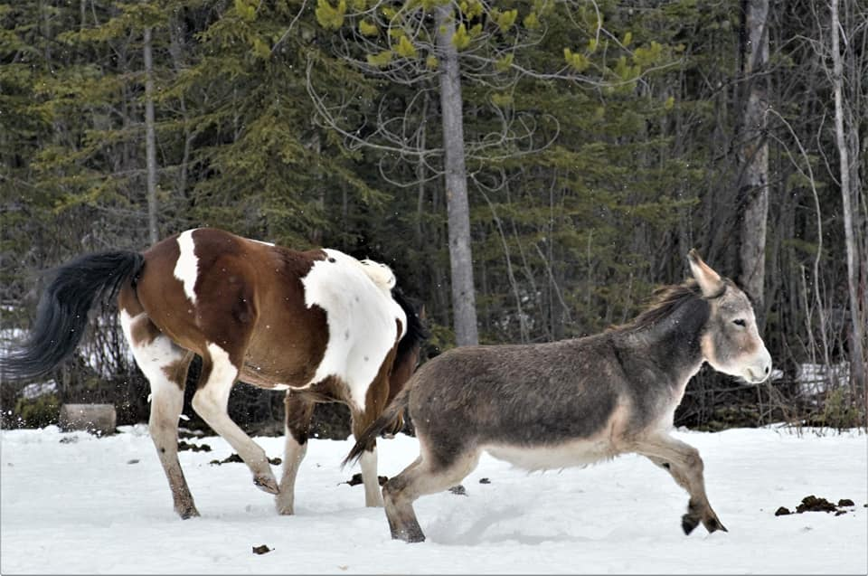
DIFFERENCES BETWEEN DONKEYS AND HORSES
EARS –The long ears of the donkey, which are well supplied with blood vessels, are a desert adaptation for cooling the body.
EYES – The larger eyes of the donkey gives him a wider field of vision than the horse.
TAIL - The unusual tail with the tuft on the end is like that of a cow.
SPINAL COLUMN – The donkey, like the Arab horse, lacks the fifth lumbar vertebra in the spinal column.
HOOF – The donkey hoof is an upright, smaller, tougher and more elastic structure than the horse foot. Donkeys rarely need shoes.
COAT – The donkey is a desert animal. Even though his coat is longer and coarser than that of the horse, he does not have the protective undercoat of the horse. The donkey can catch cold more quickly and needs protection in our cold climate.
VOICE – The distinctive bray.
LONGEVITY – The donkey life span is 30 to 50 years, generally greater than that of the horse. Miniature and Mammoth donkeys do no live as long as standard donkeys.
• The angle of the larynx at the back of the throat (top of the trachea) of the donkey is different than in horses, and donkeys have a pharyngeal diverticulum (pocket) in their throat, excess tissue in their pharynx, and elongated laryngeal saccules (part of the airway that aids in vocalization).
• Nasal intubation also is more challenging because donkeys have narrower nasal passages than horses
• Donkeys tend to grow longer, coarser coats that lack the protective undercoat that horses have in the winter. The coat does not provide the protection needed during periods of weather extremes (colder and wet weather).
• An obscured jugular furrow (the place where blood samples are taken or tranquilizers are given). The cutaneous coli muscle is much thicker than in the horse and hides the middle third of the jugular vein. It is easier to find the upper third of the jugular.
• The nasolacrimal duct of the donkey is located on the flare of the nostril rather than the floor of the nostril as it is in the horse.
• Some medication can produce complications such as breathing in donkeys
• Higher doses (typically 1.5 times the horse dose) of a number of drugs are needed in donkeys. An exception is guaifenesin (a centrally acting muscle relaxant). Horse doses of this drug in donkeys can cause respiratory arrest.
• Lungworms are reported to be more common in donkeys than horses

