PART SIX of Appropriate Tack and Fit for Mules, Horses & Donkeys
By Marlene Quiring
PACK SADDLE FIT
Packsaddle fit should be no different than fitting a saddle tree; in fact it should be much easier as the bare tree can be checked for fit without blankets or pads at any time. All that has been previously written in the preceding articles regarding fitting a saddle tree applies to fitting a pack saddle.
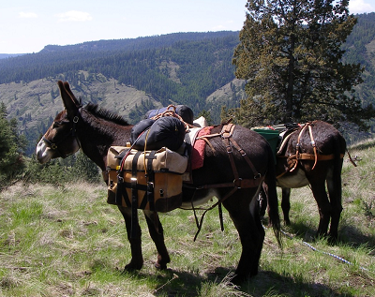
If you purchase a wooden sawbuck saddle then you must rasp the wood to fit your animal’s back. Again you must be sure that the width of the tree fits your animal and that the angle is correct. Good pack animals always have their own individually fitted saddles.
By now, you should realize that the shape of the tree should mirror the shape of the pack animal’s back, with no pressure points but even distribution throughout the bars. Unfortunately, people don’t always consider this and will use any packsaddle on any animal not understanding that without individual fitting, they limit the animal’s ability to work by forcing it to accept an ill-fitting saddle. Behavioral problems with a pack animal are often directly linked to bad fitting tack.
It is also easier to make sure that the packsaddle is set far enough back so that the front edge of the tree is out of the way of the animal’s front shoulder. This is especially important because when he turns, he will shorten the side of himself that he is turning into, so there must be allowance for no interference from the tree.
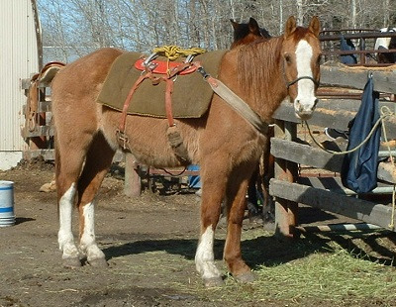
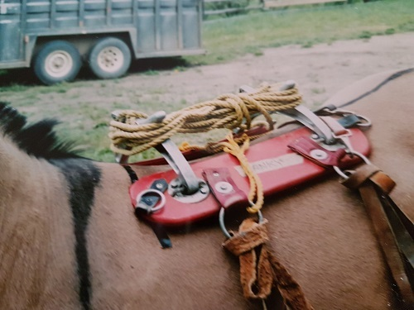
Here we see an adjustable [angles] pack saddle, with wooden bars. This was called a pack saddle for mules but as you can see these bars are much too flat for this mule. It is sitting too far forward and it actually needs to be pulled back several inches from the black tape [ marking the shoulder blade]in order to not interfere with the mules movement. Even set back it would not be a good fit. This pack saddle did fit a specific mule, but not this one. The name of the mule it fit went with the saddle. Besides this saddle being placed too far ahead, it would take a lot of rasping and adding on to make the bars fit this mule. For starters, this mule needs a tree with some belly in it.
The packsaddle pad should be at least 1’’ thick of a good material and of a larger size than a regular saddle blanket. The pad needs to give more protection from objects being carried and should have long enough sides so that your front and back cinch rings set on the pad and not against the animal’s hide [unlike in this photo] Many packers make their own pack saddle blankets, as large enough pads are not always easy to find. The cinches on a pack saddle should be wide so as to distribute the pressure. Different areas of the country use different riggings. We like a double rigging with the back cinch placed way back so that it fits behind the belly of the animal. We ride our saddle mules with the back cinch in the same position. With a little desensitizing, it doesn’t take long for the animals to get use to a tight back cinch in this area.
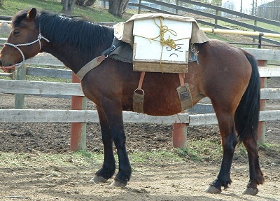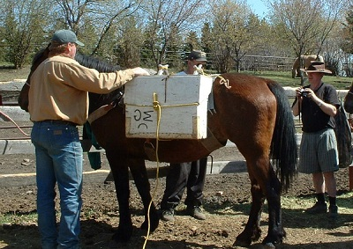
The above photos show a pack horse with good distribution of cinches and a breast collar that sits above the horse’s point of shoulder. However the saddle blanket needs to be much larger to provide cushioning under the cinch rings and also to protect the horse from the edges of the box. Usually a britchen is also added to help keep the load from moving ahead when going downhill.
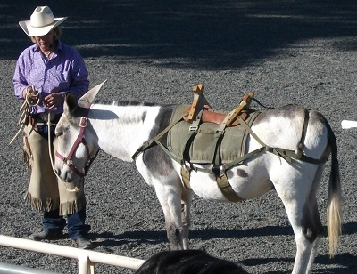
This donkey has a wooden pack saddle. It is hard to access the fit of it without a closer check. The cinches are in decent positions; however the breast collar is much too narrow and also appears to be much too tight. The britchen is also too narrow although it is positioned well. Both however would need to be changed in order for the donkey to comfortably carry a pack in any challenging terrain.

SADDLE FIT FOR DONKEYS
There has been very little attention paid to fitting saddle trees to donkey backs. As with packsaddles or saddletree fitting all of the same principles apply as detailed in previous articles. When you study a donkey’s back, you will notice the differences as compared to a horse. Imagine that saddle that fits your horse being strapped on to your donkey and expecting it to be comfortable for your donkey. The tree in the saddle will likely not ‘’mirror’’ his back but instead create pressure points which will cause your donkey discomfort as instead of your weight being distributed evenly over the surface of the bars of the tree, it will be concentrated in a few spots. Sometimes that can be only on a few square inches and likely on each side of the middle of his back where the horse tree will have more belly. Imagine yourself having to carry around 150 pounds of weight, 75 pounds of pressure on 2 square inches on each side. Every wonder why your donkey wants to misbehave or buck when you ride him too long or ask him to lope? It could be a very real matter of pain.
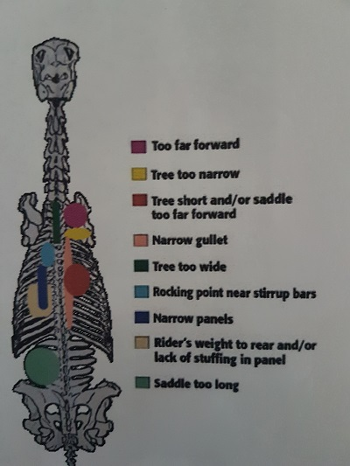
The diagram here is color coded to help show you where the pressure points will affect the back relating to specific problems in a saddle that is not fitting the donkey, mule or horses back.

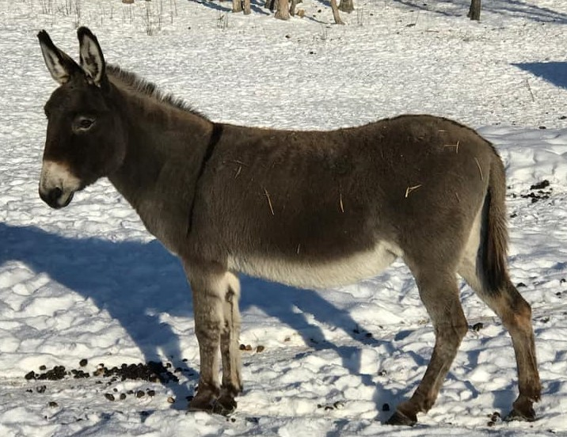
Donkeys will have even flatter backs then mules and less wither, but they do tend to have more ‘’level’’ back conformation which can sometimes cause the saddle to move forward or back, thus making a breast collar and a crupper or a britchen even more necessary to prevent the saddle from sliding around. The addition of a snug string or mohair back cinch catching their belly will also help keep the saddle in position.

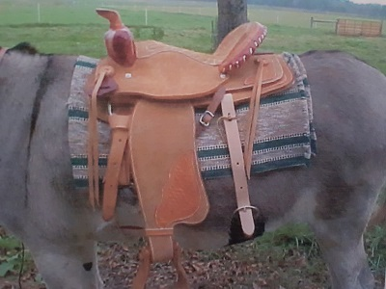
The saddle in this photo appears to be a decent fit. It is well behind the donkey’s shoulder blade and the full double rigging on it is well positioned with lots of elbow room by the front cinch and a snug back cinch that captures the donkey’s belly. Notice how level the donkeys back runs from the croup to the wither.
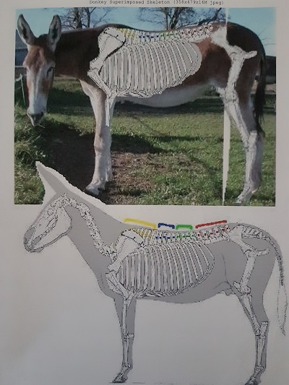
There are definitely some saddles with mule trees that will fit some donkeys. But remember mule trees vary in size and shape also, so make sure you fit a saddle to your donkey before investing in it. If your only choice for now it to get by with a ‘’horse’’ saddle on your donkey, the best advice that I can give you is to place that saddle on your donkey’s back without a pad and really evaluate it for fit, reviewing the previous articles in this series regarding how to do this. Always make sure that you set the saddle several inches behind the donkey’s shoulder blades as opposed to setting your saddle too far forward. The blue and green lines on the donkeys back in the diagram are where your saddle should be centered. Determine where the bars of the saddle are touching and where they are not. Then make the adjustments in your tree or in your padding to compensate for the lack of fit of the saddle. As long as you are not spending long hours in the saddle, you might find your adjustments work well enough for you and your donkey.
NEXT UP – Part 7: Bits and Bridles

