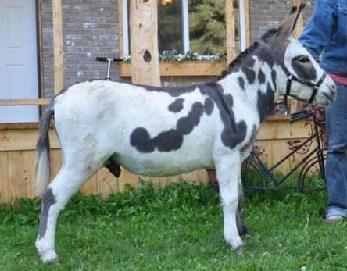
TO GELD OR NOT TO GELD?
By Deborrah L. Maywood
I am sorry if this sounds a little harsh, or if I hurt someone’s feeling or upset them, but this needs to be said, as it could save a lot of heartache, injuries & so forth. And I have seen too many people complaining about the same thing over & over again.
When it comes to having a Jack [intact] donkey, you need to know what you are doing and getting into. Donkeys are excellent pets, therapy animals, companions, kids play mates, etc. But they NEED to be GELDED.
The only reason to have a donkey STILL intact is for the use of breeding. And not all studs make stud material. They need the proper conformation, health, disposition, etc.
Having a problem with them biting, kicking, etc. their other herd mates? Having a problem with unwanted pregnancies? Having a problem handling them? Having a problem when you go into their pen, during your monthly visit from Aunt Flow? Having a problem with their temperament? And so on, and so on.
Well guess what? It is because you obviously do not know enough about this incredible animal to know that they need to be gelded. It is unfair to everyone & other animals to keep them intact if not being used for what was intended. It is natural for them to behave this way; it is how the male species was created. To fight for the females, dominate them to breed, show their leadership towards the rest of the herd, and potentially hurt or kill anything that gets in their way of just doing what God created them to do. It is what nature intended, and it will be in their brains & thoughts until they are castrated.
You cannot blame the donkey, & it is unfair to them to live their life in isolation or to ship them off to be someone else’s problem.
My stud when not being used for breeding, was boarded off my property on a quarter section far away and spent most of the year with his buddies. (3 geldings & a flock of sheep). No females around for miles & miles. And when he was home breeding, he had a biting muzzle on. And guess what, I never had an issue, no injuries, no temperament problems, no hard of handling problems, no biting, no nothing. If you are not ready to make the commitment to do what is best for any animal - DO NOT GET THEM.
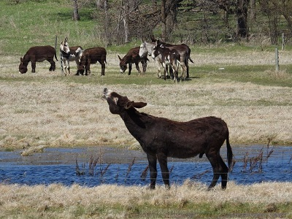
More on to Geld or not Geld a Donkey Jack
By Paulette Jacklin
If you are keeping an intact Jack only because you want to experience a baby you will need to have him castrated as soon as possible once you've been given the baby you've wanted. Intact jacks are nothing to play around with especially if you're new at this.
If you are thinking about becoming a breeder it is also a bad idea if you don't know donkeys very well and/or have never bred donkeys before. Somebody or something is going to get hurt.
Are you planning on keeping the baby forever once it's a grown adult? If not, there is no valid reason for any donkey owner to keep a whole jack or to breed donkeys in general. With so many donkeys losing their desert habitat and so many others waiting for adoptive homes in rescues, it simply doesn't make sense to breed more. If you really want a baby, contact a responsible breeder and then plan to keep that baby forever. Please don't pawn it off once it's outgrown its cuteness.
Many people have no idea how unpredictable and dangerous an intact jack can be. It’s not unusual to hear from an owner of an uncastrated jack ‘’I don’t know what came over him. He was always such a sweet, loveable guy!’’

