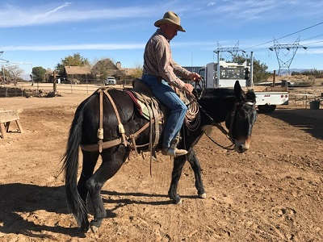
Teaching Left and Right Lateral Flexion and Why it’s Important
by Jerry Tindell
Left and right lateral flexion is very effective in keeping you safe in the arena and on the trail.This drill is an important step in gaining total body and mind control of your horse, mule or donkey. Practice it at a standstill first, and once you have both learned the lesson well you can progress to working on it at the walk, trot and later also the canter.
When mounted and using a well fitted bridle with a snaffle bit [no leverage], pick up your left rein, and ask your mount to flex to the left side and immediately release when they do, even if it is just a small try. If they move their body, keep your hold on the rein until their feet stop. When the feet stop, quietly and quickly release your rein which releases their face.
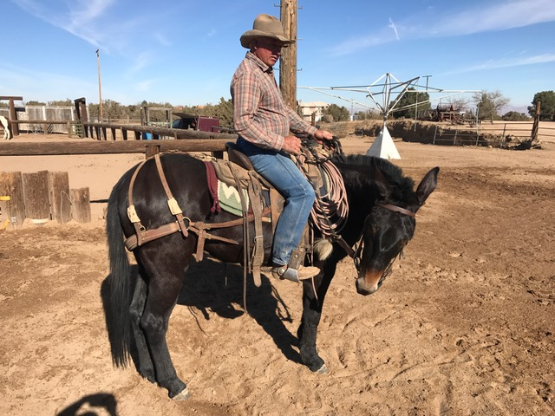
Once working reasonably well on the left side, move to the right side repeating the same sequence. Ask for some flexion from the pressure of the right rein and when you get some bend in his neck immediately release the pressure. Ask again this time with a little more flexion and build on that until you get a soft, easy response with no movement of the feet. You should also be bending your hip and your leg should be back, in the third position but with no pressure from it. Your leg is there but not asking for any movement at this time. The goal in this drill is to have your mule bending softly left and right at a standstill.
While teaching this there are some problems that can happen. The mule might get nervous or confused, throw his head, chop on the bit or move his feet, but if a rider will get him to learn to accept a nice quick release, pretty soon the mule waits on the release instead of pulling against the pressure. You must be careful to not release him when he moves his feet, but keep the pressure until his feet stop and then reward immediately with the release. You do not want to reward a negative response. The flexion must be a separate movement at this point from movement of their feet.
So first you both learn to succeed at this maneuver at a standstill with flexion left and right and then you will learn to add the control of the hindquarters. At this point your leg will be in the back or third position but is neutral and not asking for hindquarter movement.
So here are some challenges of this drill. The rider must learn to apply each step and separate each step. When you are asking your mule for a soft bend laterally and they move their feet, don’t discourage the movement but don’t release it either. You must wait for the mule [and yourself] to separate these maneuvers.
For example the first movement is left flexion, you have your left leg back but you are not using it. Then you switch to right flexion, right leg back but again don’t use your leg. If you ask for flexion and your leg is back and they’re moving their feet and you didn’t request the feet, wait till the feet stop. The feet or the body should only move when you apply energy to an active leg. Right now the mule will likely make the mistake of moving because they don’t yet know how to stay.
In your contact you’re looking for lightness, not heaviness. You’re not looking for a huge degree of bend; you’re turning loose of the slightest try. Also make a note that you do not want to lean your body, you do not want to tip your mules outside ear to the ground while they are flexing. You want to keep their head fairly level. If a mule, horse or donkey pulls that outside ear to the ground it’s from a rider pulling for flexion but not allowing flexion to come through the mind and soft through the body.
If in the beginning the mule takes the rein back too quickly, I would turn loose and do the other side. And I would make a note that as they give, immediately release. Then give and hold two seconds and give. Then ask them to stay three seconds and so on. While you’re in the process of teaching them to wait, ask for seconds and give instead of trying to force them to hold for longer than they are able. Build on that and then you can let them wait on you and then turn it loose.
Eventually they will hold that flexion as long as you ask it if you go through that process of letting them know they cannot take it back. I’m not real critical about that in the beginning because they can’t hold it. If you go to holding too long you build brace in the neck so let go and do the other side. Pretty soon they will stay longer anyway because of your releases. So eventually they get the soft feel more instilled in their mind.
You may need to recognize when a horse or mule is testing you. A mule that been ridden that has a bad habit of pulling on the reins I would make wait a few seconds before I let him go. Remember we want to gain ground in everything we do.
Pretty soon you’ll have the mind soft if you work at this drill as I’ve described. And you don’t ever want to discipline the mule for wanting the release, but you do want to teach him to wait on you.
You don’t want to fix the problem, because that’s not what the mule is dealing with; the mule has been taught to pull back quickly or to not wait.
Once you have accomplished the flexion drill, now you’re ready to add the second component which is movement of the hind quarters. Picking up on your left rein, ask for soft flexion to the left and using pressure from your left leg, ask him to roll the hindquarters to the right. When the hindquarters move, release your leg, hold the rein to softness, and let the rein go once they don’t push on the bit. With your leg off, let the feet stop while still holding the flexed rein. When they stop the feet, release the rein.
For either flexion, position your same leg back but don’t use it. When the neck is soft apply the leg, roll the hindquarters away, take the leg away, let the hindquarters stop, let the face get off of the bit and release.
In this drill you end up teaching body control in its very early phases. You teach them to give to your hand laterally, you teach them to be soft to the bit, you teach and introduce the first part of your leg yield which is moving the hindquarters from that bend in the body.
Remember if you start holding the mule he’s going to get heavy and lean; his feet get heavy and then he’s using his body to hold onto you instead of the soft releases we are trying to build. Wait on the try. When I know a mule is going to take it back, I let go first. I wouldn’t let him learn to lean on me holding it.
A person makes a mistake if they let the mule drag the rein through their hand. We don’t want them to pull any resistance so we’ve got to let go of the freedom. So I let go so they can’t learn to pull on me. And in the very beginning, that’s just timing.
You can use your leg to help him move that rib a little bit and also soften the neck. A horse or mule that’s real bad to give laterally, I always tickle them with my leg, and they’ll give to my hand through the help of my leg.
Once you master this drill so the responses become easy and automatic, you will also be able to use it to control the mule’s mind and body while moving forward at a high rate of speed. It’s easy, its’ safe and it’s so effective.
The benefits and necessity of this control; flexibility, the one rein control and controlling the feet comes in two forms. All three animals the horse, the mule, and the donkey come by this naturally. They have two body shapes.
Body shape’’ A’’ is flexible, soft, safe and secure. Positon ‘’B’ is straight, protective, stiff, defensive and always self-preserving. Either position can happen anytime in their world and anytime in the world of their herd. Body shape A and B can happen in a moment’s notice. Position A can be first or B can be first. They can turn that switch at any time. That’s the reason for the necessity of this flex drill that I do for the body and for the feet. Both position A and B are normal and good for the stock.
Flexibility while being soft and safe is also good for the human. The stock is in their best mind when they are flexed, soft and have self-control. They can do this drill naturally but we need to learn to ask them for it. I teach myself how to achieve posture A, which is flexible, soft, and secure.
I teach this in three steps or areas. First I want then to be in a controlled quiet environment where we can work on these drills without anything bothering them. The second step that I teach is practicing the drill when they’re distracted such as something new in the arena or on the trail.
When they get really good at giving to my hand, and they move off of my leg and move their feet, keeping their body flexed, that’s the most vulnerable space they can get into. It’s the most secure place that we can teach so the beauty about this drill is when they are bent and flexible and still get to move their feet they can be so confident and controlled even if they’re a little bit upset, nervous or spooky.
So after they are controlled and quiet even when distracted then I work on the drill in situations where they think they can’t! If you don’t work on generating this type of maneuver when they feel in a threatening situation, they will lift their head, straighten their body, power their feet and maybe bolt or do whatever they might feel is necessary to be self-preserving.
We see it a lot on trail rides when someone is having trouble and their animal might bolt or spook and take off and cause others in the herd to react negatively also. So we want to be able to fix that before we need it. We want to be early. We want to have done our homework and be prepared.
This drill when well learned to achieve a soft and secure response, with softly giving to the bit, moving off the leg and being able to stop, can put the stock into neutral. Flexibility in the neck and moving off the hindquarters are all related.
When the mind gets troubled the body gets powerful and straight and they load the feet. They can have negative reactions from a preservation instinct or just from habit. This is not the response you want, thus train for response A, which will keep you and your stock safe when it really counts!
I hope this helps you to break down and learn this drill and how important it is to your safety. It’s not that complicated. It takes a little while to teach in the sequence of the releases and when to let go. It takes a little practice in timing, rein length and position of your leg, but it’s the most important drill that I think we can do.
Let me know what you need and we’ll be hoping to see ya soon!
Jerry Tindell of Tindell’s Horse and Mule School is a professional horse and mule trainer from California. He has been training and shoeing horses and mules since 1971. His unique training abilities help mule owners understand and apply proven techniques to communicate in a soft, safe, and secure manner with their animals. He offers private lessons, stock analysis, and problem solving seminars and instructs Colt Starting, Riding, Driving, Packing and other clinics in the U.S. and Canada. He has worked successfully with all breeds of horses including mustangs but his main passion is for mules. His on Line Training program and more is offered at www.jerrytindell.com.

