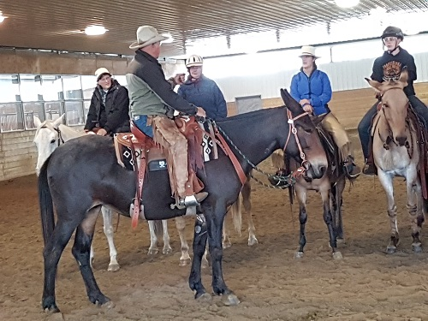
SADDLE MULE CONFORMATION
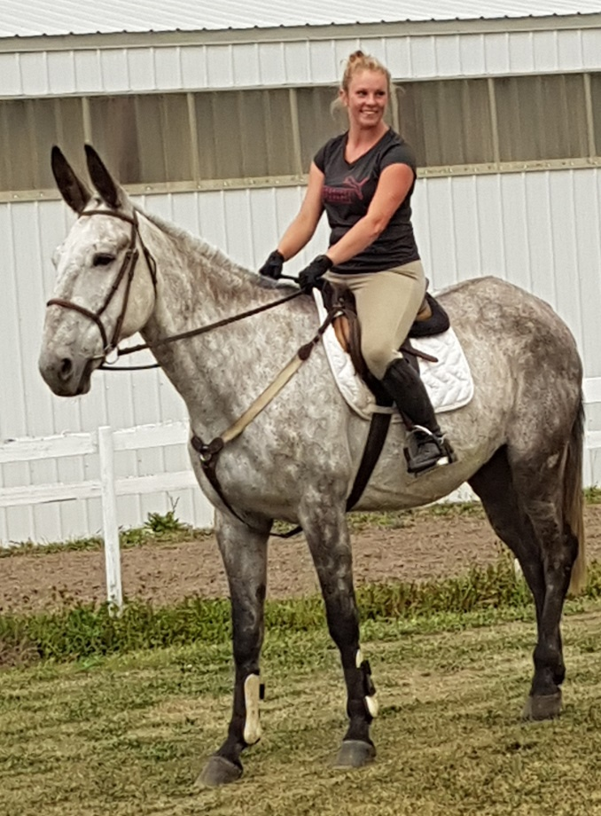
Over many centuries, conformation standards have been carefully worked out for the horse. This is primarily due to the fact that the horse is a riding as well as a draft animal, and has been considered an ’’aristocratic’’ subject of study. We shall attempt to show here some of the results of the study of proper conformation for the mule, and since the saddle mule has had the least attention over the years, we will pay primary attention to this type of animal. Before considering the question of conformation, that is the physical build of the animal, we must note one very important thing. There is a great difference between the concepts of GENERAL CONFORMATION and BREED TYPE. For instance, the general conformation of a good riding horse is the same, no matter what the breed, and basic conformation faults are the same in all equines, and all breeds or types. On this set of general rules, the special qualifications of the breed are imposed.
There is a great deal of difference in the looks of the ideal quarter horse and the ideal Arabian, yet these differences are in BREED TYPE. As with horses, two mules may look entirely different, yet both be well conformed animals, the differences simply individual type. When judging conformation in relation to type it is important to note that the animal is WELL BALANCED. This is, the legs are in proper proportion to the body in length and thickness of bone, the neck is in proportion in thickness and length and the head in size etc. A list of the points of conformation will be useful. The more closely the mule follows the basic ideal conformation standards of the riding horse, the better saddle mule he will be.
THE FOOT: Outline of bearing surface almost round, large enough to properly support the mule. Allowed to be narrower and slightly more upright than the perfect horse foot, but must be sound and tough and large enough to be in proper proportion to the animal. Hind somewhat smaller than fore and more oval in shape. Horny wall should be smooth, dense, and tough, and approximately twice as high in front as at the heel. This proportion is proper for horses, but heels are allowed to be higher in mules, as donkey feet are boxier with higher heels. The frog should be tough, elastic, large and on the ground. Heels should be broad in keeping with the foot and well separated by the frog.
THE PASTERN: Clean cut and wide from front to rear and thick from side to side. When these two dimensions are large the bone and ligaments are well developed and strong. However the pastern should not be coarse, rather clean cut and strong looking. The pastern should be of medium length. A short, stubby pastern will give a jolting ride [less in mules than horses], whereas a long pastern lacks spring and strength and the mule may break down under hard riding. The slope should be approximately 60 degrees with the horizontal in front and 65 degrees in the hind pastern.
FETLOCK JOINT: Clean cut, well defined and thick from side to side. Wide from front to rear. If both pasterns are thick and wide and devoid of puffiness or coarseness, it is evident that there are big, clean bones at the heads of the pasterns. Likewise it indicates that the tendons and sesamoid bones are well developed and strong. A coat of fine hair indicates good breeding, and clean cut definition reveals lack of wear and tear and indicates good quality of bone.
THE CANNON: Relatively short when compared to length of the forearm, but not excessively so. Wide from front to rear. Dense, clean cut and well defined and vertical when viewed from any direction. Thick from side to side when seen from the front. The tendons considered separately from the bone should be large, well defined, clean cut and well detached from the cannon bone. The total width of the cannon and tendons should be the same from just below the knee to just above the fetlock. Size should be in proportion to type of animal. Cannons lacking width are a serious defect.
SET OF FRONT LEGS: Front legs should be straight when seen from the front. Feet should not be too close, far apart or splayed.
THE KNEE: Well defined with all bony prominences revealed in a clean cut manner. Thick when viewed from front, wide from front to rear. The direction of forearm, knee and cannon should be vertical when viewed from either front or side.
THE FOREARM: Long, wide, thick, well directed and muscular.
THE ELBOW: Prominent, standing well away from chest, not deviated outward or too close.
THE ARM: Long, upright and muscular, the humerus should be hidden by powerful muscles.
THE SHOULDER: Oblique as possible, donkeys usually have straight shoulders and pass this on to mules. Long, flat, blending into the neck with no bulging outward at the point of the shoulder. The spine of the shoulder blade can always be felt and provides the true slope.
THE HOCK: Wide and thick. Clean cut with normal bony prominences well defined. Dense and powerful, appearing with a large open angle of about 160 degrees at the front face when seen from side. Width and thickness mean strength and power, while well defined, clean cut bones make good lever arms and points of attachment for muscles and tendons. In a well directed leg, a perpendicular line, dropped from the point of the buttock should pass one or two inches to the rear of the hock and be parallel to the back line of the cannon.
THE LEG: The leg proper is formed by the tibia and peroneus and slopes downward and backward connecting the stifle and hock joints. The baskin, corresponding to the calf of the leg in man, is the most important part of the thigh and should show great muscular development.
THE STIFLE: Set close to abdomen, turned slightly outward, well developed and prominent. Be sure it is sound and not ‘’slipped.’’
THE THIGH: Upright, approaching the perpendicular, long and well covered with muscle. Wide from stifle joint to the point below the buttock which is farthest to the rear when viewed from the side. Thick when viewed from the rear as a result of well developed muscles.
THE CROUP: Long, approaching the horizontal, wide, muscular and thick. THE APPARENT LENGTH OF THE CROUP IS MEASURED FROM THE POINT OF THE HIP TO THE POINT OF THE BUTTOCK…NOT at the top of the croup from the top of the hip to the tail set. A mule with a short appearing and sloping croup often has, in reality a long ischium and ilium bone combination which gives a long croup in reality if not in appearance. In this case the croup is properly strong and the objection is aesthetic only.
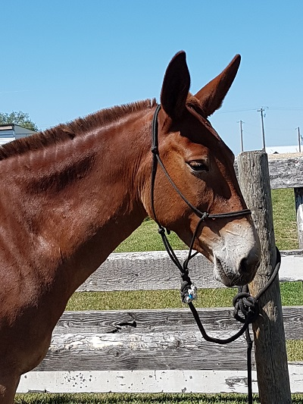
HEAD AND NECK: Forehead broad and flat, eyes mobile, clear, prominent and set well apart, large and mild appearing. Ears fine and in proportion to the animal, long, upright, clean cut and alert, the badge of a well bred mule. Front line of face straight or slightly ‘’roman’’ depending on your own preference. Facial bones should be clean cut and easily seen, hair should be fine, the nostrils large and lips firm. The lower jaws should be separated toward the neck, allowing ample room for the windpipe. The bars of the mouth should be sensitive. If too thin and knifelike they will be too delicate if the animal is not ridden with utmost care. Teeth should be in good condition. NECK should be in proportion to the body, as long as possible, clean cut, muscular and tapering toward the jawbones. A heavy thick neck may indicate an animal with such strength as to become unmanageable if treated improperly. Many mules have this type of neck which is not necessarily a fault in a chunky, heavy set mule, but a long fine neck is a necessity for a really good reining mount. A concave or ewe neck denotes weakness and is ugly.
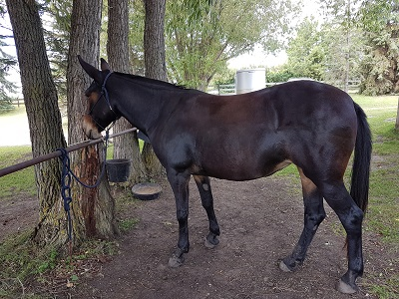
THE WITHERS: The withers should be as high and run as far back as possible. For this reason, mares chosen to produce saddle mules should have very good withers. Since the jack has almost no withers, low or rounded withers are common in mules.
TOPLINE: The topline should dip gradually to the rear from the withers, and run gracefully into the back, thence it should continue almost horizontally through the loin to the point of the croup, then slope gracefully and not too steeply to the tail set. Length should be in proportion to the animal. A long back with SLACK LOINS is to be avoided. A very short back denotes little speed but is often common to good endurance.
THE CHEST: Deep and broad, ribs should arch outward to give proper breath and be long for good depth. Breast should be muscular, wide in proportion but not too wide or narrow.
