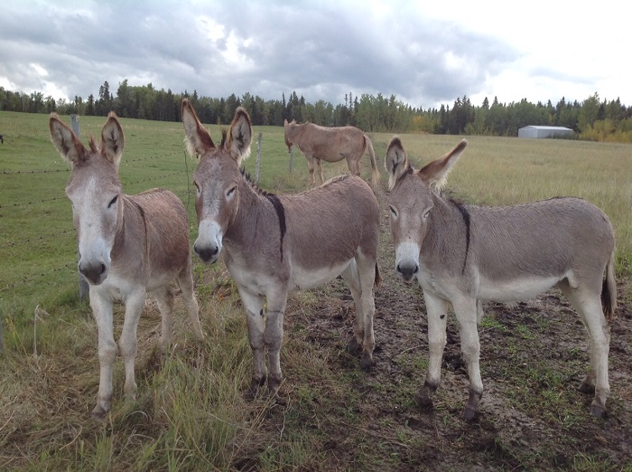
All About Donkeys
By Sue Ann Weaver
Ready to try something new? Something innovative? Something really different? Then why not add a new kind of equine to your stable this year?
Buy yourself a donkey and get ready for some fun. Just a few years ago, donkeys (also known as burros, asses, and mountain canaries) were kept mainly as family pets. Nowadays, folks of all ages ride and drive donkeys for pleasure and in competition. They show tiny Miniature Mediterranean donkeys and huge Mammoth jack stock. Some people take along a donkey friend when they go backpack camping and let the obliging brayer pack their gear.
In Colorado, people take things a bit farther with pack burro racing, a really grueling marathon run across rugged mountain terrain, each runner leading a fully loaded pack burro. Donkey fanciers also use their long eared buddies to breed mules and hinnies. And donkeys still make outstanding backyard pets--especially for equine aficionados whose means or facilities are too limited for horse keeping.
Donkeys come in many shapes and sizes. You say you're 5 feet 10 inches and weigh 200 pounds so no donkey on earth is big enough for you to ride? Not so. Or perhaps your argument is that you live in the suburbs and have no room for a donkey? Wrong again. Donkeys come in a size to fit every fancier and every need. The donkey most familiar to many people is the "standard". This is the amiable fellow commonly known as a "burro". Standard donkeys stand between 36.01 inches at the shoulder to 48 inches in height, a good size to make a handy driving animal or a safe, dependable mount for a child. These guys are the least expensive donkeys to buy and one of the least expensive to maintain. This is the size of the wild burros that one can adopt out of the west and these wild ones make good reliable pets soon after they are adopted and begin to be loved and petted by their families. Those who frequent petting zoos are likely to be familiar with the standard's cousin, the miniature donkey. Miniatures are 36 inches and less. Most of these tiny donkeys hailed from the Mediterranean area, mostly Sicily and Sardinia. At one time, miniature donkeys could only be had in the usual donkey color, Grey-dun (the mouse color that horsemen know as grulla, always with dorsal stripe and shoulder cross and sometimes with stripes on ears and legs). Nowadays miniature breeders offer animals in nearly all donkey colors, white, blacks, browns, chestnut and spotted. Miniature longears can be kept in small backyards and housing in bad weather can be 6 x 6 ft. box stall in the garage. Where zoning laws pose no problems a miniature donkey can be the ideal pet. Miniatures also make delightful driving animals and carts and harness and wagons can be bought for them scaled down to their size. Miniature donkeys even enjoy status as pack burros for their owner's camping ventures.
At the opposite end of the spectrum we find massive Mammoth jack stock donkeys. Mammoth jennets (females) stand 54 inches and above, and Mammoth jacks (jacks are ungelded males, few mammoths are castrated because of their monetary value, however a mammoth gelding could be ideal as a riding or driving animal for a larger individual) must be 14 hands, 56 inches tall. Many modern mammoth jacks are very tall standing from 15 to 16 hands. Mammoth jacks are also massive, weighing from 1,000 to 2,000 pounds. Thus, there are donkeys large enough for even the biggest and brawniest of men to ride. Mammoths are most generally used for breeding fine mules, and more mammoth jack stock. But more and more jack stock owners are also taking to the show ring, exhibiting in donkey pleasure, trail and harness classes. A mammoth jack, National Champion "Black Bart" appeared in exhibition at the 1984 Olympics harnessed to a pleasure cart. The desirable jack stock color in the past was black with white or silver hair on the muzzle, eye areas and underbelly. Blacks are still desired but so are chestnuts, and all the other donkey colors including spotted.
In between the standards and the mammoths, we find the regular riding-size longears, the "Large Standard" donkeys. Large standard jennets range from 48 at the withers to 53 inches. Large standard jacks and geldings from 48 to 56 inches (between standard and mammoth size in other words). The large standard is perhaps the most useful donkey of all. He can easily carry an adult, pull a cart, and pack a weighty load or even breed saddle mules or hinnies. Donkey show performance classes are filled with adults riding these intermediate size brayers both English and Western. For their size donkeys are strong and sturdy and have great weight-carrying ability.
The last donkey note is the American Spotted Ass. Several decades ago, the American Council of Spotted Asses was established to register and promote paint and leopard spotted donkeys. These colorful donks come in all sizes, miniature to mammoths, and can be double registered with the ACOSA and the American Donkey and Mule Society.
DONKEY CARE
If you know horses you already know how to care for a donkey. Treat him like a small, quiet natured horse and things will go smoothly. However, there are a few special concerns about donkey care that are worth noting. Donkeys do not require a lot of feed and certainly not a lot of high energy, heating feed if they are in good condition to start with. Go light on concentrates and legume hay. Despite what those good 'ol boys will tell you, donkeys can and do founder if overfed. Young donkeys are prone to the same leg problems that plague horse youngsters who are overfed on grain. Overweight donkeys tend to develop very unsightly "sausage roll" crests which tend to fall over and detract from a donkey's good looks. Donkeys that are allowed to get over weight are actually in very bad health and if their condition is not addressed, they are subject to early death. Feed your longears according to his size needs and the use you put him to.
Donkey feet are incredibly tough yet pliable and will not under normal domestic circumstances wear down or chip off like horse's hooves do. You will have to keep your don's feet properly trimmed, or he may develop "Sultan's slipper" feet. Donkeys need to be wormed and have the same injections as horses and if lung worms are a problem in your area, be sure to worm all donkeys with the Ivermectin wormers as they are particularly susceptible to lung worms.
If you decide to breed your donkey remember jennets have a longer gestation period than mares do. The normal span is 12 months, but donkeys have been known to carry their foals 13 months and still have a normal baby. BE SURE not to breed your jennet unless you have an assured home for the foal.
There is so much to learn about donkeys and their kind, and so much to do with them including the pure enjoyment of their personalities. So if you are an equine fan, try a donkey, you won't regret it!

