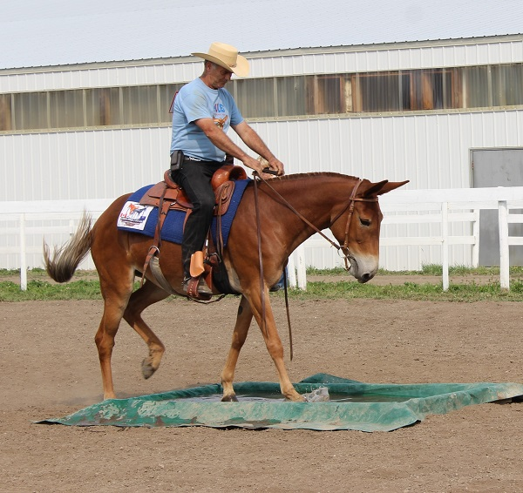
A VETERINARIAN SUGGESTS YOU RECONSIDER THE MULE
By Robert M. Miller, D.V.M.
Soundness, a trail-wise disposition, and sure-footedness in hazardous terrain make the mule an attractive mount for country horsemen.
The place is Bishop, California. Memorial Day weekend 1977. Mule Days. The three-day celebration, exclusively for mules, is in full swing. Warm sunshine and clear blue skies bless this town on the eastern slopes of the Sierra Nevada. Immediately to the west loom snow-topped peaks; the grandstand is packed with mule fanciers, curious horsemen, and bemused tourists. All through the day, and on through the evening, they watch the varied events.
There are chariot races, a mule parade, packing contest, jumping events, roping competition, driving and pulling contest, trail classes, reining classes, and many other horse show and rodeo events. All limited to mules. We see mules cutting cattle, roping steers, and bucking in the wild mule-packing contest. The mule’s range in size from miniature teams to draft mules with teams representing the western national parks. There’s also a hilarious braying contest – performed by humans; one lively contestant loses his false teeth in his enthusiasm.
And there are races. Mules run sprints ranging from 50 yards to a quarter mile, and races vary in length up to a mile. At the finish line five veterinarians inspect the winners. Although they are not designated race officials, their fascination is professional. They look at racing mules seven, eight, ten year of age; many have been racing since they were two. Some are entered in many events each day.
One mule runs several sprints and a mile race in a single day, in addition to barrel racing, stake racing, and a variety of regular show classes. Their legs are clean and sound, Not a splint or a windpuff can be seen. There isn’t a single big knee, a bucked shin, or an enlarged tendon. None are lame. Why? How do they stay sound?
Seeking answers, the veterinarians – all of whom are equine practitioners exposed daily to the tragedy of lameness in beautiful horses – look at the mules, run their hands down the tough little legs and wonder.
Recently, an older veterinarian mentioned to me that he was thinking of retiring. “What are you doing to do?” I asked. “Oh,” he said, “retire to my ranch and maybe raise mules.”
“Why Mules?” I asked, not mentioned my own interest in those hybrid creatures.
“Because they stay sound.” He explained.
The fact the mules usually stay sound probably explains the interest many veterinarians have in the animals. But there are other qualities that attract horsemen to mules, and one does not have to be a veterinarian to appreciate them. What Qualities? The beauty of the beast? Their noble heads? Not likely. There is little prestige in being mounted on a mule; one has to value the mule, and ignore the impressions of society.
My own interest in mules began several years ago when I asked a fellow equine practitioner why he was raising mules. “Well, after you’ve trail ridden a few good mules, you’ll prefer them to horses.”I snorted: “Come on now!”
My friend looked hurt. “Okay,” he said. “I’m going to loan you a good mule for a year, and you’ll see what happens.”
A couple of weeks later, he delivered a 27-year-old gelding named Jerry to my house.
Over the years I’ve had a bit of experience with mules. I packed salt on a mule one summer when I was cowboying. She was a perverse gray creature, and constantly led the horses over low spots in the pasture fence and over cattle guards. Later as a veterinarian I treated a couple dozen mules, usually anticipating great difficulty, but was usually pleasantly surprised at how well I got along with them.
Jerry taught me about mules. He took me up steep canyon walls. He taught me to respect his judgment. I learned that if he refused to cross a creek at a given point, it was because he had spotted a shallower place downstream. If he refused to slide down a shale slope to the bottom of a wash, it was because he had observed a game trail that was easier going a few yards ahead. I tested all the myths I had heard about mules on Jerry and learned they were not myths. After a 20-mile trail ride on a summer day, he refused to drink water for four hours – unlike a horse; an overheated mule will usually not founder himself by drinking too much water.
At 27 years of age, Jerry stayed fat on a minimum of good feed. He relished poison oak and chaparral. He never gets excited. His flinty feet never needed shoeing, at least not for the riding I was doing. Most remarkable of all, after a lifetime of matched racing, pulling a stagecoach, herding cattle, arena roping, and countless miles on the trail, he was still absolutely sound. He covered the miles in a smooth little running walk that never faltered.
Finally, I took him on a trail ride; sixty-five riders gathered one Saturday morning. Sixty-two were on horses representing almost every breed. Three of us were mounted on mules. It was hot, and our destination was a mountain peak, uphill all the way. We started out with most of the horses jigging with excitement and the three mules (a two year old molly, a three year old molly and old Jerry) placidly taking up the rear. Several hours later the three mules were up front, still patiently stepping out, sweating only behind their long ears, which paddled rhythmically in cadence with their feet. Behind us were 62 wrung-out and strung-out horses, lathered and heaving, the sweat pouring off their fetlocks in a steady stream.
That ride did it. My riding was now confined to trail riding, either alone or with a group. I had to have some mules, and I decided to raise my own. I started by breeding my wife’s fine Quarter mare (of racing lineage and schooled for dressage) to a jackass.
My current project has been greeted with some scorn, particularly from some of my clients who own good thoroughbreds, or Arabians, or other well-bred horses. Their contempt can’t be based on past poor performance by mules. After all. The record for high jumping was once set by a U.S. Army mule, and wasn’t the Bicentennial cross-country race won by a mule?
Perhaps it’s just that mules, despite their desirable qualities, suffer from a form of blind discrimination.
Mules are, of course, a hybrid creature; the sterile offspring of a mare and a jack- a male donkey. I believe that much of the mule’s fabled intelligence can be accounted for by virtue of his sire’s characteristics.
For example, horses when frightened will usually panic and flee blindly, often injuring themselves in the process. A frightened mule, on the other hand, will usually assess the situation, and avoid injuring himself. The first time a horse entangles himself in barbed wire; he will usually fight the wire and may inflict severe self-injury. By contrast, a mule enmeshed in wire will usually quietly wait for help. Why this difference?
The horse evolved on the open plains. When frightened, his best method of survival was instantaneous flight. The donkey, on the other hand, learned to survive in rocky and rugged terrain. Rash and hurried flight there, when frightened. would have meant death or serious injury; so the wild ass learned to first judge the situation and then react. In each case, nature equipped the species to respond in the best manner to insure survival.
Horses and asses have different chromosome counts, and a mule is a true genetic hybrid, not just a kind of long-eared horse. The equine-only endurance rides that prohibit the entry of mules are therefore biologically justified in their decision. A mule is only half-horse.
The hybridization not only explains the judgment and decision-making ability of the mule, but also accounts for his amazing strength and stamina. Hybrid vigor is a recognized characteristic, and examples abound in both a plant and animal kingdom.
As a horseman, I am attracted to the mule by his endurance, his smoothness of gait, his calmness his versatility, and his easy-keeping qualities.
As a Veterinarian, I am fascinated by the mule’s resistance to disease, his longevity, and his tendency toward soundness.
Most of all, as an amateur animal behavior scientist, I am intrigued by the personality of the beast. He does not respond blindly to training; he makes up his own mind. The mule is said to be unforgiving, and if abused will eventually settle the score with the person who hurt him. It’s a common saying when it comes to training. “Mules will separate the men from the boys.” Crude and quick techniques that often work on horses won’t always work on mules. I like that. If mules force us to use more patient and scientific horsemanship and fewer gimmicks, then I am all for them. Physically and psychologically, what we learn from mules will, I hope, benefit horses.

