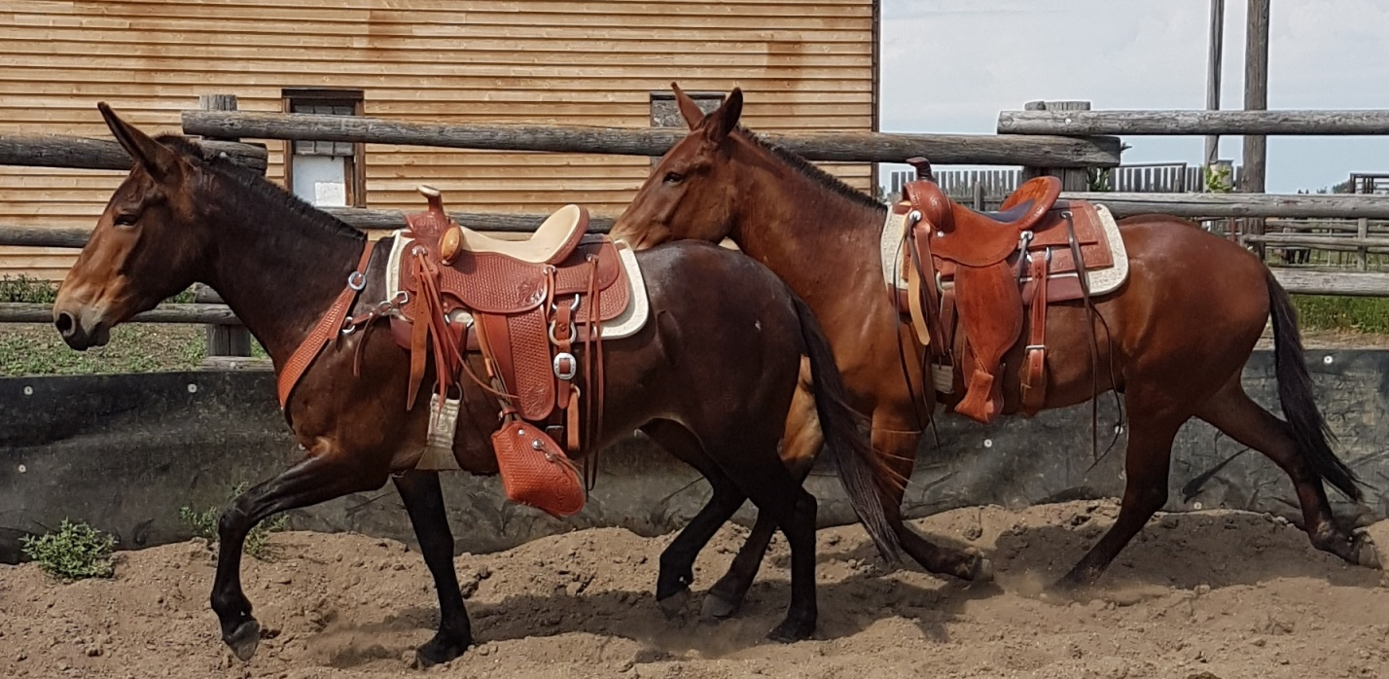
MOVE THEIR FEET!
By Jerry Tindell
“Move their feet,” is not a training concept put together by all equine trainers or widely used by trainers. Having a true understanding what “Move their feet “means can be difficult for students who typically ride only through their hands.
Jerry Tindell has worked around horses, donkeys and mules his entire life, but early in his career he began to think the feet were the most important key to training stock. A top notch farrier, Jerry evaluated horses’ movement through their feet, and made mental notes how to correct the horse’s hooves to help gain fluid movement. As his passion grew to train horses and help their owners so did the belief everything started with the feet.
In the real world movement is vital to horses, prey animals have to have the ability to flee whether it’s for the pecking order of the herd or a predator. The movement is quick, precise, and decisive; little thought is given to the movement other than to flee. As a natural horse trainer Jerry had studied the movement of a horse and understood the how, when and where horses move their feet. To work with the mind of the horse you have to listen to what the feet are telling you.
The concept of “Move their feet,” begins by observing the two kinds of movement in the horse; Subtle, soft, and safe movement or fast, stiff and defensive. Look at the cadence of the horse and the components of their foot falls. Basic movements such as a walk (four beat gait), trot (two beat gait) and lope (three beat gait) allow the horse movement for performance.
Check for soundness, how they use their feet as they work through these transitions, rate the speed and how their feet hit the ground. Are the feet heavy and pounding or are footfalls subtle and light? Powering out of control or brace identifies fear or self-preservation in the horse; with fear the mind gets troubled. The horse’s body becomes stiff, the head is high. Hindquarters become very powerful; feet are locked and loaded as concern builds for the flight response.
A secure horse’s head is down with natural expressions that are soft and relaxed. Feet are light bringing the body into a correct position, allowing the mind to be quiet.
Rarely do we think of the feet as we ride. It is very difficult to learn to focus on each moving part and what the movements represent in small incremental parts. The ability to lift one foot or square up all four feet begins when we become aware of the feet. As the “Move their feet” concept begins to make sense, keep in mind the following training exercises:
Allow movement: We cannot succeed if we are holding the face and body.
Build on the movement: Be aware of how your posture affects the horse’s movement, for example leaning your body puts weight on the foot you want to be picked up softly.
Build cadence and rhythm last: Just moving the feet does not make the change you want; change comes when you arrange the feet correctly for the body to follow.
When you can arrange the feet for soft body control, then you can settle the mind when troubled. If the horse can hold together through support, the fear will dissipate more each time. “It’s not the face running off, it’s the feet!”
Jerry Tindell's childhood links him to a time when mules and horses were a vital part of the American story. The 8th child of a Missouri timber man, Jerry grew up watching his father work with both draft horses and mules to support the family by skidding logs. That connection shaped his life, and he has followed his love and respect for animals to build a successful career which now focuses on training both equines and humans. Coming to California in 1971, Jerry worked as a farrier with his older brother Duke. This led to working with law enforcement units, first as a farrier and later as a trainer, work he continues today. Currently his schedule is filled with clinics throughout U.S.A. and Alberta, Canada. A regular at Back Country Horsemen events, his clinics focus on learning to support the animal in making the right choices. Jerry's methods open a window into a logical, humane, and effective method of increasing the communication between riders and their mounts. Jerry has several training options including on line help, plus several DVD’S . You can contact Jerry through his website at www.jerrytindell.com

