PART FOUR of Appropriate Tack and Fit for Mules, Horses & Donkeys
By Marlene Quiring
MODIFYING TREE OR SADDLE FIT
If your pocket book can handle it and you know of a good saddle maker that is willing to listen to what you want, a saddle built with a custom tree modified to fit your mule, horse or donkey and yourself can be a valuable investment. However, armed with sufficient knowledge it is quite possible to find a less expensive saddle that is close to fitting your animal and making the modifications necessary to obtain a better fit.
Some saddles can be modified as long as the tree is not too narrow and the bars not too long for a particular back. If they are either you must look for a different saddle.
If your saddle tree is a raleigh [plastic] tree, you can grind down areas with a grinder or rasp or fill in areas with Bondo, a plastic filler used to fill in dents and scratches in automobile bodies. If your tree is a rawhide tree, [covered in skin] you cannot grind it down in any way, but you can glue or tack extra leather to it to modify its shape. Remember ‘’you cannot change the fit of a tree if it is too narrow or long. ‘’
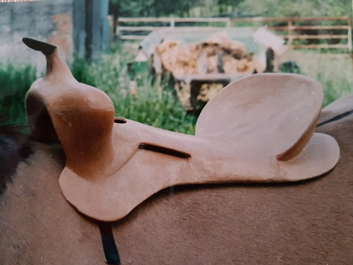
The front of this bare plastic tree is sitting right up on the shoulder blade. You can see how the front edge of the tree even digs into the scapula. Imagine once you add a rider's weight. It is also bridging [connecting only front and back but not in the middle] which is not visible from this view. A very bad fitting tree makes for a very bad fitting saddle. But how, do you know this once it’s all covered with leather and sitting on a saddle pad? That's why it's so important to really pay attention to saddle fit.
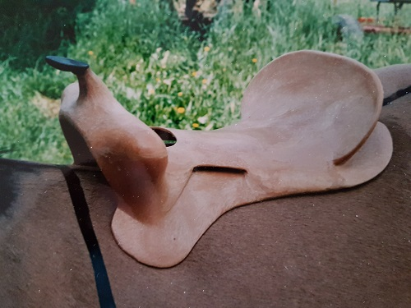
Now the tree is moved back to a better position. Even though the bars of the tree seem to fit reasonably well along the mules back, what you can't see from this photo is that the bars are only connecting to the mule's back along the outside edges of the tree, making the surface weight distribution area very tiny. You would be able to see this by looking down the gullet. The angle of this tree is too steep for the mule.
If you are in a situation where your saddle must be used on more than one animal, then you have to look at ways to attain the change you want in individual blanketing or padding for each animal. It is not the best, but if careful attention is paid to precision and position, modifying a pad for each individual equine to best make that saddle usable is possible short term.
English saddles can have their panels re-stuffed to better fit an animal’s back. Unfortunately, often there is not enough leather in the panel and when it is re-stuffed you can end up with a very narrow panel which is not desirable. Most Australian saddles have panels that can be successfully re-stuffed to change their shape.
If your saddle is bridging, you can cut shims out of felt that will fill in the middle area of your tree that is not connecting with your mule’s back, but always be aware of keeping any pressure off the mule’s spine. If your saddletree has too much rock in it [too much belly in the tree] you may have to pad up the front and the back of your saddle to make it fit. Make sure these pieces of felt are beveled at the edges so they will join in smoothly to the rest of the pad. You will want to use a thin pad and built on to it with the felt shims and glue them into position [a spray adhesive works great or attach Velcro] and then keep this pad for the particular animal you have designed it for.
Slapping on extra saddle pads is not the answer for a bad fitting saddle or tree. If you are in a bind, and need to make a saddle fit to get you through a situation, you can take a Navajo type saddle blanket and carefully fold it to fill in the areas that need extra padding. You do want to be careful of your folds as they can create their own pressure spots after a while. You must also make sure that you always place your saddle pad in the correct position so that your modifications are effective and not harmful instead.
An alternative to adding shims onto a pad would be to purchase a good thick felt pad and use a side grinder to grind down the pad in the necessary places or even cut out the areas where the pressure is most evident.
Expecting an animal to pack you around with an ill-fitting saddle would be like strapping a poorly fitting backpack on your back or wearing an ill-fitting pair of boots and going for a hike. Try it sometime and you will really take a second look at your gear for fit.
LEVELLING THE SADDLE
Besides making sure that your saddle is shaped to fit your mule’s back and that you are setting your saddle out of the way of his shoulder blade movement, you need to check and make sure that the saddle is now BALANCED or LEVELLED.
Balancing or leveling your saddle will most likely be necessary because once you move your saddle back to accommodate the movement of your mule’s shoulder blade, your saddle may be tipping ahead if your animal has a downhill back.

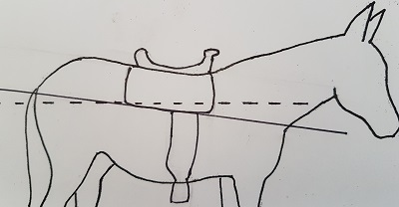
In this diagram, the dotted line is running parallel to the ground. If your saddle has level, straight skirts you should be able to draw a line along the bottom of the skirt that is parallel to the ground but in this case the line is downhill. This can be a sign that your saddle is not sitting level. You may find yourself being thrown ahead in your saddle and always fighting to keep yourself upright. Downhill equine backs can cause your saddle to sit downhill and want to slide into your mount’s shoulder blades.
Unless our horse or mule has a level back or we have a saddle that already accounts for this or we have one specifically built to the conformation of our equine, it would be good to learn how to level our saddle so as to ride in a balanced position if our equine’s croup is higher than their withers. Each saddle and equine of course will be different.
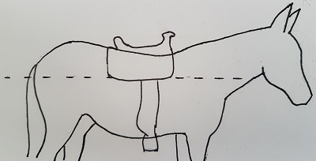
I had an old Eamor saddle that was built so that even when I rode my down-hilled- back mule the saddle sat level and I did not have to lift up the front end in order to ride balanced. With other saddles I generally have had to lift up the front end with shims to keep from feeling tipped ahead. If only the seat of the saddle is leveled and not the actual bars of the tree, you will still have a saddle that wants to move ahead as gravity will force it to seek the low spot. A tight back cinch will help the saddle to stay where you want it. It took me many years of riding with sore knees and hips before I learned now simple it could be to fix a balance problem. After a while, you will be able to tell just by looking at the saddle whether it is sitting level or not.
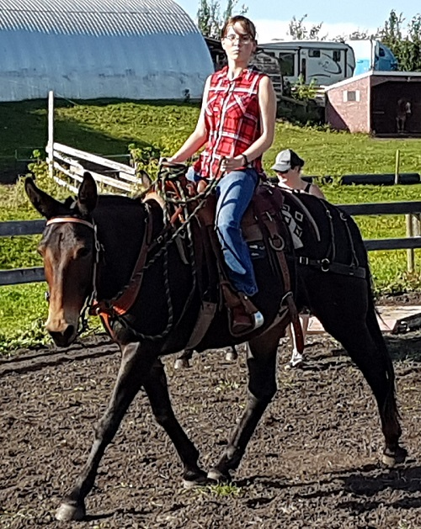
The easiest way to level your saddle, besides modifying the actual saddle tree is to add felt shims to the front end of your saddle until it sits level. Depending on individual backs, the thickness will vary from animal to animal. Always make sure that the edges of the shim taper off to blend with the regular pad so as not to create a pressure spot. A thin felt or wool pad underneath the shims should be sufficient if your tree fits well. Extra saddle pads will not fix the problem. Adding pads to a saddle changes the angles and fit of the tree, front and back so be careful. A Navajo saddle blanket folded up so that is it thicker in front will do the job if in a bind. Take care that the folds are carefully layered so they do not create pressure spots.
Too many pads cannot fix a bad fitting saddle and may aggravate the situation. Too thin a pad will not give any cushioning and will not absorb sweat properly. Wool is still one of the best materials with felt pads being a good second choice. Synthetic pads are not recommended because they do not wick away moisture but trap it instead and can cause scalding. Saddle pads must be kept free from dirt and mud, which can irritate the skin causing chaffing and sores.
Experimentation with each animal and their saddle fit is necessary. Once that horse or mule has his tack fitting to him, it should stay with him and not be switched around with another animal. Backs do change with growth, conditioning and outside forces. Keep that in mind when fitting your tack. Always be watching for signs of change that require you to make adjustments in padding and tack.
NEXT UP – Part 5: Saddle Rigging, Cinches, Breast Collars and Britchens

