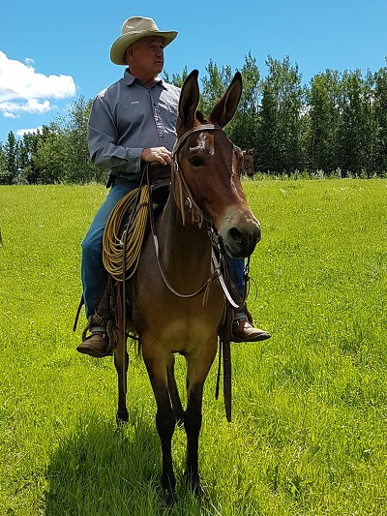
BUILDING A SAFE RIDE
by Jerry Tindell
Have you ever evaluated the behavior of your mule? If he is hard to catch, spooky, nervous, snorts, high headed, stiff necked, or is easily distracted, you may not have a good ride. If you don’t pay attention and are unaware of these behaviors, you will not realize the power in their hindquarters until it is too late.
The more these animals are in control, the more out of control we become. When they lift their head high in the air, push on the bridle, or lean against your legs, they are unable to listen to the subtlety of our signals and their mind is going to take them away from us.
It is the human’s responsibility to read and be able to build body control through the feet in order to get to the mind to re-gain control. It is about being aware of and identifying the body language of the animal to make sure we have control of the mind and the feet.
For a ride to go from safe to sorry, these are the behaviors that are left unattended by the human. It is time for the human to take these matters seriously and stop waiting and hoping they will disappear. Especially when in the back of your mind you feel something is wrong but you don’t act on it to fix it. If you do not act you will be acted upon. You need to formulate a plan today.
The training program I use is based on six steps of body control in order to address behavior building on a progressive sequence from the round pen, to ground work, to riding. The six steps are: the backup, shoulder control, the forward flex circle, hindquarter control, the stop, and stand. Each one of those steps helps me determine if things are going to flow nice and smooth or it there is going to be a problem.
These six movements are identified and used in the round pen, on a halter, or when I ride The round pen is used to contain the mule in order to teach it to stay within a boundary. Movement, direction, and connection are the basis for everything we do in the round pen.
I use the round pen to evaluate movement, to work on transitions so they become smooth and non-fearful, and to check for soundness. The round pen is where a lot of people could spend a little more time to avoid problems. When used properly, the round pen can take a fearful mule and teach him to stay, get connected, and trust the lessons that are coming.
For example, we know mules have the ability to run off on a halter rope and this is due to putting the animal in a situation they don’t understand or trust, and when they feel pressured or uncomfortable they leave. This behavior is undesirable and unsafe; it needs to be addressed and fixed in the round pen.
Once the negative behavior is learned they may never forget it; therefore, it is the human’s responsibility to get better to fix the problem. This is done by establishing a connection with them in the round pen and then continuing to work them on the halter while in the round pen. You cannot continue to blame the animal for the negative behavior.
Once you have identified negative behavior, take the mule to the round pen for the lesson where it is in a safe and controlled environment. When you see red flags while working with your mule always go back to a place that is controlled, soft, and safe.
Once my round pen work is complete, I have my mules moving well, doing both outside and inside turns, they are coming to me and connected I start my ground work on a halter.
The process of the ground work is applied to allow the animals to be gentle, unafraid, and create movement with suppleness. I looked for the six steps in the round pen while at liberty and now we start teaching them on the halter rope. I use the length of the halter rope to build the boundaries.
In the round pen, they can only leave as far as the wall and then they have to come back to us. Once I get my halter on I allow, direct, and control movement.
I like to take enough time on the halter work to keep softness in their face, flexion through their body, and proper placement of their feet. It is very important to me and the animals I work to do this slowly and create suppleness as this is their first introduction to feel. I am teaching them to follow their nose and to move their hindquarters.
For example, if I am on the right side of the mule, I would position myself back towards the wither, while being two to three feet away; I ask him to bring his neck to the right and to move the hindquarters to the left so that they move away from me.
During this process I start becoming aware of four controls on the halter rope: the backup, stepping the shoulders over or away, stepping forward with good flexion, and stepping under from behind with soft hindquarters. This is about the neck and the hindquarters, because when mules run off its not so much about their face, it is about their feet.
People often ask me what kind of bit they need for their mule because he runs off and I tell then it is not his face running off, it is his feet. Take the time to manage their feet.
This introduction to your halter work is really important because this is where they can learn to escape on a halter rope. If we apply too much pressure, or move too quickly, the mind of the mule leaves and then the feet leave; now we have failed the mule because now he knows he can leave. I spend a lot of time getting the mule soft and supple through ground work.
You ride the mule you lead. If we raise our standards our mule will be as good on the ground as he is under saddle. By being thorough in our round pen and ground work, we are now ready to ride.
They are good to catch, they lead well and are soft on a halter rope, you have control of the front and hindquarters, with a backup, stop, and a stand, all on the halter rope.
They stand well to be groomed, you can easily handle their feet, and they stand well to be saddled.
The first thing I do when I get mounted is take a seat, making sure I have both stirrups, and sit quietly. I check out my lateral controls by asking them to flex left and right with a soft feel. I then take that lateral control and with the inside leg ask the hindquarters to move away. I do this on both sides.
After that checks out alright I’ll ask them to walk forward, guiding them with a direct rein [one rein]. I like them to move out willingly without resistance. I start checking my controls early, making sure they give to the bit, are not pushy in any way, making sure they can bend their neck around and follow their nose. I check for hindquarter and shoulder control and always check for my backup.
The backup is really related to the stop. To make sure I have a safe ride I always check out these controls; if I wait until I need them and find out they are not working it is too late. This is why it is called training. Take the time and make sure all these things work.
When you are training your mule, ask the animal and then give them time to respond; don’t get after them when they make a mistake because they don’t know they made a mistake. I’ve learned to get with them so I don’t have to get after them.
Take time to observe and evaluate your mule. You have to allow yourself time to TEACH them and allow them time to LEARN it; do not expect them to know it without learning it.
There are three things I do: I know what I want, I know how to ask for it, and I know when I get it. You have to teach them to succeed and as a result your mule will trust you, establish confidence and willingness to do what is asked of them.
In closing, always be safe, keep your mule soft and you won’t be sorry. If you think your mule won’t back up, if you think your mule can’t stop, if you think your mule is really hard to turn left and right; if you think your mule is avoiding because he wants to, think again.
These conditions are all related to training and need to be addressed. So why not spend the time to get prepared so you and your animal can enjoy the ride? You will both be happier with the results. If at any time you feel unsafe or in over your head, please consult a professional trainer for help.
Jerry Tindell of Tindell’s Horse and Mule School is a professional horse and mule trainer. He has been training and shoeing horses and mules since 1971. His unique training abilities help mule owners understand and apply proven techniques to communicate in a soft, safe, and secure manner with their animals. He can be reached at www.jerrytindell.com or by phone at 760 403-3922.

