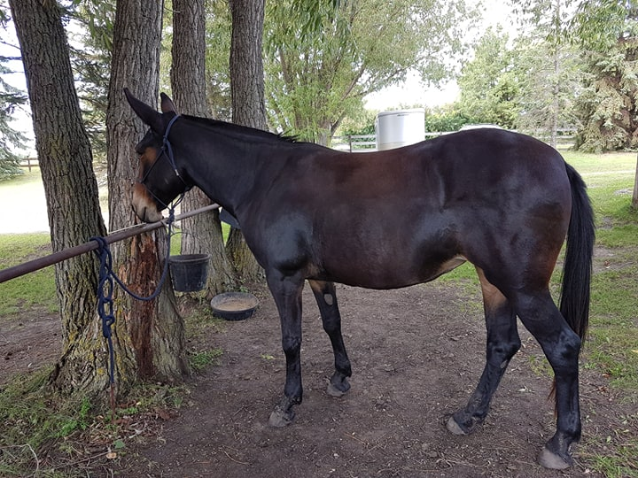

An Introduction to the Mule

THE MULE

To produce the hybrid equine called a mule, mate a male donkey (jack) and a female horse (mare). The opposite cross, using a male horse (Stallion) and a female donkey (jennet) is called a hinny. Even though the mule and hinny hybrids have the same sexual characteristics and drive as their parents, they are sterile due to an uneven number of chromosomes – 63. The Mule gets some of its characteristics from the sire, which tends to come out in the extremities. Thus, a mule….has a short thick head ( if the jack has a short thick head), long ears, a short mane, thin legs, narrow hooves, a narrower body than a horse, and no hindlimb chestnuts, like an ass; in size, shape of neck and croup, speed, strength and type of tail, it is like a horse. A hinny is smaller and more horse-like than a mule, with shorter ears, a larger head and broader hooves; but has the ass’s calmer disposition. (Note: while these things are generally true, the truest thing is that animals vary so much from individual to individual that sweeping generalizations are not to be taken too seriously)

Contrary to popular belief, a mule is neither vicious nor stubborn, but will respond as he is treated. The mule which is well cared for and not abused makes an excellent riding or working animal.

Mules come in all sizes, from the small miniature to the giant draft mules. The smallest mules come from miniature jacks and miniature horse mares. The draft mules come from Mammoth jacks and large draft mares. Saddle mules are being bred from Quarter horse mares, thoroughbreds, and other pleasure riding type mares and standard & large standard sized jacks. Hinnys come in about the same sizes, but as E.C. Porter states in A Breeder’s Notebook, It is simply the very low conception rate of the jennet (even to a Jack), which makes the breeding of hinnys much less sure and not at all profitable, compared to the breeding of mules.”

Mules today are used for packing, pleasure riding, “coon” hunting and jumping, driving, and even racing. Because of their strength and sure – footedness, mules are being used more and more by cross – country and endurance riders as good, dependable mounts. As a matter of fact mules today are being used in many areas that were thought of as the exclusive province of horses such as fox hunting, dressage, combined driving, cow work and all sorts of recreational uses.

Modern American breeds of Asses

Miniature Donkey: Originally imported from the Italian islands of Sicily and Sardinia, plus some other places around the Mediterranean, these donkeys must be under 36 inches at the withers to be registered by ADMS as miniature. These animals are registered by the American Donkey and Mule Society. They are often referred to as Sicilian donkeys, but this is colloquial usage.

Standard Donkey: This covers the size range of most donkeys in the world. The size range is from 36.01 inches to 48 inches at the withers. This size donkey is often called a “burro”.

Large Standard Donkey: Donkeys from 48.01 up to 54 inches for females and 56 inches for males are designated large standard donkeys. These are good donkeys for adults to ride or work and for breeding saddle mules.

Mammoth or American Jack Stock: This is the largest breed of donkey in the world. Males must stand 56 inches and up, and females must be 54 inches and up. These animals have their own registry The American Mammoth Jack Stock Registry and also can be registered by ADMS.

American Spotted Ass: While asses of all sizes can come in “pinto” or spotted coloring, the term American Spotted Ass is a trademark for asses registered with the American Council of Spotted Asses, which is trying to establish foundation stock for spotted asses.

AMERICAN BREEDS OF MULES

The old breed terms of Cotton, sugar, mine mules etc. are not relevant today. The breed names are now the following. Keep in mind that these breeds are not differentiated so much by size as by the type of mare the mule was bred from.

Miniature Mule: Bred from various types of pony mares or miniature horse mares, Fifty inches is usually considered the cut-off point for miniature mules.

Saddle Mules: Bred from mares of saddle horse breeding. These vary in size from small to very large but have riding type conformation and looks.

Pack/Work Mules: Bred from mares with some draft blood or of heavy work rather than for saddle type conformation.

Draft Mules: These are the largest mules and are bred from various breeds of draft mares. Belgian mules are the most common, valued for their bright sorrel color, but mules from, Percheron, Clydesdale, Shire and other draft breeds are popular also. The larger and heavier the better with these mules, but refinement is desired as well.

What is a mule?

The mule is a hybrid equine produced by mating a horse mare to a donkey jack (stallion). Sounds easy, but most donkey jacks will not cross the species line to breed horse mares! Donkeys intended to be used for mule breeding need special raising and training so that they will breed mares.
Male mules are called horse mules and should be gelded around six to nine months of age.
Female mules are called mare mules or molly mules.
Hinny refers to the opposite cross from the mule. This equine hybrid is the product of mating a donkey mare (jennet) to a horse stallion. The hinny resembles the mule very closely but tends to be more horselike in general appearance.

WHY OWN A MULE?

Mules have been bred for some 3,000 years. Mules were used by the Jewish people before the time of King David and by the Ancient Greeks and Romans for harness racing, as draft animals, in farming, and as saddle animals for the nobility and clergy.
The mule combines together many of the good features of both parents such as the intelligence, longevity and sure-footedness of the donkey with the size, and rounded body conformation of the horse. Because mules are a hybrid, they exhibit hybrid vigor and are noted for their stamina and endurance.
Mules are highly intelligent, and like the donkey parent, have an extremely well developed instinct for self-preservation. This instinct makes them less prone to injuries to themselves and their handlers.
Mules are noted as easy keepers and are renowned for their strength and endurance, and ability to withstand heat.
Mules come in a variety of colors and sized ranging from miniature to saddle and draft types. They are a “made to order” animal that is created in just one generation.
Most mules today excel in the recreational field – trail riding, endurance riding, packing, driving, and cutting cattle to packing out big game – a good mule is worth his weight in gold.

