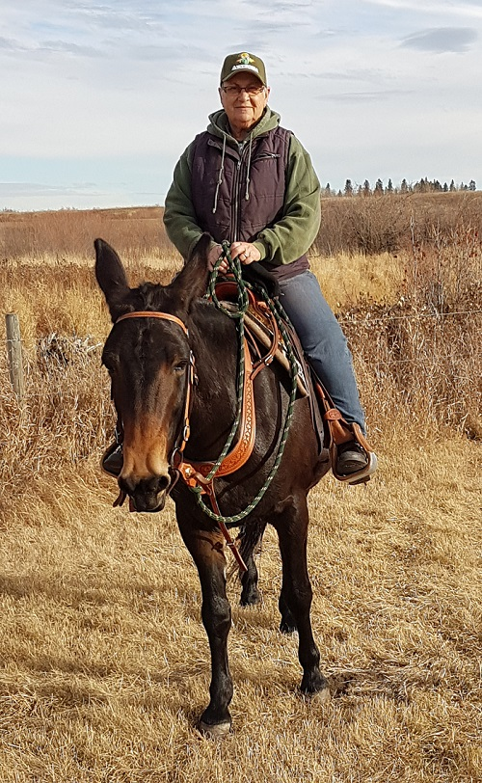
Buying a Mule
by Marlene Quiring
Landing in the position of being in the market for a new mule can be a humbling experience. Once you have owned and cherished a good mule, replacing that mule or perhaps looking for a suitable mule if you are a first time mule convert can be emotionally wearing and financially draining, especially if you have not done some homework first.
Jerry Tindell of Tindell’s Horse and Mule School of California, advocates that ‘’buyer beware’’ is very much applicable in the industry today when looking for a new mule. Unfortunately, there are those who misrepresent the stock they are selling and then there are folks who really don’t understand what they are selling. If you the buyer, don’t have a basic standard of what you expect in a mount, or lack the ability to recognize a mule with a good foundation, or cannot judge the temperament you need in the mule, you definitely run the risk of buying something that does not work for you.
Tindell further advises that the problem he sees when buying stock is that the buyer often doesn’t see the animal out of its comfort zone. What this means is a lot of people, perhaps unknowingly, keep their mules, horses or donkeys at a real nice even keel at home, where they are easy to manage and comfortable as long as their environment doesn’t change. They are compliant with their routine, but taken out of that environment and put in a new situation their reactions might not be what you desire. Unless you are a seasoned and experienced handler the safety of both might be compromised.
Personally, speaking from experience it is very important to communicate with someone you trust to access the mule you are interested in as to whether it would be a good match for your level of skill. Pick a mentor that is able to judge the mule’s reactions to different situations and gauge whether the seller is presenting an honest representation of the mule. While conformation of the animal is important for soundness, temperament should always be at the top of the list for most riders.
Beware of sellers that tend to ‘’sugar coat’’ their stock and keep them in environments that make them appear quiet and calm or put riders on them that can make them look better than what they really are. It seems to be the rage right now to use tricks and/or gimmicks that can actually falsify the type of temperament the animal actually has in order to impress the buyer. Over exposing the mule to outside stimuli such as roaring chainsaws, cracking whips, and other noisy or disturbing distractions doesn’t always mean that the mule will not react to that or something else once you own it. In fact, sometimes the over exposure dulls them to things they should be wary of. My preference is for a mule that still has its preservation instinct not totally taken away.
Now we have a big part in this deal also! We need to make sure that we have the skill level that is at least up to the level of the training of the mule and if not, we need to take the steps to educate ourselves up to the mule’s level of training, and beyond. This may mean lessons and clinics from several instructors until you find someone that resonates with you. They should be able to clearly explain all instructions and the reasons behind them and they should instill confidence in you and the desire to learn more. It should be a fun and rewarding experience and they should always have you and your mule’s safety at heart. If you have a bad experience with a teacher or trainer, take what you can learn from the experience and move on.
If you are just beginning as a rider, it is imperative that you look for an older, well trained, but easy going mule to start with. Walk away from the young mules that may look ‘’broke’’ unless you plan to send that mule to a trainer and spend your time under a mentor that you trust. No matter what, lesson or clinics with established and admired teachers and trainers is always a good plan. There are too many ‘’riders’’ out there that get hurt because they never took the time to make sure they have educated themselves beyond what they learned as a kid, and too many mules out there that have not had a solid foundation and are being ridden by unaware and uneducated riders.
We’ve all seen or read about a mule selling for five figures. While it’s great that the value of a good mule can go through the roof, these steps I'm outlining still need to be remembered. The high price tag doesn’t always guarantee success! Now this can partly be the new owner’s fault for over estimating their own skill level, however what also can happen is their new mule has been groomed to look good in the show pen, but might lack a good solid foundation which then sets the mule and the owner up for failure. There are a lot of things that become clear when the mule is put into a new environment.
When you prepare to visit a prospective new mule, ask that the mule NOT be caught, groomed, feet picked up, warmed up, saddled and bridled until AFTER you arrive. It can be a big red flag when all this is already done and you have not seen how well the mule behaves with each step. Have the seller ride the mule first and watch the mule’s behavior. This is when your more experienced accomplice might pick up on things you might miss as you are very susceptible to seeing what you want, which is maybe not that which is being presented.
Whether you pay top dollar for a mule at a sale or from a private seller, you might be told that you can return the mule. But does that mean that you can get your money back or does it mean you can trade it in for another mule? If you thought you were getting the ‘’cream of the crop’’ for that high dollar animal, what are you going to get when you have to trade it in on something? That’s not a very promising scenario!
Tindell has worked with mules from clients that cost thousands of dollars, but once home the mule was not what they thought they bought and the original seller only offered them a few hundred dollars back or another mule with a lower price tag. So check these things out before you seal the deal.
Take your time, do your research and don’t be pressured by sale tactics. Take the advice of a trusted trainer or knowledgeable friend who has your best interests at heart. The amount of money you spend does not always equate to the best mule for you. Remember and practice ‘’buyer beware!’’
Marlene has been a passionate mule lover and past breeder for many years. She believes the best way to ensure a good life for those long ears she loves is to help educate their owners.

