PART FIVE of Appropriate Tack and Fit for Mules, Horses & Donkeys
By Marlene Quiring
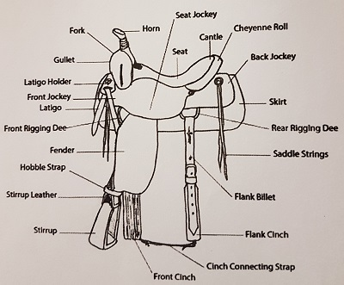
SADDLE RIGGING & HOW TO KEEP YOUR SADDLE IN POSITION
The tree of your saddle should not sit on any moving parts of the animal, thus the rigging must accommodate your animal’s build so that the tree does not interfere with the motion of the shoulder.
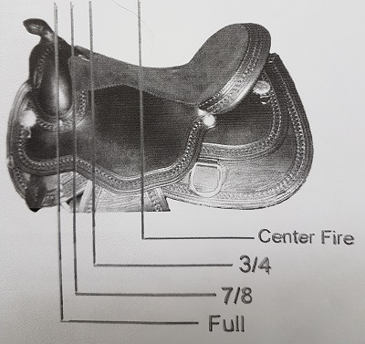
There are several saddle riggings available. If you drop a line from the center of your pommel [from the side] and the center of the plate or ring is directly in line with the center of your pommel then that is a full rigging. This rigging is used on cutting and roping saddles, where bursts of speed and a lot of strain is put on the tree for a short time.
A 7/8 rigged saddle will have the front cinch an inch further back from a full rigged position and a ¾ rigged saddle will be 1 ½ ‘’ back from that. These two positions are generally used in most of the pleasure type saddles. A 5/8 to center fire rigging places the cinch back toward the middle of the animal’s barrel, which is seen in old style saddles but rarely used today. Have a good look at the rigging on your saddle and make sure that your rigging is appropriate for your animals build.

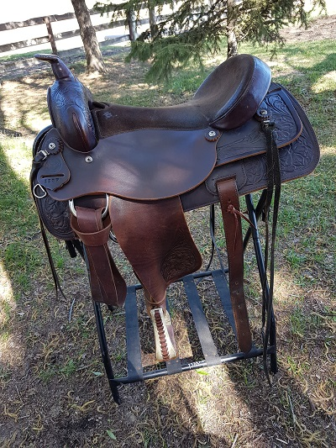
A full ‘’double’’ rigging means that there is a back cinch which is crucial for security for performance events and for mountain trail riders. The saddle in the photo is a ‘’full double.’’ The rigging is centered with the saddle pommel. Contrary to what some think, most mules and horses actually require a full or 7/8 rigging once the saddle is moved off of their shoulders. Often a full rigging is blamed for cinch soring an animal and many mule folks want a ¾ or even a center fire rigging to get away from this. In reality, when you set your saddle so the tree is several inches back from the end of your mule’s shoulder blade, a full or 7/8 rigging will still leave ample clearance room for your mule’s elbow. If you need a ¾ or a center fire rigging to do this, you are likely riding with your saddle too far ahead. A full double rigging will also stabilize your saddle much better than a 7/8, ¾, or center fire because the front and back cinches can be spread further apart.
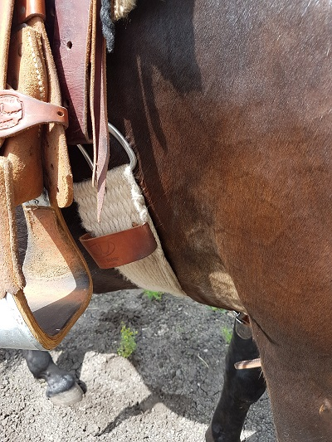
The photo shows ample room between the elbow and the front cinch. Your goal will be to have your saddle rigging so that your front cinch sits well back on the girth area and does not rub the elbow. Horses require 3’’- 4’’ of space between the cinch and their elbow, mules can require up to 5’’ - 6 ‘’ because many mules have more elbow movement that a horse. Cinch sores should not be regarded as normal. Check your saddle position and where your rigging is riding.

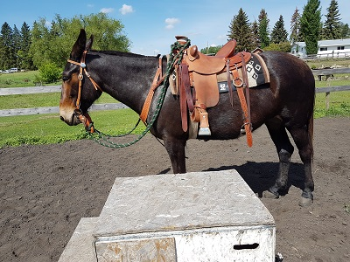
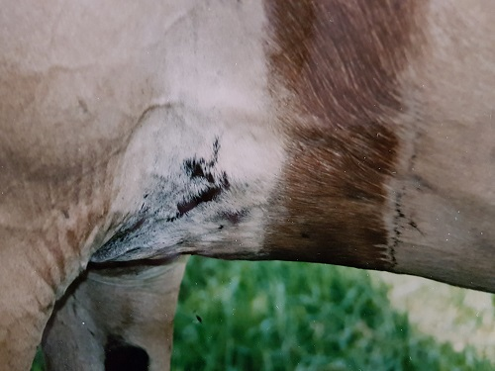
The sweat line on this mule shows where the cinch needs to be in order to avoid rubbing the elbow. You can see the scarring left by the previous owner with a saddle or rigging riding too close to the mule’s elbow. The scarring over this area was fragile and would easily bleed if the cinch ever came too far forward.

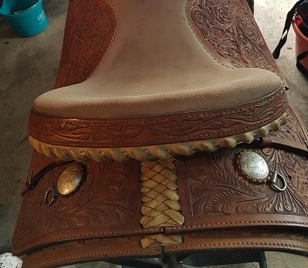
Mounting your animal from an elevated position is always a good idea as it’s much easier on their back and keeps the saddle from being pulled out of position. This also keeps the hairs on their back from being pulled back and forth by the disturbance of a rider mounting on one side, especially if the rider has difficulty. Ruffing up their hair is also prevented by setting your saddle pad further ahead before saddling and then pulling it back into position so it goes with the lay of their hair. Also saddle skirts need to be able to flex and preferably have no lacing at the back. If they do you can remove the lacing if you see that your mule is getting rub marks on his loin. Always pocket your saddle pad at the gullet so when you tighten your saddle the pad is not stretched over the wither but instead allows space for air flow from front to back.
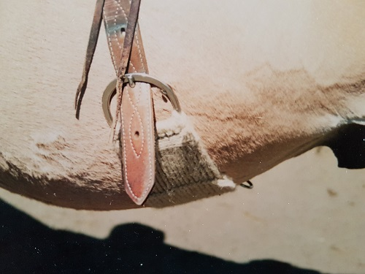
A snug/tight back cinch stabilizes the saddle and allows for some play in the front cinch. In order to be useful a back cinch should be tight enough so that it is as tight as your front cinch when preparing for a mountain ride. You should be able to fit the flat of your hand under the back cinch but just barely. This photo shows a nicely positioned mohair back cinch, catching the mule’s belly thus using gravity to help keep the saddle in position.
FRONT & BACK CINCHES
For pleasure, trail and mountain riding you might consider swapping out your leather back cinch for a cotton or even better, a mohair string cinch. Leather is slippery and often too narrow. The wider string cinch covers more area and provides more grab. It needs to be behind the belly roll of the mule without getting into the flank area. It will stabilize your saddle and help to keep it from moving ahead, even when going downhill. You might have to lengthen out the hobble strap [the leather strap connecting front and back cinch] or find, or make a longer one as some are just too short.
There are situations where you want the back cinch on the ribs of your mount. This is the case with ropers who know how important a tight back cinch is but besides needing a wide cinch for better impact absorption, the cinch has to be on the horse or mule’s rib cage so as to distribute the force when the cow or bull hits the end of the rope. If you had the back cinch on the soft part of the horse or mule’s belly the sudden impact could knock the wind out of him and he would not be a happy camper! However for pleasure and trail riding, it becomes beneficial to wear the back cinch behind the belly roll for greater stability.
It’s important when cinching up your back cinch tight for the first time to first desensitize your mount to the new pressure. Turn your animal loose in a pen with no rider and push them through the transitions both ways, tightening up the back cinch until they no longer are bothered by it. Some might want to buck; many don’t care, but its best to do this for the first few times before you mount up.
Riding with a back cinch that is loose does no good at all. In fact it is very unsafe as a back foot, a stick or a branch can get hung up in it. Riding with a snug back cinch secures the position of your saddle, helps keep the saddle off their shoulder blades and keeps it from scooting back and forth across their spine.
The secret to cinching up with double cinches is this: The rib cage of the equine could be compared to the shape of a football that tapers in on the ends. Because of this natural slope of the rib cage, if you tighten up the front cinch first, the front cinch will seek the low spot, which in this case will end up right against the mule’s elbow. This is not what you want! Therefore, do up the front cinch but only secure it enough to keep the saddle on should the mule move, then do up the back cinch and do it up snug in the position you need. After moving the mule around a bit, retighten both cinches, but always the back cinch first. When you tighten the back cinch first, it secures the saddle and will prevent the saddle [and the rigging] from being pulled ahead when you go to retighten the front cinch. This really works!
There are different materials available for cinches. Neoprene, cotton or mohair string cinches, felt cinches and so on. Each can be useful put into the right working situation. It’s your job to pick the cinch that works best for the kind of riding you do. Cinches should not cause cinch sores if they are fitted and positioned correctly and of good quality.
BREASTCOLLARS, BRITCHENS AND CRUPERS
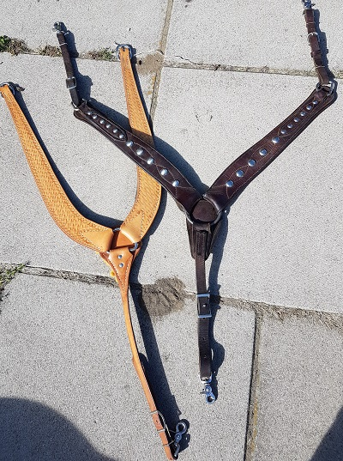
The light colored collar in the photo is referred to as a ‘’pulling’’ collar and quite popular. For one thing it is easier to adjust properly. A breast collar is helpful in stabilizing your saddle especially for mountain and trail riding. In fact, if you had a cinch break, you would be best to ride with a tight back cinch and a breast collar and you would have very little problems finishing your ride. A breast collar that is not adjusted properly is useless and can cause sores instead. The rule of thumb is that your breast collar should be tight enough so that you can stick your hand in the front of it and by pulling ahead, can get only about 2’’ of slack. If it is too loose, it cannot do its job and instead may end up dropping over the point of the shoulder and causing rubs, sores or a bursitis. It’s not uncommon to see ill-adjusted breast collars on the trail. There are various shapes of breast collars available and some will work for one animal but not the other. Make sure that the breast collar you use on your horse or mule sets above the point of his shoulder but not so high that it cuts off his wind.
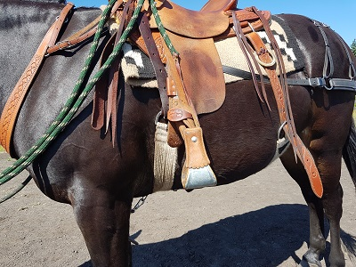
This photo shows good breast collar placement, front and back cinch placement and britchen placement. A lot of people who ride mules advocate riding them with a britchen or a crupper. There can be situations where one or the other can be helpful, but if your saddle fits well and you use your back cinch and breast collar properly, some mules do just fine without them even for mountain trail riding. There’s a time and a place for them, but they do not have to be an automatic part of a mule or donkey’s gear. If your saddle moves or rocks, a britchen or a crupper will help but first have a good look at how your saddle fits in the first place.
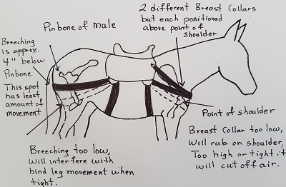
If you do find that a britchen is helpful to your saddling situation, make sure that you have it adjusted properly. Often riders get their britchen dropped too low on the hindquarters of the mule. It should set about four inches below your mule’s pin-bone [see diagram]. Any lower and there is too much leg movement that results in burns and rubs. It will also restrict your mule’s leg movement if it is tightened in a position that is too low. Adjusted properly, you should be able to comfortably slide the flat of your hand between the britchen and the animal.
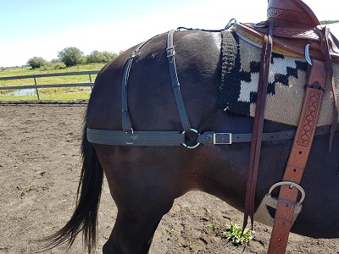
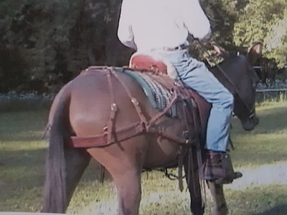There are different ways to attach the britchen to the saddle. If the britchen is attached to the rear cinch ring and to the back rigging ring [the ring on the saddle], it will not only hold back the tree but will also hold back the back cinch so that it functions by putting pressure against the roll of the belly and stops the tree from moving ahead. Some attach to the front cinch ring which then helps hold the front cinch out of the elbow. Try what works for you best. The straps that run down from the top of the britchen carrier should be adjustable in order to maintain the britchen seat, which should ride approximately 4 ‘’ below the pin bone.
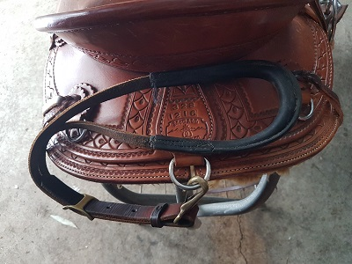
The crupper is favored by some people as a lightweight piece of equipment that maintains the position of the saddle but it doesn’t have the ability to hold the front or back cinch back and a britchen does. The section of the crupper that goes under the mule’s tail must be of a soft and supple material or it will cause sores. Be careful of crupper pieces that are filled with foam as it becomes hard and brittle after time. And it goes without saying that you first want to desensitize your horse or mule to the crupper in the round pen with no rider.
NEXT UP – Part 6: Pack Saddle & Donkey Saddle Fit

