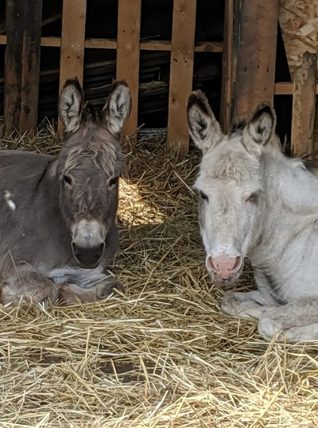
CARE OF YOUR DONKEYS THROUGH THE COLD WINTER MONTHS

By Paulette Jacklin

A donkey's coat is not waterproof so you'll need to help them withstand the lower temperatures. Donkeys don't like being closed in; so rather than shutting them completely in a stall barn all winter long, provide them with a waterproof shelter or a stall with an attached run so they can go in and out as they desire
.
Shelters don't have to be anything elaborate; a simple lean-to will do just fine. An ideal shelter should be located at an angle that protects them against drafts and prevailing winds. It should have three solid walls from the ground up, a sloping roof and, preferably, a gravel base with rubber mats. The entrance should lead out into a fenced dry lot area if their paddock or pasture is too waterlogged
.
Have blankets ready (in case it gets cold enough to require blankets) and rain coats (for heavy rain conditions). Young and healthy donkeys probably won't need blankets or rain coats, but your seniors, very young donkeys and sick or injured donkeys should wear them because it's a lot harder for them to maintain their body heat. Show people who shave their donkeys will need to use blankets also because they won't have that natural winter coat to help them through the cold winter months. And a good rule of thumb...if you observe shivering, they need a blanket.

It's always a good idea to have a spare blanket and raincoat in case one gets really wet, dirty or damaged. On warm, dry sunny days, remove your donkey’s blanket or raincoat for an hour or two so their coat can air out, their skin can breathe and they can get warmed by the sun.

Get in the habit of examining your donkey for sores, scratches or cuts when you take their raincoats or blankets off. Brush your donkeys to encourage circulation. Do not, however, brush them if they are wet as brushing will push water down to their skin causing them to become chilled. clean their eyes, nose, ears and pick out their feet to avoid problems like thrush. Bedding and shelters should be kept clean and dry and donkeys should be kept off muddy fields.

Rainscald and Mud Fever are conditions that occur when the skin and coat remains wet for long periods of time. It's more widespread during the winter and early spring, particularly if your donkeys don't have access to a shelter and dry lot area
.
RAINSCALD is a condition that affects their shoulders, back, rump and, occasionally, the face. In mild cases, the donkey may just have a few scabs containing tufts of hair. When the scabs are removed the underneath surface is slightly moist and sometimes raw. In severe cases the coat over their back and rump will consist of clusters of scabs next to each other. If the scabs are removed the donkey may be left with a large area of bare, raw skin.
MUD FEVER (a.k.a. Dew Poisoning) is often caused by a mixture of bacteria or fungal organisms which causes irritation and dermatitis in their lower legs resulting in painful sores and scabs and the limbs may become swollen. Mud fever most commonly affects the back of the pastern, the fetlock and the heel.

Impaction colic (common during freezing cold winters) is often attributed to insufficient water intake. Donkeys will drink more water if it's warmer. So keep it at a tepid, warm temperature if at all possible. This can be accomplished by keeping the water in a heated water bucket or using a water trough heater. Be sure to safeguard the chord to prevent curious, playful donkeys from chewing on it or playing with it. Provide a mineral block and a salt block near their water source.

If you found this information useful or interesting, please share it with other donkey owners and wannabe donkey owners.
#shelters
#equineblankets
#rainscald
#mudfever
#impactioncolic
#WinterDonkeyCare

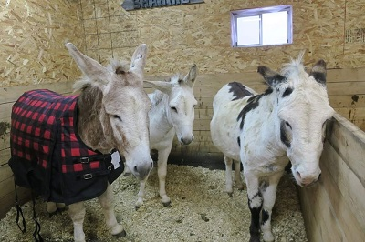

KEEPING YOUR DONKEY WARM AND DRY IN THE WINTER.

By Paulette Jacklin

Most donkeys will prefer the freedom of being out even in the colder weather as opposed to being shut in a stable or barn stall for days on end. However, according to a study from The Donkey Sanctuary, donkeys are less able than horses to adapt to colder, wetter climates and therefore require additional protection in the winter to meet their needs.

From a donkey's standpoint, their worst case scenario is not cold and frost, but being wet on a windy day. Donkeys lack a waterproof coat; so a proper shelter is important if you want these once desert dwellers to be comfortable in the winter. Since donkeys don't like being closed in, rather than shutting them completely in a stall barn all winter long, provide them with a waterproof shelter.

A suitable donkey shelter doesn't have to be anything fancy or elaborate. A simple three sided structure with a lean-to roof situated in such a way that they are sheltered from the wind and from the hot afternoon sun during the summer is adequate. It should have gravel (preferred) or concrete base. It should have solid walls from the ground up on three of the four sides with an opening on the fourth side that will allow them to come and go as they please.

A fenced area of hard standing, pavement or gravel next to your shelter should be provided should your donkey need to be kept off the wet, muddy, or frosty ground for a period of time to protect their feet.
#donkeyshelters
#winterdonkeycare
#shelters
*If you found this information useful or interesting, please support HEALING HEARTS DONKEY SHELTER AND REFUGE by sharing it with other donkey owners and wannabe donkey owners. It's painless, and YOU can make a difference!

