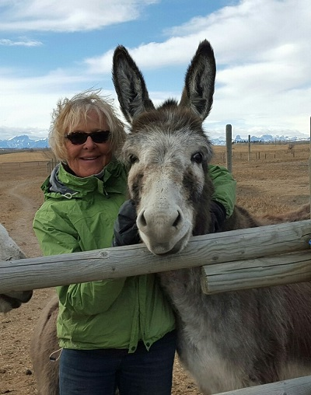
AN INTRODUCTION TO THE DONKEY
To most people the donkey is an animal, which has long ears and brays. But, you can also recognize him by his frequently grey or brown coat, (although he does come in other more “sporty” colors) a light nose & belly, a black cross on his back and shoulders, a short thin upright mane and a tail which is tufted at the end resembling the tail of the cow more than the horse. The hooves of the donkey, which he doesn’t like to get wet or muddy, are small and box shaped, and much more elastic than those of his cousin, the horse.
The donkey probably has more names than any other species in the equine family. His Latin name is Equus Asinus or Ass – with the male of the species being a Jack (hence the term Jack Ass). His lady friend is a Jennet or Jenny. Donkey was originally an English name for the Ass taken from “dun-key”. Meaning a small dun or grey colored animal. Those of us in the Southwest use the Spanish word, Burro, for the ass.
Besides having a lot of names, the donkey comes in about as many different sizes, shapes, breeds, and colors as the horse. Visit one of the many donkey and mule shows across the country and you will see four basic size groups: Miniature – up to 36” tall at the withers; standard – 36 to 48” tall; and large standard – 48” to 56”. The mammoth – or Jack Stock is over 56” or 14 hands tall. Within those sizes you will see many colors, gray, browns, blacks, reds, and even spots. Also you will see many body types from deerlike and graceful to strong and sturdy, something for every job or personal preference.
As Betsy Hutchin’s states in The Donkey’s & Mule as a Backyard Hobby, “The most enjoyable thing about Donkeys as members of the equine world is the fact that they are exceptionally loving, almost in the same manner as a dog. They love to be touched and no amount of playing with, or loving will spoil them for work. They are highly intelligent. For some reasons, rumors to the contrary have always existed, but all one has to do is once have a horse and then a donkey and any belief in the stupidity of the ass is banished. They also have a definite sense of humor, sometimes mischief, and a great love of human company. All in all, whether you ride or drive your donkey, or just love him, he is an unexcelled pet in the large animal category.”

ORIGIN OF MODERN AMERICAN BREEDS OF ASSES
The donkey is one of four members of the equine family, whose most common member is the horse. The following species make up the equine family:
1. Equus caballus – horse
2. Equus assinus – ass (donkey)
3. Equus zebra
4. Equus hemionus – onager, kiang, kulan, khur
The mule, since it is a hybrid, is not considered a species.
Domestic donkeys descend solely from the wild asses of Africa: the Nubian wild ass, now extinct, or the Somali wild ass. Donkeys were domesticated long before the horse.
A number of Asiatic wild asses also evolved, all of which look quite different and have different chromosome counts. Three are endangered in number and none are domesticated. These include the onager, kiang, kulan, and khur. The onager appears more horse-like, and is the wild ass referred to in the Bible.
The breeds of donkeys in North America are now so mixed that they are classified only as to size. Various countries of origin have been identified, however.
Miniature donkeys were bred from animals imported from Sicily, Sardinia, other Mediterranean locations, and Ethiopia.
Standard donkeys arrived with Columbus (six animals) but mostly with the Spanish Conquistadores.
Mammoth donkeys were also imported from Spain, particularly Catalonia and Andalusia, as well as from Malta and Majorca. Another interesting import, although in small numbers, was the rare French Poitou, a large, coarse donkey with extremely long, wavy hair, used mostly for mule breeding but also introduced into Mammoth donkey bloodlines.
Miniature and Mammoth donkeys with proven bloodlines from specific foundation stock can be registered with the Canadian Donkey and Mule Association and the American Donkey and Mule Society.
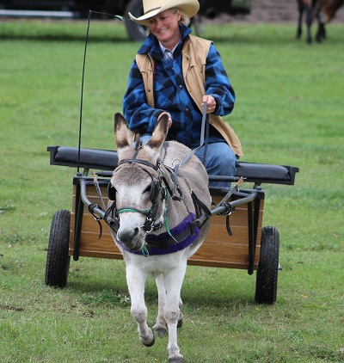
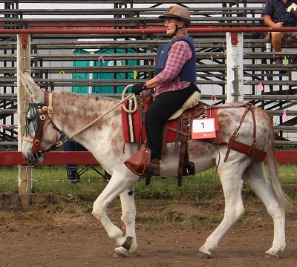
ORIGIN OF MODERN AMERICAN BREEDS OF ASSES
The donkey is one of four members of the equine family, whose most common member is the horse. The following species make up the equine family:
1. Equus caballus – horse
2. Equus assinus – ass (donkey)
3. Equus zebra
4. Equus hemionus – onager, kiang, kulan, khur
The mule, since it is a hybrid, is not considered a species.
Domestic donkeys descend solely from the wild asses of Africa: the Nubian wild ass, now extinct, or the Somali wild ass. Donkeys were domesticated long before the horse.
A number of Asiatic wild asses also evolved, all of which look quite different and have different chromosome counts. Three are endangered in number and none are domesticated. These include the onager, kiang, kulan, and khur. The onager appears more horse-like, and is the wild ass referred to in the Bible.
The breeds of donkeys in North America are now so mixed that they are classified only as to size. Various countries of origin have been identified, however.
Miniature donkeys were bred from animals imported from Sicily, Sardinia, other Mediterranean locations, and Ethiopia.
Standard donkeys arrived with Columbus (six animals) but mostly with the Spanish Conquistadores.
Mammoth donkeys were also imported from Spain, particularly Catalonia and Andalusia, as well as from Malta and Majorca. Another interesting import, although in small numbers, was the rare French Poitou, a large, coarse donkey with extremely long, wavy hair, used mostly for mule breeding but also introduced into Mammoth donkey bloodlines.
Miniature and Mammoth donkeys with proven bloodlines from specific foundation stock can be registered with the Canadian Donkey and Mule Association and the American Donkey and Mule Society.
Miniature Donkeys:
Developed in the United States of America from importations of very small donkeys from Sardinia in the late 1920s. Later additions of Sicilian and Ethiopian bloodlines have mixed to produce today's Miniature Mediterranean donkey in North America.
Small & Large Standard Donkeys:
These donkeys probably developed from those brought to South America and Mexico by early explorers Christopher Columbus and the Spanish Conquistadors in the 15th and 16th centuries. Slowly they migrated further north into what is now the United States.
American Mammoth Jack Stock:
This is the largest size class of donkeys recognized in North America. The breed was developed in the mid-18th century by George Washington who was given the gift of several large Spanish donkeys by the King of Spain. These animals, with later additions of Maltese, Majorcan and Poitou bloodlines, became the foundation of Mammoth Jack Stock. The breed is on the Rare Breeds List in North America because of the low numbers in existence.
DONKEY TERMS
Ass: The correct term for the animal commonly known as the donkey, burro or jack stock. The term comes from the original Latin term for the animal which was Asinus. The scientific term for the term is equus asinus. Thus ass is the correct term. The term fell into disrepute through confusion with the indelicate term “arse” meaning the human backside. You are never at fault when you refer to one of these animals as an ass, and the term is not improper unless you misuse it so yourself. The difference between asses and horses is a species difference. You might compare it to the difference between zebras and horses, different species but closely related and able to interbreed.
Jack: The term used for the male of the ass species. Thus, often used term jackass – which is correct if redundant.
Jennet: The term for the female of the ass species. The more usually used term is Jenny, which is considered correct in non-technical use.
Burro: A word taken directly from Spain. It means the common, everyday working donkey found in Spain and Mexico. It came into usage in the Western United States. As a general rule, the term burro is heard West of the Mississippi and the term Donkey east of the Mississippi where English language is more common.
Wild Burro: These are the feral (originally domestic) asses, which run wild in the Western part of the United States. The American Donkey and Mule Society prefer to keep the term burro for these animals. When registered they are registered as “Standard Donkeys” and the origin and breeding is given as wild burro.
Donkey: A word taken from England. The derivation is uncertain but most authorities think that the name comes from dun (the usual color) and the suffix “ky” meaning small. Thus “a little dun animal”. In earlier England the word ass as taken from the Romans, was the word used for this animal. The donkey variation is a relatively recent variant.
Jack Stock: The term for plural of the American Mammoth Jack and Jennet. These animals are never called donkeys or burros, but the term is perfectly correct for them, as they are simply a breed of the species.
WHAT IS A DONKEY?
The donkey is one of four members of the equine family whose most common member is the horse. Zebras and Asiatic wild asses are the other two species.
His proper name “Ass” comes from Latin. The name Donkey comes from an old English word meaning animal in the dun-key or colour.
Sometimes he is also called Burro, which is the Spanish word for ass. Today the word burro usually refers to the feral donkeys that roam wild in various parts the North and South America,
A male donkey (Stallion) is called a jack. Castrated male donkeys are donkey geldings.
The female donkey (mare) is called a jennet (sometimes written as jenny, but both are pronounced the same).
Young donkeys are called jack foals or jennet foals.
Jennet or gelding donkeys are by far the best animals for these activities or for a family pet. Jacks are not suitable for pets.
Donkeys have many uses – riding, driving, companions, pack animals, guard animals, acreage pets, first animals for children and as Jacks to produce mules.
Size Classes of Donkeys Recognized by The Canadian Donkey & Mule Association and The American Donkey and Mule Association
When measured at the withers:
Miniature: 36" or less
Small Standard: over 36" to 48"
Large Standard: over 48" to under 54" for jennets, under 56" for jacks & geldings
Mammoth: 54" and over for jennets; 56" and over for jacks and geldings.
[when comparing with horse sizes note that 1 hand = 4"]
Some Advantages & Disadvantages:
#1 - Miniature:
- small size = small feed bills
- vet & farrier bills remain the same
- ideal for small acreage
- ideal first riding animal for very small child
- can be driven & packed (maximum about 50 lbs. or so with proper conditioning & training) within limitations of their small size
- can be used for mini-mule production if jacks properly trained to breed ponies or mini-horses
~~~~~~~~~~
- vet bills can be considerably higher if specializing in tiny Miniatures 30" and under where jennets may require a Caesarian section
- quickly outgrown by children
- require custom carts & custom harness although these are more readily available than a decade ago
- these tiny donkeys may require extra protection (special fencing) from marauding dogs and coyotes
- generally too expensive and too small for guard donkey work
#2 - Small Standard:
- similar to Minis, but somewhat more versatile due to larger size
- well suited to a small acreage
- good first animal for small children to ride, not as readily outgrown as Minis
- Shetland or small Welsh pony size carts and harness can be adapted for these donkeys. This equipment will be less expensive than custom equipment
- Can be driven & packed (46" - 48" tall donkeys could pack 100 lbs. or so with proper training and conditioning)
- Useful as ‘’nannies’’ to weanling horse foals
- Can be used to produce small mules from pony mares if jacks are properly trained for breeding
- Small end of class [over 36’’ – 44’’] can fall prey to marauding dogs and coyotes
- Small end of size class easily outgrown as a riding animal for children
-
- #3 - Large Standard
- Very versatile for riding, driving and packing. Can pack 100 – 150 or so with proper training and conditioning
- Can be used by small adults. Not as easily outgrown by children
- Can use Welsh pony or Cob size carts and harness, with adaptations.
- Top end of this class [52’’ – 54’’] is a good size for farm work and possible guard donkey or halter breaking donkey for calves and colts.
- Large Standard Jacks in the 13 - 13.2 hh [52’’ – 55’’ ] range with at least 50% Mammoth blood can be suitable for saddle mule production if jacks are properly trained.
#4 - Mammoth
- very versatile for riding, driving & packing by adults and children. Not easily outgrown. Can pack 150-200 lbs. or more when properly trained and conditioned
- found in both draft type (heavy boned) & saddle type (more refined)
- can be used for draft mule or saddle mule production if jacks are properly trained
~~~~~~~~~~
- on American Rare Breeds List due to low population and low numbers being registered
smaller gene pool than the other three size classes
- require even more space than Standard size donkeys
- not usually suggested for guard donkeys due to size and purchase costs
- more costly to feed than all other sizes, but still more economical than a horse or pony of similar size

