PART TWO of Appropriate Tack and Fit for Mules, Horses & Donkeys
By Marlene Quiring
SADDLE POSITIONING & RIDING TOO FAR FORWARD
Tim Barton, college instructor in equine anatomy and outfitter and packer of mules and horses for over 50 years, states that ‘’ 95% of the people I see do not set their saddles or pack saddles far enough back on their animal. The tree must be away from the animal’s shoulder blade so as not to interfere with the animal’s natural movement. When you ride or pack with your saddle too far ahead you are jamming the front of your saddle tree into your animal’s shoulder. This will make them sore and it will seriously limit their ability to work for you.
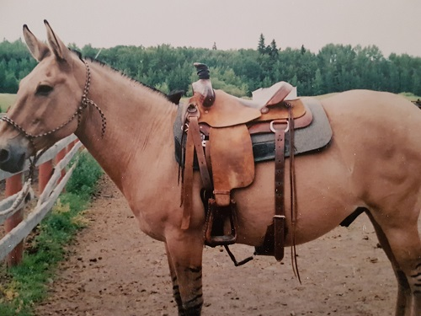
Once you understand the importance of analyzing the different back structures you may begin to realize the importance of properly positioning your saddle so that you are not limiting the performance of your animal by your tack.
In this photo, the saddle is too far forward and will be riding the shoulder blades, the cinch is right at the mule's elbow and will rub and the back cinch is hanging and totally useless as is.
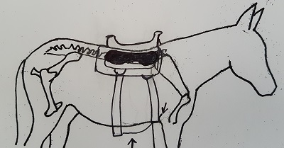For those who are fearful of not riding over their mule’s ‘’center of balance.’’ We know that in order for an animal to move to his optimum ability, we ourselves have to ride him in a ‘’balanced’’ position, meaning having our weight evenly distributed from side to side and front to back. Your weight directly over the center of the mule doesn’t affect his balance when he’s standing still, but it certainly does affect his balance as soon as he moves.
The term ‘’center of balance’’ can be used for different reasons. There is a ‘’center of mass’’ that moves as we move back and forth on top of the animal. Most of us work hard to get our mule or horse light on the front end and working off their hindquarters. If we have most of our weight on our mule’s front end, his center of mass is also forward so how does that easily enable him to develop lightness on his front end? If we move our weight a little back off of his front end and more in the center, we will give our mule a mechanical advantage. We ask our mule to be light on his front end but we are riding with our weight too far forward. By moving our weight a bit back, we make it easier for him to lift up his front end and get his rear end underneath him. The muscles that lift the front end are located in the loin and hip of the mule so by riding ‘’balanced’’ on his back and moving his center of mass back, we enable him to move his front end much easier.
If you look back at pictures of horseback riders throughout history, they are sitting in the middle of their mount’s backs, not up on the withers. When we ride too far forward, we are literally forcing our animal to speed up as he fights to keep his balance by moving his center of mass further back. Riding with the saddle well forward originated in horse racing, because this ‘’out of balance’’ saddle placement literally forced the horse to speed up. This still works because our racetracks are short, but for long distances the horse will tire quickly because of being out of balance. Competitive, endurance, and trail riders will find they will tire their horses much sooner when they set their saddles too far ahead.
A saddle that fits well when your mule is standing will not necessarily fit as well once the animal starts moving. When the animal turns left or right, he shortens the side of his body he is turning into so if you put your saddle too far forward on your mule, this becomes even more of an issue because you are asking your saddle to sit and fit on the animal’s moving shoulder blade.
The comment is often heard that if we have our saddle too far back we will ‘’hurt the kidneys.’’ Yes, too far back can be a problem too but rarely seen. Their kidneys are a suspended organ well protected by layers of muscle and bone, not next to the surface of the loin but laying deep within their body cavity. It’s pretty hard to hurt their kidneys but you can definitely sore the surface of the loin muscles with a tree that is too long or digs in at the back.
When we ride with our saddle too far forward we end up riding our animal’s shoulder blades or scapula. The wither can help hold the saddle in place but should not be used as an anchor. If you have a good look at your equine’s back, you will discover in many cases that his back dips down from his croup or loins to directly behind his withers. This is a downhill back conformation and can cause problems in saddle fitting.
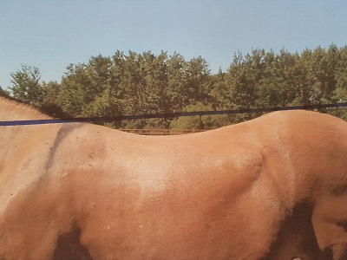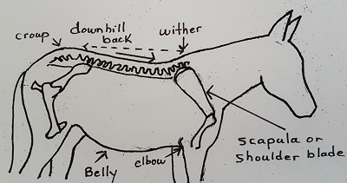
Note in the photo above that the croup and the withers are almost level, but there still is a downward slope towards the withers, so unless the saddle is positioned and leveled, it will still want to move ahead following gravity.
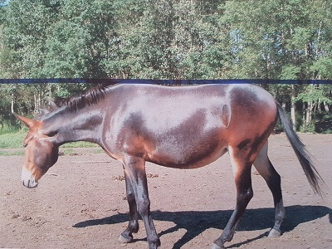
This photo shows a mule with a level back and as long as the saddle fits properly with a snug back cinch that sits behind the belly roll, her saddle will stay in position much easier than most.

Even those breeds that are known for good withers, often still have downhill backs. Most people are very surprised to realize this as we have been taught to believe that if the withers on an animal are higher than or at least level with the loins, that we have a level back.
It’s highly likely that many of us are trying to ride a mule or horse with a downhill back. That means that our saddle will want to ride to the low spot. Some folks refer to this as the ‘’sweet spot.’’ This is only a position affected by gravity and likely not where the saddle should ride. If you want to enable your animal to move to the best of his ability, position the front edge of your saddletree to at least 2’’ behind the back edge of your mule’s shoulder blade when his front leg is in full extension.
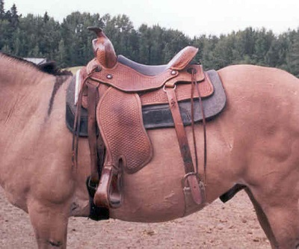
This saddle is set behind the mule’s shoulder blade. This mule has a slightly downhill back so a shim is set under the front of the saddle to help with leveling. The front cinch is well back of his elbow and the back cinch is very snug and captures his belly roll, all helping to keep the saddle in position Some saddles have an inch or so of leather in front of the edge of the tree so don’t get fooled by the leather; it’s where the front of your tree is that counts. Some mules require that the front edge of the tree sit up to 4’’ behind the end of their shoulder blade as that’s how much their shoulder blade moves!
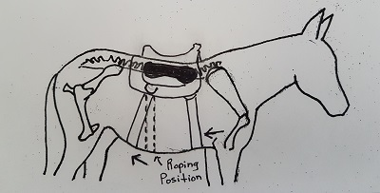
A saddle in this position allows for free movement of the scapula, thus more extension of the front legs of the horse or mule. The tree is well behind the shoulder blade, the front cinch is well back of the elbow and the back cinch is snug and behind the belly roll. HOWEVER, if you use your horse or mule for ROPING, make sure your back cinch stays on the rib cage for the animal’s comfort and safety to protect them from a sudden jerk or the pressure when catching or holding a cow or bull.
If you’re not convinced that your saddle should stay off of your mule, horse or donkey’s shoulder blade, try this little example. Set your saddle without a pad so that the front of the tree is on top of your animal’s shoulder blade. This is where most of us tend to saddle anyway. Stick your fingers under the front edge of the tree and next to the top back edges of their shoulder blade. Have someone put just a little pressure on the front of the saddle by pushing down on the horn. I bet you will say ‘’ouch.’’ Think about your weight in the saddle and how this must feel to their shoulder. Not only that, but then you expect them to comfortably move their shoulder blade every time you ask them to walk, trot, lope or perform a maneuver. With the mule and donkey especially being self-preservers, they will react in some way or another! At the very least, they will become short- strided.
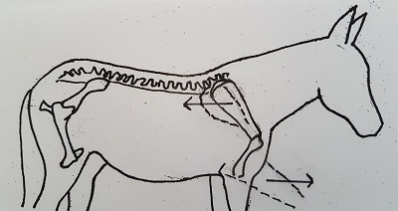
You can also experiment to check how far back your animal’s shoulder blade moves when he strides out. Have your friend pick up the front leg of your equine and pull it ahead. With your finger on the end of their shoulder blade at the stand still, note how much it moves back when the equine’s leg is pulled ahead. This is the same movement that happens when they stride out. This gives you a good idea of how much room you need to leave to allow for no interference with the front of the tree.
In this diagram, when the mule’s front leg moves forward his scapula will move between 2 inches to 4 inches back, depending on the individual. If your saddle tree is too far forward, you will jam his shoulders with the front of the tree.
Today more good saddles are being built with flared bars which allow for easier movement of the shoulder blades even if you place your saddle too far forward or it ends up moving there because of other problems. This allows for some shoulder relief but it’s best to set your saddle back in the first place and keep it there to relieve excessive weight bearing on your mount’s moving shoulder blade. Tree bars should also have some flare at the back of the tree to make sure the saddle will not dig into the loins.

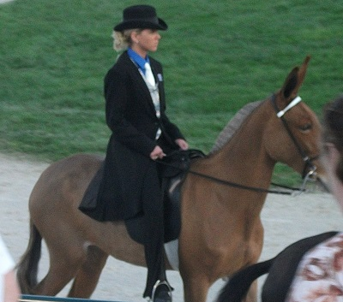
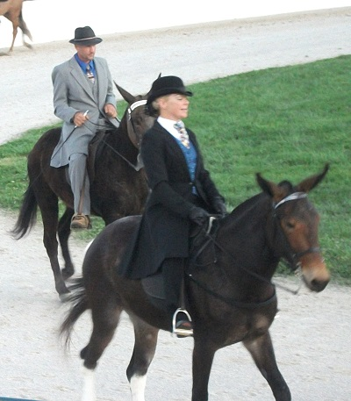
Gaited horses and mules often have sloping shoulders that literally push the saddle back if allowed. Watch the Saddle Seat riders and see where they set their saddles. They don’t ride the shoulder blades but sit in the center of their horse’s back. They do NOT want to interfere with their horse’s shoulder as to do so would inhibit the horse or mules ability to move out. There are some horses that are not exactly built to ride because they have such sloping shoulders that the saddle would need to sit on their loin to get away from their shoulder.

NEXT UP – Part 3: Poor Saddle Fit Signs and Tree Fitting

